 | Scottish Infected Blood Support Scheme  Practitioner Services  Gyle Square  1 South Gyle Crescent  Edinburgh, EH12 9EB  Email: NSS.SIBSS@nhs.scot  www.nss.nhs.scot | 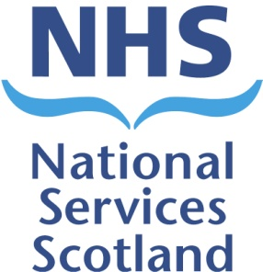

Minutes
Meeting: Scottish Infected Blood Support Scheme – Advisory Group
Date: 29th August 2018, 13:00-15:00
Location: Meeting Room GS 2.13, 1st Floor, Gyle Square, Edinburgh

Attendees:
David Knowles (DK) NHS National Services Scotland - Practitioner Services (Chair) Sally Richards (SR) NHS National Services Scotland - Practitioner Services
Kelly Watt (KW) NHS National Services Scotland - Practitioner Services (Minutes)
David Goldberg (DG) NHS National Services Scotland - Health Protection Scotland – Tele
Tommy Leggate (TL) Scottish Infected Blood Forum
Dan Farthing-Sykes (DF-S) Haemophilia Scotland
Leon Wylie (LW) Hepatitis Scotland

Observers:
Sam Baker (SB) Scottish Government

Apologies:
Joyce Donnelly (JD) Scottish Infected Blood Forum
Petra Wright (PW) Hepatitis C Trust

Welcome and Apologies
DK welcomed everyone to the meeting and took the group through the agenda for the morning. Apologies were noted for JD and PW.

Actions from precious meeting held 18th May 2018
The group went through the previous minutes and they were agreed.

Scheme Update
29 August 2018 Advisory Group Meeting
SR updated the group on the scheme progress. Statistics shared below;
- Total number of beneficiaries – 516
- Applications processed April – Aug - 37
- % Processed within 2 weeks - 100%
- Value of payments made April – Aug - £2.7m
- Unsuccessful applications – 1
- Deceased since April 2018 - 4
- No appeals

Scottish Government Update
SB reported the following;
- RG no longer part of the group as he is now working in another area on the Public Health Reform. Replacement appointed but will take time for the new person to start in the post.
- Still awaiting Ministerial final decision with regards to the Clinical Review. If agreement is made on the recommendations, this would be implemented very quickly. Discussions already held with DK & SR with regards to implementing payments processes – payment start date still to be agreed. DF-S advised Haemophilia Scotland would like to meet with the ministers first before the decision is made public.
- Public inquiry still ongoing and very challenging for Scottish Government with possible duplication with regards to the Penrose Documents (around 25,000 docs). Concerns over resourcing for Boards, SNBTS etc – legal costs.

SIBSS Survey Results 2018

DK reported that the results had not been published publically yet but that P&CFS were very pleased with the results and the good comments with regards to the service and contacts.

TL suggested a minor change be made to the below paragraph. The reference to the FRG group should be removed;

‘The current different payment arrangements for people with chronic Hepatitis C (formerly Stage 1) and those with advanced Hepatitis C (formerly Stage 2) are due to recommendations made by a Financial Review Group, which involved a number of organisations representing beneficiaries. However, the Review Group recommended that there should be an evidence- based clinical review of the health impacts of chronic Hepatitis C.’

Action 020 - Results to be published before the Clinical Review Result.

AOB
Survey Results – TL congratulated SR’s team on the survey results.

Additional notes added after review of minutes at 6th December 2018 meeting.
Infection Statistics – DF-S advised that FOIs had been completed with regards to the death rates in Britain and there had been some concerns with regards to the high death rate in Scotland compared to England. DF-S suggested that the charities worked together with assistance from Prof Goldberg on a separate study to look at this in more detail and would amalgamate the data gathering into one document. This would then be brought to the SIBSS Advisory Group for review.

Next Meeting: 6th December 2018 at 1pm.

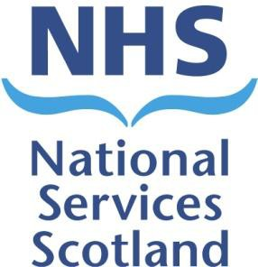
Action Log  Scottish Infected Blood Support Scheme – Advisory Group  29th August 2018, 13:00-15:00, Meeting Room GS 2.13 Gyle Square, Edinburgh | Scottish Infected Blood Support Scheme  Practitioner Services Gyle Square  1 South Gyle Crescent  Edinburgh, EH12 9EB  Email: NSS.SIBSS@nhs.scot  www.nss.nhs.scot

Action no. | Action details | Owner | Date raised | Target date | Updates | Status
010 | Advisory Group members to consider and forward suggestions of websites offering support that could be made available to beneficiaries. | All | 05/05/2017 | 16/06/2017 | 25/08/17 – Ongoing 22/12/17 – Ongoing 18/05/18 – Ongoing  29/08/18 - CLOSE | Close
011 | BW and TL to provide the scheme with details of the SIBF/Haemophilia Scotland meeting in October. | BW / TL | 05/05/2017 | 16/06/2017 | 25/08/17 – Ongoing 22/12/17 – Ongoing 18/05/18 – Ongoing  29/08/18 - CLOSE | Close
017 | Group to have a think about a potential replacement for Grant Sugden. | ALL | 18/05/18 | ASAP | 29/08/18 – DK advised a subject matter rep was still required. DK/SR agreed to draft an advert paragraph to be placed in the newsletter. Ongoing. | Open
018 | SR to send info on age groups of the scheme to the group | SR | 18/05/18 | ASAP | 29/08/18 - CLOSE | Close
019 | Slides and Newsletter to be forwarded to the group | SR/KW | 18/05/18 | ASAP | 29/08/18 - CLOSE | Close
020 | Agreed to publish the survey results before the clinical review result. | SR | 29/08/18 | ASAP

