Appendices for the: Safe Management of the Care Environment - Cleaning Specification for Older People and Adult Care Homes (SHFN 01-05)

May 2021

Contents
Appendix 1: Standard Operating Procedures (SOP’s) 1
Cleaning of Sanitary Fixtures and Fittings 2
Fixtures and Fittings (including dispensers) 3
Toilets/Urinals 4
Sinks, Wash Hand Basins and Baths 6
Showers 8
Cleaning of High levels 10
Cleaning of Furniture, Fixtures and Fittings 12
Cleaning of Soft Furnishings 14
Cleaning of Low Levels 16
Cleaning of Paintwork, Walls and Doors 18
Changing/Hanging Curtains 20
Cleaning of Floors 22
Cleaning of Floors: Method 1 - Dust Control Mopping 23
Cleaning of Floors: Method 2 - Suction Cleaning 25
Cleaning of Floors: Method 3 - Damp Mopping 27
Cleaning of Floors: Method 4 - Machine Scrubbing 29
Cleaning of Floors: Method 5 - Machine Buffing (where applicable) 31
Appendix 2: Cleaning Record/Schedule 32
Cleaning Record A: Residents room and en-suite 32
Cleaning Record B: Sluice and any clinical areas for treatment or medicines preparation 34 Cleaning Record C: Sanitary areas i.e. staff changing facilities, visitor’s toilets, shared bathrooms etc 36
Cleaning Record D: Dining Room Serveries/Pantries 38
Cleaning Record E: Offices 40
Cleaning Record F: Store rooms e.g. laundry stores, activity cupboards etc 42
Cleaning Record G: Dining Rooms/lounge/activity rooms/quiet rooms 44
Cleaning Record H: Entrance ramp/stairs and circulation areas 46
Cleaning Record I: Cleaning Services Room 48
Appendix 3: Environmental Check and Action Plan 50
Appendix 4: Checklist for Compliance 52

Appendix 1: Standard Operating Procedures (SOP’s)

Cleaning of Sanitary Fixtures and Fittings
- Fixtures and Fittings (including dispensers)
- Toilets/Urinals
- Sinks, Wash Hand Basins and Baths
- Showers
Cleaning of High Levels
Cleaning of Furniture, Fixtures and Fittings Cleaning of Soft Furnishings
Cleaning of Low Levels
Cleaning of Paintwork, Walls and Doors Changing/hanging Curtains
Cleaning of Floors
- Method 1: Dust Control Mopping
- Method 2: Suction Cleaning
- Method 3: Damp Mopping
- Method 4: Scrubbing
- Method 5: Buffing (where applicable)

Essential Information
For each task, the below essential information must be carried out:
- check COSHH sheet and relevant risk assessments for each task;
- prepare cleaning agent, if required, following manufacturer’s instructions;
- follow your local Manual Handling Policy.

Cleaning of Sanitary Fixtures and Fittings
This process involves the cleaning of sanitary contact surfaces to effectively reduce the risk of cross contamination and includes: toilets, urinals, bidets, sinks, wash hand basins, baths, showers and all dispensers.
1,000 parts per million available chlorine (ppm available chlorine (av.cl.) should be used routinely on sanitary fittings.
Required Outcome
Following the cleaning process, the required outcomes are expected:

- surfaces should be free from smudges, smears, bodily fluids, soap build up and mineral deposits;
- walls, fixtures and fittings should be free from dust, grit, streaks, smudges, mould, soap build up and bodily fluids;
- consumable items are well stocked in appropriate clean, sealed dispensers.
Required equipment and materials
Ensure all equipment is clean prior to use and cleaned and dried prior to return to store.
Equipment could include:
- PPE (i.e. apron, gloves, safety goggles etc.)
- colour coded equipment such as buckets and microfibre cloths
- disposable cloth or paper
- chlorine releasing agent

Fixtures and Fittings (including dispensers)
Method

Preparation steps  - Wash your hands, prior to wearing appropriate PPE | 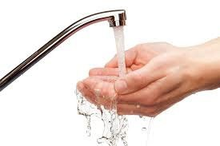
- Always dilute chemicals following Manufacturer’s instructions | 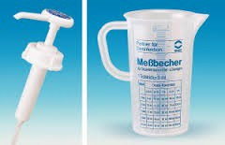
Cleaning steps  - correctly position wet floor sign to identify cleaning task taking place | 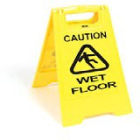
- using a new disposable cloth and 1,000ppm available chlorine, wipe the surface with the damp cloth using one swipe, fold a section of the cloth over to reveal a clean unused surface and wipe again. Ensure to always work clean to dirty, paying particular attention to touch surfaces such as handles and light pulls/switches, dispensers’ undersides and nozzles, then dispose of cloth. | 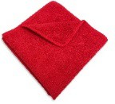
- When refilling clean inside of dispenser | 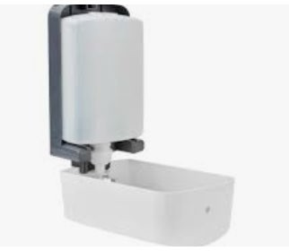
- rinse surfaces with clean water and dry with a clean cloth or paper roll | 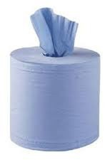
- remove refuse from the room, tying and labelling appropriately and clean waste bin | 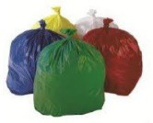
- remove PPE and dispose of in appropriate waste stream following waste segregation local procedure
- remove wet floor signs
After cleaning steps  - ensure all equipment used is cleaned and stored correctly | 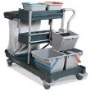
- Dispose of PPE appropriately and wash your hands

Toilets/Urinals
Required equipment and materials
Equipment could include:
- PPE (i.e. apron, gloves, safety goggles etc.)
- toilet brush
- colour coded equipment (buckets, microfibre, cloths)
- disposable cloth or paper
- chlorine releasing agent
Method

Preparation steps  - Wash your hands, prior to wearing appropriate PPE | 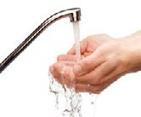
- Always dilute chemicals following Manufacturer’s instructions
Cleaning steps
- correctly position wet floor sign to identify cleaning task taking place
- flush before cleaning, never put cloth into the waste overflow beyond the strainer | 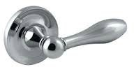
- push the water in the pan behind the bend with the toilet brush, leaving about an inch and put cleaning agent in bowl giving it time to work, as per manufacturer’s instructions | 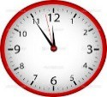
- using a new disposable cloth and 1,000ppm available chlorine, wash pedestal of sanitary ware from the base to the bowl (clean to dirty) towards the rim of the pan. Dispose of cloth. Using a new cloth dampened with 1,000 ppm available chlorine solution continue cleaning, flush handle, cistern, surrounds, hinges and finally toilet seat. Dispose of cloth. | 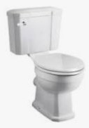
- clean inside bowl including the rim with the toilet brush and then flush, keep brush in the fresh flushing water to clean | 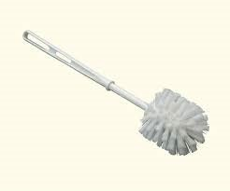
- rinse surfaces with clean water and dry with a clean cloth or paper roll
- remove PPE and dispose of in appropriate waste stream following waste segregation local procedure
- remove wet floor signs | 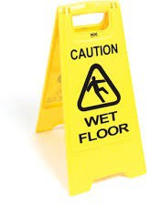
After cleaning steps
- ensure all equipment used is cleaned and stored correctly

- dispose of PPE appropriately and wash your hands

Sinks, Wash Hand Basins and Baths Required equipment and materials Equipment could include:
- PPE (i.e. apron, gloves, safety goggles etc.)
- colour coded equipment (microfibre, cloths)
- disposable cloth or paper
- chlorine releasing agent
Method

Preparation steps
- Wash your hands, prior to wearing appropriate PPE
- Always dilute chemicals following Manufacturer’s instructions
Cleaning steps
- correctly position wet floor sign to identify cleaning task taking place
- clear plug and overflow of debris | 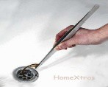
- damp clean soap and towel dispensers | 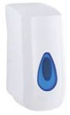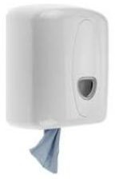
- clean splash back working from top to bottom | 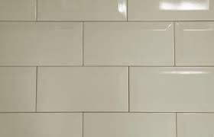
- clean the underside of the sink/basin working from rim downwards | 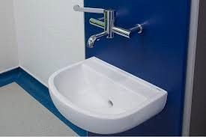
- using a new disposable cloth and 1,000ppm available chlorine, clean tap(s) first. Start at the tap outlet end (do not put cloth inside the tap outlet), finish at the base and then clean tap handles
- using the same cloth clean the accessible part of the overflow or waste outlet to remove visible dirt, dispose of the cloth in the appropriate waste bag
- clean round the inside of the sink/basin from top rim of bowl
- rinse surfaces with clean water and dry with a clean cloth or paper roll
- remove PPE and dispose of in appropriate waste stream following waste segregation local procedure
- remove wet floor signs

After cleaning steps
- ensure all equipment used is cleaned and stored correctly
- Dispose of PPE appropriately and wash your hands

Showers
Required equipment and materials
Equipment could include:
- PPE (i.e. apron, gloves, safety goggles etc.)
- colour coded equipment (buckets, microfibre, cloths)
- disposable cloth or paper
- chlorine releasing agent
Method

Preparation steps
- Wash your hands, prior to wearing appropriate PPE
- Always dilute chemicals following Manufacturer’s instructions
Cleaning steps
- correctly position wet floor sign to identify cleaning task taking place
- clear plug of debris | 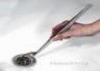
- using a new disposable cloth and 1,000ppm available chlorine, starting at highest point clean shower walls downward, then clean shower head, hose and taps
- pay particular attention to shower head and report any mineral deposit build up | 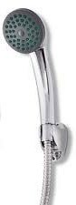
- if a shower tray is present clean inside and outside, if a wet room mop or mechanically clean floor, do not push cloth in overflow or waste outlet | 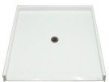
- rinse surfaces with clean water and dry with a clean cloth or paper roll
- remove PPE and dispose of in appropriate waste stream following waste segregation local procedure | 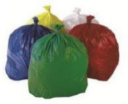
- remove wet floor signs
After cleaning steps
- ensure all equipment used is cleaned and stored correctly

- Dispose of PPE appropriately and wash your hands

Cleaning of High levels
This process involves the cleaning of high level surfaces to prevent the build-up of dust and includes: high surfaces including ledges, pipes, vents, grills, direction signs, curtain rails and screen rails or any ‘harder to reach’ areas or items that require additional equipment to clean. High levels should always be cleaned before Low levels.
Required Outcome
Following the cleaning process, the required outcomes are expected:

- each item is cleaned in a systematic way to reduce the risk of cross infection;
- hard surfaces should be free from soil, spots and dust;
- soft surfaces should be free from soil, stains, film and dust;
- edges, corners and wheels are free from soil, dust and film;
- surfaces should be free from tape and sticky residue.
Required equipment and materials
Ensure all equipment is clean prior to use and cleaned and dried prior to return to store.
Equipment could include:
- wet floor signs
- colour coded equipment (buckets, microfibre, cloths), disposable cloth or paper
- Cleaning agent
- PPE (i.e. apron, gloves, safety goggles etc.)
- high duster frame and head
Method

Preparation steps  - Wash your hands, prior to wearing appropriate PPE | 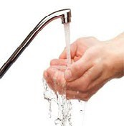
- Wear safety goggles and half fill bucket with water and add the cleaning agent in line with manufacturers’ instructions; change cleaning solution as appropriate
Cleaning steps
- correctly position wet floor sign to identify cleaning task taking place
- remove any debris, sticky tape from the surfaces
- dampen and fold the cloth top to bottom then left to right to make a square to give 8 cleaning surfaces before discarding, which will give you a number of clean cloth surfaces, wipe all high level surfaces with the damp cloth using one swipe, fold a section of the cloth over to reveal a clean unused surface and wipe again. Ensure to always work clean to dirty preventing cross contamination

- continue to do this until all the clean surfaces on the cloth have been used then replace the cloth | 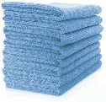
- remove wet floor signs
- remove PPE and dispose of in appropriate waste stream following waste segregation local procedure
After cleaning steps
- ensure all equipment used is cleaned and stored correctly
- Dispose of PPE appropriately and wash your hands

Cleaning of Furniture, Fixtures and Fittings
This process involves the cleaning of touch surfaces, to reduce the risk of cross contamination and includes: all furniture including beds (undercarriage, head and foot), tables (including over bed tables), desks, lockers, exam couches, chairs, external surfaces of cabinets, bed lights, light switches, light cords, control panels, pictures, general TV, HiFi equipment and remote controls, radiators, ledges, fire extinguishers, clocks, bump bars and buffers, exam lights and patient call buttons (as per local policy), glasswork and refuse bins. Service Users personal belongings included in this.
Required Outcome
Following the cleaning process, the required outcomes are expected:

- all surfaces should be free from soil, spots, dust and fingerprints;
- edges, corners and wheels are free from soil, dust and film;
- furnishings and fittings should be free from tape and sticky residue.
Required equipment and materials
Ensure all equipment is clean prior to use and cleaned and dried prior to return to store.
Equipment could include:
- colour coded equipment (buckets, microfibre, cloths)
- disposable cloth or paper
- cleaning agent
- PPE (i.e. apron, gloves, safety goggles etc.)
- high dusting tool (if required)
Method

Preparation steps
- Wash your hands, prior to wearing appropriate PPE
- wear safety goggles and half fill bucket with warm water and add the cleaning agent in line with manufacturers’ instructions
Cleaning steps
- correctly position wet floor sign to identify cleaning task taking place
- remove any debris, sticky tape from the furnishings and fittings
- wipe the surface with the damp cloth, or disposable hard surface wipe, using one swipe, fold a section of the cloth over to reveal a clean unused surface and wipe again. Ensure to always work clean to dirty; change solution when dirty or at 15 minute intervals or when moving to new task or location. Particular attention should be given to the touch surfaces such as handles, door plates and switches etc. | 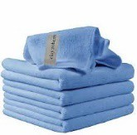

- dry the surface then dispose of cloth or paper | 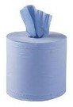
- remove PPE and dispose of in appropriate waste stream following waste segregation local procedure | 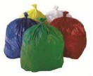
- remove wet floor signs
After cleaning steps
- ensure all equipment used is cleaned and stored correctly
- Dispose of PPE appropriately and wash your hands

Cleaning of Soft Furnishings
This process involves the cleaning of soft furnishings and fabrics, to reduce the risk of cross infection emphasis requires to be placed on the cleaning of contact surfaces. Soft furnishings can include chairs, foot stools, couches, cushions and carpets, Service Users personal belongings included in this.
Required Outcome
Following the cleaning process, the required outcomes are expected:
- all surfaces should be free from spots, soil, stains, dust, crumbs and fingerprints;
- furnishings and fittings should be free from sticky residue and odours.
Required equipment and materials
Ensure all equipment is clean prior to use and cleaned and dried prior to return to store.
Equipment could include:
- wet floor signs
- disposable cloth or paper
- carpet cleaning machine with upholstery cleaning attachment
- suction cleaner
- carpet shampoo: solution
- soft furnishing wipes
- **pre-spotter/stain remover
- ***odour neutraliser
**carpet shampoo, pre spotter and soft furnishing wipes should always be tested on an inconspicuous area of the fabric prior to full application
***for surfaces where odour is an issue, specific odour neutralising solutions can be considered, use following manufacturer’s instructions
Method

Preparation steps
- Wash your hands, prior to donning appropriate PPE
- gather equipment required for the task – this may include soft furnishing wipes for ‘spot’ cleaning or vacuum cleaner, carpet machine and upholstery nozzle, depending on the task to be completed
Cleaning steps
- correctly position wet floor sign to identify cleaning task taking place
- remove any visible debris and vacuum the surface to be cleaned. Apply pre spotter to any ingrained or stubborn marks Prepare carpet shampoo solution, fill carpet machine and attach upholstery cleaning nozzle when cleaning upholstery

- work in a methodical manner working the nozzle over the surface(s) that require to be cleaned. Take the nozzle back over the surface, on ‘vacuum mode’ to remove excess moisture, repeat the process again if required, to achieve the finish required | 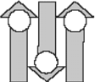
- leave surface to air dry completely | 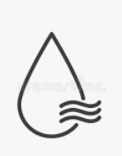
- For ‘spot’ cleaning and smaller surfaces, wipe the textile surface with the soft furnishing wipe using one swipe, fold a section of the wipe over to reveal a clean unused surface and wipe again. Take a new wipe as required. Ensure to always work from clean to dirty | 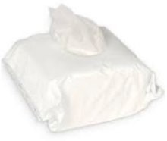
- **For staining, apply pre spotter/stain remover solution and work from outer edge of stain towards the centre, blot with paper roll to remove or loosen the stain and re apply if required. Follow up with the process detailed above
After cleaning steps
- Empty carpet machine, rinse solution tank and upholstery nozzle through with clean water, dry and store with lid offset. Hoses should be hung to allow any excess water to dry
- Clean and dry other equipment that has been used and store correctly
- Dispose of PPE appropriately and wash your hands

Cleaning of Low Levels
This process involves the cleaning of any surface which might attract dust and spillages and includes: low surfaces including ledges, trunking, vents, pipes and partition ledges, skirting and sockets.
Required Outcome
Following the cleaning process, the required outcomes are expected:

- hard surfaces should be free from soil, spots and dust;
- soft surfaces should be free from soil, stains, film and dust;
- edges, corners and wheels are free from soil, dust and film;
- surfaces should be free from tape and sticky residue.
Required equipment and materials
Ensure all equipment is clean prior to use and cleaned and dried prior to return to store.
Equipment could include:
- wet floor signs
- colour coded equipment (buckets, microfibre, cloths), disposable cloth or paper
- cleaning agent
- PPE (i.e. apron, gloves, safety goggles etc.)
- kneeling pad if required
Method
Preparation steps
- Wash your hands, prior to wearing appropriate PPE

- Wear safety goggles and half fill bucket with water, using fresh running water where possible, and add the cleaning agent in line with manufacturers’ instructions.
Cleaning steps
- correctly position wet floor sign to identify cleaning task taking place

- remove any debris, sticky tape from the surfaces

- dampen and fold the cloth top to bottom then left to right to make a square to give 8 cleaning surfaces

- wipe the surface with the damp cloth using one swipe, fold a section of the cloth over to reveal a clean unused surface and wipe again. Continue to do this until all the clean surfaces on the cloth have been used then replace the cloth.
Ensure to always work clean to dirty; change solution when dirty or at 15 minute intervals or when moving to new task or location.
- continue to do this until all the clean surfaces on the cloth have been used then replace the cloth

- remove wet floor signs
- remove PPE and dispose of in appropriate waste stream following waste segregation local procedure
After cleaning steps
- ensure all equipment used is cleaned and stored correctly
- Dispose of PPE appropriately and wash your hands

Cleaning of Paintwork, Walls and Doors
This process involves the cleaning of paintwork, walls and doors in a systematic way to reduce the risk of cross contamination and includes: wall surfaces and doors and door frames (including the top of the door frame), handles, hinges, jambs and other door closure mechanisms, door vents, kick plates and door signs. Includes window sills and window frames.
Required Outcome
Following the cleaning process, the required outcomes are expected:

- all surfaces should be free from soil, spots, dust and fingerprints;
- low level air vents, grilles and any other air outlets are unblocked and free from dust, grit, soil and cobwebs;
- door tracks and jambs are free from grit and other debris;
- all surfaces are free from tape and sticky residue.
Required equipment and materials
Ensure all equipment is clean prior to use and cleaned and dried prior to return to store.
Equipment could include:
- wet floor
- colour coded equipment (buckets, microfibre, cloths), disposable cloth or paper
- cleaning agent
- PPE (i.e. apron, gloves, safety goggles etc.)
- safety ladder, if required, in accordance with ‘Working at Height’ guidance and training
- high duster frame and head
Method

Preparation steps
- Wash your hands, prior to wearing appropriate PPE
- Wear safety goggles and half fill bucket with water and add the cleaning agent in line with manufacturers’ instructions; change cleaning solution as appropriate
Cleaning steps
correctly position wet floor sign to identify cleaning task taking place
- remove all forms of soiling and graffiti from the surface to be cleaned
- wipe the surface with the damp cloth using one swipe, fold a section of the cloth over to reveal a clean unused surface and wipe again. Ensure to always work clean to dirty

- continue to do this until all the clean surfaces on the cloth or paper have been used then replace the cloth
- remove wet floor signs
- remove PPE and dispose of in appropriate waste stream following waste segregation local procedure
After cleaning steps
- ensure all equipment used is cleaned and stored correctly
- Dispose of PPE appropriately and wash your hands

Changing/Hanging Curtains
This process involves the removal and hanging of curtains in all service user areas.
Required Outcome
Following the cleaning process, the required outcomes are expected:

- curtains are in good state of repair and free from stains, soiling and dust;
- curtains hang in a uniform manner and have sufficient and appropriate hooks/fasteners;
- rails, fittings and fixtures required for curtains and should be in good state of repair and free from dust, grit, spillage, residue or any tape or attachments which may compromise cleaning.
Required equipment and materials
A local risk assessment should be carried out to determine the number of operatives and type of kit required to undertake the task safely and effectively. This is essential when working at heights, in occupied areas and handling large, heavy curtains.
Ensure curtains are freshly laundered and in good state of repair. Equipment could include:
- wet floor sign
- colour coded equipment (buckets, microfibre, cloths), disposable cloth or paper
- cleaning solution
- PPE (i.e. apron, gloves, safety goggles etc.)
- laundry bags
- curtain hooks and container
- clean curtains
Method

Preparation steps
- Wash your hands, prior to wearing appropriate PPE
- Wear safety goggles and half fill bucket with water, using fresh running water where possible, and add the cleaning agent in line with manufacturers’ instructions
Cleaning steps
- correctly position wet floor sign to identify cleaning task taking place
- using the safety ladder, and in line with outcome of risk assessment, take down the curtain
- remove the curtain hooks and place in the container | 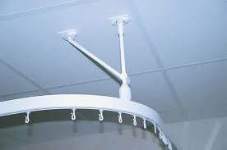

- bag curtains and label bags, for transfer to laundry as per local policy | 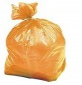
- dampen cloth/paper and wipe curtain rail and associated fixtures. Wipe the surface with the damp cloth using one swipe, fold a section of the cloth over to reveal a clean unused surface and wipe again. Ensure to always work clean to dirty
- wash curtain hooks in cleaning solution and dry | 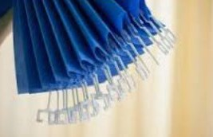
- fit the curtain hooks to a clean curtain at appropriate, evenly spaced intervals
- carry and hang curtain as per recommendations from risk assessment
After cleaning steps
- remove stepladders and wet floor signs
- remove PPE and dispose of in appropriate waste stream following waste segregation local procedure
- ensure all equipment used is cleaned and stored correctly
- Dispose of PPE appropriately and wash your hands

Cleaning of Floors
This process applies to types of floor cleaning for all surfaces which might attract dirt, dust and spillages and entails 5 different methods, where applicable:

Method 1: Dust Control Mopping - applies to the removal of adherent dust and dirt from floor surfaces using Dust Control Mopping equipment.
Method 2: Suction Cleaning - applies to the removal of adherent dust and dirt from floor surfaces using a suction cleaner.
Method 3: Damp Mopping - removal of floor soil or ingrained dirt using mopping system.
Method 4: Scrubbing - removal of floor soil, ingrained dirt and scuff marks using a floor scrubbing machine.
Method 5: Buffing (where applicable) – provides a uniform, streak free appearance to the floor surface.
Carpeted areas: see ‘Cleaning of Soft Furnishings’ for carpets requiring to be shampooed.
Required Outcome
Depending on the relevant cleaning method, the required outcomes are expected:

- surfaces should be free from debris, dust and grit;
- inaccessible areas are free from debris and dust;
- edges and corners are free from soil, dust and film;
- barrier matting is free from ingrained debris, dust, grit, stains and chewing gum;
- surfaces should be free from tape and sticky residue;
- stains that cannot be removed by suction cleaning should be spot cleaned or deep cleaned using carpet cleaning kit;
- to ensure the floor is cleaned in a systematic way to reduce the risk of cross contamination.

Cleaning of Floors: Method 1 - Dust Control Mopping
Required equipment and materials
Ensure all equipment is clean prior to use and cleaned and dried prior to return to store.
Equipment could include:
- wet floor sign
- mop frame/tool
- suction cleaner and attachments
- disposable cloth or reusable or disposable mop head
- appropriate bag for soiled mops
- PPE (i.e. apron, gloves, safety goggles etc.)
- refuse sack
- scraper
*always refer to the individuals care plan around the management of their furniture
Method

Preparation steps
- Wash your hands, prior to detail of appropriate PPE
- fit appropriate microfibre or disposable mop head to frame | 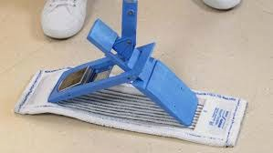
Cleaning steps
- correctly position wet floor sign to identify cleaning task taking place
- remove larger items of debris from floor, using scraper to remove any chewing gum, and dispose of in an appropriate waste stream, ensure to follow local procedure for waste segregation | 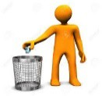
- with frame, width wide in front of you, walk forward round edges of room against skirting board, ensuring the mop head is never lifted from the floor and debris is not brushed off with bare hands | 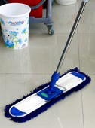
- visually divide room into wide strips. Hold mop with narrow end facing you and sweep to one side. At end of side sweep, twist the mop head so that the other narrow end is facing towards you and sweep the next line. In this way the dust will be pushed in front of the mop head and not left against edges. Never brush off debris in a clinical area | 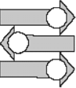
- mop the remaining floor using leading edge, working backwards towards the door | 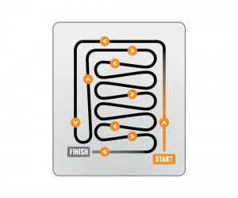
- remove wet floor signs

After cleaning steps
- ensure all equipment used is cleaned and stored correctly
- Dispose of PPE appropriately and wash your hands | 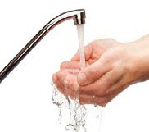

Cleaning of Floors: Method 2 - Suction Cleaning
Required equipment and materials
Ensure all equipment is clean prior to use, PAT tested, cables are in good condition, clean and dried prior to return to store. (Report any unsafe equipment to Supervisor/Manager)
Equipment could include:
- wet floor sign
- suction cleaner and appropriate attachments
- dust pan and brush
- filters/bags
- refuse sack
- PPE (i.e. apron, gloves, safety goggles etc.)
*always refer to the individuals care plan around the management of their furniture
Method

Preparation steps
- Wash your hands, prior to wearing appropriate PPE
- assemble the suction cleaner and check that bag and filters (HEPA if applicable) are in place and serviceable | 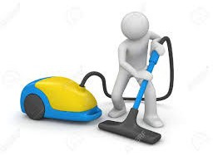
- before cleaning takes place, visually inspect the room or area being cleaned; if mobile objects can be moved*, remove these safely, following local Manual Handling Policy, and place out of the way of traffic | 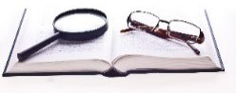
- unwind cable and run the length of cable through a cloth to ensure the cable is free from splits and plug is not loose or broken
Cleaning steps
correctly position wet floor sign to identify cleaning task taking place
- remove larger items of debris from floor and dispose of in an appropriate waste stream, ensure to follow local procedure for waste segregation
- plug suction cleaner into the nearest available socket and switch on the power, ensuring that the cable is never placed over the user’s shoulder | 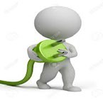
- do not move from room to room or run the cable across/through doorways, ensure cable stays behind the operator when working
- when suction cleaning stand upright with feet shoulder width apart and using even strokes; divide area into sections to ensure complete area is covered and suction clean the edges and corners first, using the hose attachments if available, then work systematically around the room | 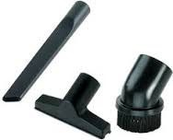
- adjust position on suction cleaner head to suit flooring height, remember to bend knees when reaching under furniture

- on completion, return mobile objects which were removed prior to the cleaning process taking place following the Manual Handling Policy
- remove wet floor signs
- remove PPE and dispose of in appropriate waste stream following waste segregation local procedure
- Wash your hands
After cleaning steps  - return suction cleaner to cleaning cupboard | 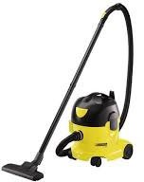
- suction clean filters regularly and replace when required; check if bag needs replaced and change as required | 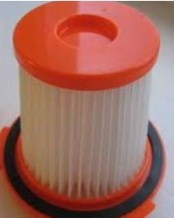
- remove hose from body; hang separately so that hose is not bent causing stress and weakening | 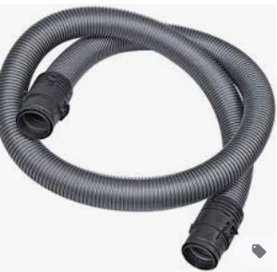
- remove head, wash, and leave to dry on paper | 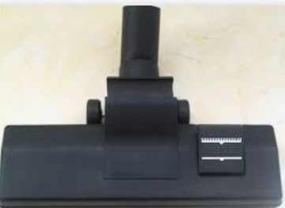
- clean and wind cable around body of suction cleaner securing the plug | 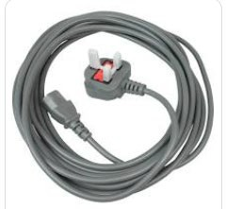
- ensure all equipment used is cleaned and stored correctly
- Dispose of PPE appropriately and wash your hands

Cleaning of Floors: Method 3 - Damp Mopping
Required equipment and materials
To ensure the floor is cleaned in a systematic way to reduce the risk of cross infection.
Equipment could include:
- wet floor signs
- dosing containers
- colour coded equipment (buckets, mops, mop frames, microfibre)
- mop wringer (traditional mopping system only)
- disposable cloth or paper
- appropriate bag for soiled mops
- PPE (i.e. apron, gloves, safety goggles etc.)
*always refer to the individuals care plan around the management of their furniture
Method

Preparation steps
- Wash your hands, prior to wearing appropriate PPE
- put on safety goggles, prepare a solution of water and make up the cleaning agent in accordance with manufacturer’s instructions
- fold the mop heads into the dosing container
- pour the cleaning agent over the mop heads and leave for a minute to allow the mops to absorb the liquid. The mops should be damp – not wet or follow your local procedure for dampening floor mop prior to use | 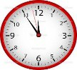
- place the container of mops onto the trolley | 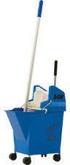
- before cleaning takes place, visually inspect the room or area being cleaned; if mobile objects can be moved*, remove these safely, following local Manual Handling Policy, and place out of the way of traffic
Cleaning steps
- correctly position wet floor sign to identify cleaning task taking place
- remove larger items of debris from floor and dispose of in an appropriate waste stream, ensure to follow local procedure for waste segregation
- standard mopping system use a clean mop head for each room or section of room, wringing the mop head as dry as possible in the cleaning solution prior to mopping | 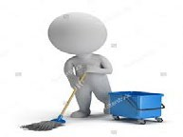

- plan the work route by starting at the furthest point from the exit working backwards to avoid standing on cleaned sections
- mop the floor edges using a straight stroke to reach corners and skirting.  Flip the mop head up to clean the skirting and reach the edge | 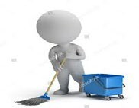
- mop the remaining floor using leading edge, working backwards towards the door, leaving a clear walkway | 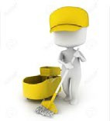
- after each room change the mop head and place it in the clear bag for laundering | 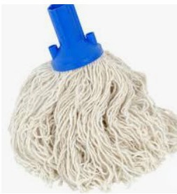
- on completion, return mobile objects which were removed prior to the cleaning process taking place following the Manual Handling Policy
- remove wet floor signs
- Dispose of PPE appropriately and wash your hands
After cleaning steps
- ensure all equipment used is cleaned and stored correctly
- Dispose of PPE appropriately and wash your hands

Cleaning of Floors: Method 4 - Machine Scrubbing
Required equipment and materials
Ensure all equipment is clean prior to use, PAT tested, cables are in good condition, clean and dried prior to return to store. (Report any unsafe equipment to Supervisor/Manager).
Equipment could include:
- wet floor sign
- scrubbing machine with disc and scrubbing pad or scrubbing brush
- solution tank
- wet suction machine/scrubber drier
- colour coded equipment (buckets, mops, mop frames, microfibre)
- mop wringer
- appropriate bag for soiled mops
- PPE (i.e. apron, gloves, safety goggles etc.)
*always refer to the individuals care plan around the management of their furniture
Method

Preparation steps
- Wash your hands, prior to wearing appropriate PPE
- assemble scrubbing machine and wet suction machine | 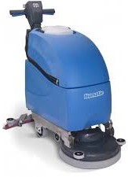
- put on safety goggles, prepare a solution of water and make up the cleaning agent in accordance with manufacturer’s instructions; fill solution tank with water and appropriate cleaning agent
- assemble mop and pole
- before cleaning takes place, visually inspect the room or area being cleaned; if mobile objects can be moved*, remove these safely, following local Manual Handling Policy, and place out of the way of traffic
Cleaning steps
- correctly position wet floor sign to identify cleaning task taking place
- remove larger items of debris from floor and dispose of in an appropriate waste stream, ensure to follow local procedure for waste segregation
- starting at the furthest away point scrub floor moving along the wall edge of the floor then going from side to side overlapping whilst doing so (small sections at a time), leaving a clear walkway, or dependant on the machine used and area being cleaned, clean accordingly

- dry floor using wet suction machine
- rinse floor area with plain water as per damp mopping Method 3, if required
- on completion, return mobile objects which were removed prior to the cleaning process taking place following the Manual Handling Policy
- remove PPE and dispose of in appropriate waste stream following waste segregation local procedure
After cleaning steps
- ensure all equipment used is cleaned and stored correctly
- Dispose of PPE appropriately and wash your hands

Cleaning of Floors: Method 5 - Machine Buffing (where applicable)
Required equipment and materials
Ensure all equipment is clean prior to use, PAT tested, cables are in good condition, clean and dried prior to return to store. (Report any unsafe equipment to Supervisor/Manager).
Equipment could include:
- wet floor signs
- scrubbing machine with disc and buffing pad or buffing brush
- PPE (i.e. apron, gloves, safety goggles etc.)
*always refer to the individuals care plan around the management of their furniture
Method

Preparation steps
- Wash your hands, prior to wearing appropriate PPE
- before cleaning takes place, visually inspect the room or area being cleaned; if mobile objects can be moved*, remove these safely, following local Manual Handling Policy, and place out of the way of traffic
- assemble machine with attachments | 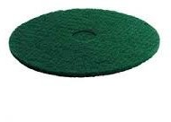
Cleaning steps
correctly position wet floor sign to identify cleaning task taking place
- remove larger items of debris from floor and dispose of in an appropriate waste stream, ensure to follow local procedure for waste segregation
- starting at the furthest away point from the door, buff floor moving along wall edges from side to side with a slight overlap), leaving a clear walkway
- on completion, return mobile objects which were removed prior to the cleaning process taking place following the Manual Handling Policy
- remove PPE and dispose of in appropriate waste stream following waste segregation local procedure
After cleaning steps
- ensure all equipment used is cleaned and stored correctly
- Dispose of PPE appropriately and wash your hands

Appendix 2: Cleaning Record/Schedule

Cleaning Record A: Residents room and en-suite
Room number: Week Commencing:

Task Group | Task Activity | Mon |  | Tues |  | Wed |  | Thurs |  | Fri |  | Sat |  | Sun
Daily Tasks
Toilet | Clean and check (clean once, check once)
Toilet brush holder | Clean and check (clean once, check once)
Soap and handtowels | Clean dispensers and replenish supplies
Glass panels or mirror/ceramic wall tiles/wet wall | Check for marks and spot clean
Sanitary fittings (wash-hand  basin, sink, taps, fixtures) | Clean and check (clean once, check once)
High level | Check for cleanliness, spot clean
Furnishings | Remove debris
 | Damp clean
Radiators | Check for marks and spot clean
Low level | Check for cleanliness, spot clean
Paintwork (walls and doors) | Check for marks and spot clean
Refuse | Collect refuse and dispose
 | Check bin and spot clean
 | Replace liners
Floors Hard/Soft | Remove debris
 | Dust control or suction clean
 | Damp mop
 | Check for spills, stains etc.

Weekly Tasks
Glass panels or mirrors/ceramic wall tiles or wet wall | Clean
High level surfaces | Clean ledges, pipes, directional signs
Low level | Damp clean
Telephone | Clean
Window blinds | Suction clean
Paintwork (walls and doors) | Remove marks
Refuse | Clean holders and containers
Floors Hard/Soft | Buff/burnish or scrub
 | Suction dry
Less Frequent tasks* | Refer to yearly tasks record and note any activities undertaken
*Refer to yearly task sheet for less frequent tasks and complete full schedule
Less Frequent Tasks – to be transferred to a yearly task sheet

Sanitary fittings (toilet, wash-  hand basin, sink, taps, fixtures) | Descale to local requirements
Furnishings | Clean castors and wheels monthly
Window Blinds | Clean opening and closing mechanism monthly
 | Consider removal and cleaning to local requirement
Cubicle Curtains | Change cubicle curtains, window curtains once every 6 months
Floors Hard/Soft | Consider scrubbing hard floors every 2nd month
 | Extraction clean for soft floors every 2nd month
 | Buffing hard floors to local requirements
 | Application of carpet protector to local requirements

Cleaning Record B: Sluice and any clinical areas for treatment or medicines preparation
Room number: Week Commencing:

Task Group | Task Activity | Mon |  | Tues |  | Wed |  | Thurs |  | Fri |  | Sat |  | Sun
Daily Tasks
Soap and handtowels | Clean dispensers and replenish supplies
Glass panels or mirror/ceramic  wall tiles/wet wall | Check for marks and spot clean
Sanitary fittings (wash-hand basin, sink, taps, fixtures) | Clean and check (clean once, check once)
High level | Check for cleanliness, spot clean
Furnishings | Remove debris
 | Damp clean
Radiators | Check for marks and spot clean
Low level | Check for cleanliness, spot clean
Paintwork (walls and doors) | Check for marks and spot clean
Refuse | Collect refuse and dispose
 | Check bin and spot clean
 | Replace liners
Floors Hard/Soft | Remove debris
 | Dust control or suction clean
 | Damp mop
 | Check for spills, stains etc.

Weekly Tasks
Glass panels or mirrors/ceramic wall tiles or wet wall | Clean
High level surfaces | Clean ledges, pipes, directional signs
Low level | Damp clean
Telephone | Clean
Window blinds | Suction clean
Paintwork (walls and doors) | Remove marks
Refuse | Clean holders and containers
Floors Hard/Soft | Buff/burnish or scrub
 | Suction dry
Less Frequent tasks* | Refer to yearly tasks record and note any activities undertaken
*Refer to yearly task sheet for less frequent tasks and complete full schedule
Less Frequent Tasks – to be transferred to a yearly task sheet

Sanitary fittings (toilet, wash-  hand basin, sink, taps, fixtures) | Descale to local requirements
Furnishings | Clean castors and wheels monthly
Window Blinds | Clean opening and closing mechanism monthly
 | Consider removal and cleaning to local requirement
Floors Hard/Soft | Consider scrubbing hard floors every 2nd month
 | Extraction clean for soft floors every 2nd month
 | Buffing hard floors to local requirements
 | Application of carpet protector to local requirements

Cleaning Record C: Sanitary areas i.e. staff changing facilities, visitor’s toilets, shared bathrooms etc.
Room number: Week Commencing:

Task Group | Task Activity | Mon |  | Tues |  | Wed |  | Thurs |  | Fri |  | Sat |  | Sun
Daily Tasks
Toilet | Clean and check (clean once, check once)
Toilet brush holder | Clean and check (clean once, check once)
Soap and handtowels | Clean dispensers and replenish supplies
Glass panels or mirror/ceramic wall tiles/wet wall | Check for marks and spot clean
Sanitary fittings (wash-hand  basin, sink, taps, fixtures) | Clean and check (clean once, check once)
High level | Check for cleanliness, spot clean
Furnishings | Remove debris
 | Damp clean
Radiators | Check for marks and spot clean
Low level | Check for cleanliness, spot clean
Paintwork (walls and doors) | Check for marks and spot clean
Refuse | Collect refuse and dispose
 | Check bin and spot clean
 | Replace liners
Lockers | Remove debris
 | Damp clean
Floors Hard/Soft | Remove debris
 | Dust control or suction clean
 | Damp mop
 | Check for spills, stains etc.
1.

Weekly Tasks
Glass panels or mirrors/ceramic wall tiles or wet wall | Clean
High level surfaces | Clean ledges, pipes, directional signs
Low level | Damp clean
Paintwork (walls and doors) | Remove marks
Floors Hard/Soft | Buff/burnish or scrub
 | Suction dry
*Refer to yearly tasks record and note any activities undertaken
Less Frequent Tasks – to be transferred to a yearly task sheet

Sanitary fittings (toilet, wash-hand basin, sink, taps, fixtures) | Descale to local requirements
Furnishings | Clean castors and wheels monthly

Cleaning Record D: Dining Room Serveries/Pantries
Room number: Week Commencing:

Task Group | Task Activity | Mon |  |  |  | Tues |  |  |  | Wed |  |  |  | Thurs |  |  |  | Fri |  |  |  | Sat |  |  |  | Sun
Daily Tasks
Soap and handtowels | Clean dispensers and replenish supplies
Glass panels or mirror/ceramic  wall tiles/wet wall | Check for marks and spot clean
Sanitary fittings (wash-hand basin, sink, taps, fixtures) | Clean and check (clean once, check once)
High level | Check for cleanliness, spot clean
Furnishings | Remove debris
 | Damp clean
Low level | Check for cleanliness, spot clean
Telephones
Paintwork (walls and doors) | Check for marks and spot clean
Refuse | Collect refuse and dispose
 | Check bin and spot clean
 | Replace liners
Kitchen fixtures, fittings, appliances | Clean spillages (twice daily)
 | Damp clean outside surfaces
 | Check and spot clean appliances
 | Clean waste disposal units (twice daily)
Cleaning Equipment | Clean and dry before storage
Floors Hard/Soft | Remove debris
 | Dust control or suction clean
 | Damp mop
 | Check for spills, stains etc.

Weekly Tasks
Glass panels or mirrors/ceramic wall tiles or wet wall | Clean
Low level | Damp clean
Paintwork (walls and doors) | Remove marks
Kitchen fixtures, fittings, appliances | Defrost and clean refrigerator
 | Clean appliances (icemaker, cooker, heated cabinets, microwaves, other appliances)
Floors Hard/Soft | Buff/burnish or Scrub
Less Frequent tasks* | Refer to yearly tasks record and note any activities undertaken
*Refer to yearly task sheet for less frequent tasks and complete full schedule

Less Frequent Tasks – to be transferred to a yearly task sheet

Sanitary fittings (wash-hand basin, sink, taps, fixtures) | Descale to local requirements
High level surfaces | Clean ledges, pipes, directional signs monthly
Furnishings | Clean castors and wheels monthly
Window Blinds | Suction clean monthly
 | Clean opening and closing mechanism monthly
 | Consider removal and cleaning to local requirement
Kitchen fixtures, fittings, appliances | Defrost and clean freezer once every 2 months
 | Clean shelves and interior cupboards monthly
 | Clean behind and under appliances once every 2 months
Floors Hard/Soft | Consider scrubbing hard floors every month
 | Suction dry monthly

Cleaning Record E: Offices
Room number: Week Commencing:

Task Group | Task Activity | Mon | Tues | Wed | Thurs | Fri | Sat | Sun
Daily Tasks
Soap and handtowels | Clean dispensers and replenish supplies
Sanitary fittings (wash-hand  basin, sink, taps, fixtures) | Clean and check
Glass panels | Check for marks and spot clean
Furnishings | Remove debris
 | Damp clean
Telephones | Damp clean
Refuse | Collect refuse and dispose
 | Replace liners
Cleaning Equipment | Clean and dry before storage
Floors Hard/Soft | Remove debris
 | Dust control or suction clean
 | Check for spills, stains etc.

Weekly Tasks
Glass panels/ceramic wall tiles | Clean
Low level | Damp clean
Paintwork (walls and doors) | Remove marks
Refuse | Clean holders and containers
Floors Hard/Soft | Damp mop (3 times a week)
Less Frequent tasks* | Refer to yearly tasks record and note any activities  undertaken
4.
*Refer to yearly task sheet for less frequent tasks and complete full schedule

Less Frequent Tasks – to be transferred to a yearly task sheet

Sanitary fittings (wash-hand basin, sink, taps, fixtures) | Descale to local requirements
High level surfaces | Clean ledges, pipes, directional signs monthly
Furnishings | Clean castors and wheels monthly
Window Blinds | Suction clean and clean opening and closing mechanism  once a month
 | Remove and clean once a year
Curtains | Change window curtains once a year
Floors Hard/Soft | Buff/burnish or Scrub once every 3 months
 | Suction dry once every 3 months
 | Application of carpet protector to local requirements

Cleaning Record F: Store rooms e.g. laundry stores, activity cupboards etc.
Room number: Week Commencing:

Task Group | Task Activity | Mon | Tues | Wed | Thurs | Fri | Sat | Sun
Daily Tasks
Soap and handtowels | Replenish supplies (weekdays)
Sanitary fittings (wash-hand  basin, sink, taps, fixtures) | Clean (weekdays only)
Furnishings | Remove debris (weekdays only)
Refuse | Collect refuse and dispose (weekdays)
 | Replace liners (weekdays)
Cleaning Equipment | Clean and dry before storage
Floors Hard/Soft | Remove debris (weekday only)
 | Spot mop (weekday only)

Weekly Tasks
Soap and handtowels | Clean dispensers
Glass panels/ceramic wall tiles | Clean
Low level | Damp clean
Paintwork (walls and doors) | Remove marks
Telephones | Damp clean
Refuse | Clean holders and containers
Floors Hard/Soft | Dust control or suction clean
 | Damp mop
 | Spot mop or stain removal
Less Frequent tasks* | Refer to yearly tasks record and note any activities  undertaken
*Refer to yearly task sheet for less frequent tasks and complete full schedule

Less Frequent Tasks – to be transferred to a yearly task sheet

Sanitary fittings (wash-hand basin, sink, taps, fixtures) | Descale to local requirements
High level surfaces | Clean ledges, pipes, directional signs monthly
Furnishings | Clean castors and wheels monthly
Window Blinds | Suction clean and clean opening and closing mechanism  once every 2 months
 | Consider removal and cleaning yearly
Curtains | Change window curtains yearly
Floors Hard/Soft | Buffing hard floors to local requirements
 | Extraction clean for soft floors every 2nd month
 | Application of carpet protector to local requirements

Cleaning Record G: Dining Rooms/lounge/activity rooms/quiet rooms
Room number: Week Commencing:

Task Group | Task Activity | Mon |  |  |  | Tues |  |  |  | Wed |  |  |  | Thurs |  |  |  | Fri |  |  |  | Sat |  |  |  | Sun
Daily Tasks
Soap and handtowels | Clean dispensers and replenish supplies
Glass panels or mirrors/ceramic  wall tiles or wet wall | Check for marks and spot clean
Sanitary fittings (wash-hand basin, sink, taps, fixtures) | Clean and check (clean once, check once)
Furnishings | Remove debris (daily, check after every mealtime)
 | Damp clean (clean daily, check after every mealtime)
Low level | Check for cleanliness, spot clean
Telephones | Damp clean
Paintwork (walls and doors) | Check for marks and spot clean
Refuse | Collect refuse and dispose (clean once, check once)
 | Clean holders (once daily) and spot clean (once daily)
 | Replace liners (clean once, check once)
Cleaning Equipment | Clean and dry before storage
Floors Hard/Soft | Remove debris (clean daily, check after every mealtime)
 | Dust control or suction clean
 | Damp mop
 | Check for spills, stains (after every mealtime)

Weekly Tasks
Glass panels/ceramic wall tiles | Clean
Low level | Damp clean
Paintwork (walls and doors) | Remove marks
Less Frequent tasks* | Refer to yearly tasks record and note any activities undertaken

*Refer to yearly task sheet for less frequent tasks and complete full schedule
Less Frequent Tasks – to be transferred to a yearly task sheet

Sanitary fittings (wash-hand basin, sink, taps, fixtures) | Descale to local requirements
High level surfaces | Clean ledges, pipes, directional signs monthly
Furnishings | Clean castors and wheels monthly
Window Blinds | Suction clean and clean opening and closing mechanism  once a month
 | Consider removal and cleaning to local requirement
Curtains | Change window curtains once every 6 months
Floors Hard/Soft | Consider scrubbing hard floors every month
 | Extraction clean for soft floors every month
 | Buffing hard floors to local requirements
 | Application of carpet protector to local requirements

Cleaning Record H: Entrance ramp/stairs and circulation areas
Room number: Week Commencing:

Task Group | Task Activity | Mon | Tues | Wed | Thurs | Fri | Sat | Sun
Daily Tasks
Soap and handtowels | Clean dispensers and replenish supplies
Glass panels or mirrors/ceramic  wall tiles or wet wall | Check for marks and spot clean
Furnishings | Remove debris
 | Damp clean (weekday only)
Telephones | Clean
Paintwork (walls and doors) | Check for marks and spot clean
Refuse | Collect refuse and dispose
 | Replace liners
Cleaning Equipment | Clean and dry before storage
Floors Hard/Soft | Remove debris
 | Dust control or suction clean (weekday only)
 | Damp mop
 | Check for spills, stains etc.

Weekly Tasks
Glass panels/ceramic wall tiles | Clean
Low level | Damp clean
Paintwork (walls and doors) | Remove marks
Refuse | Clean holders and containers
Floors Hard/Soft | Spot mop or stain removal
Less Frequent tasks* | Refer to yearly tasks record and note any activities undertaken
7.
*Refer to yearly task sheet for less frequent tasks and complete full schedule

Less Frequent Tasks – to be transferred to a yearly task sheet

Sanitary fittings (toilet, wash-hand basin, sink, taps, fixtures) | Descale to local requirements
High level surfaces | Clean ledges, pipes, directional signs monthly
Furnishings | Clean castors and wheels monthly
Window Blinds | Suction clean, and clean opening and closing mechanism  once a month
 | Consider removal and cleaning to local requirement
Curtains | Change window curtains yearly
Floors Hard/Soft | Consider scrubbing hard floors every month
 | Extraction clean for soft floors every month
 | Buffing hard floors to local requirements
 | Application of carpet protector to local requirements

Cleaning Record I: Cleaning Services Room
Room number: Week Commencing:

Task Group | Task Activity | Mon | Tues | Wed | Thurs | Fri | Sat | Sun
Daily Tasks
Soap and handtowels | Clean dispensers and replenish supplies daily (clean once, check once)
Sanitary fittings (wash-hand  basin, sink, taps, fixtures) | Clean
Furnishings | Remove debris
 | Damp clean
Refuse | Collect refuse and dispose
 | Check holders and spot clean
 | Replace liners
Cleaning Equipment | Clean and dry before storage
Floors Hard/Soft | Remove debris
 | Dust control or suction clean
 | Check and spot mop

Weekly Tasks
Glass panels or mirrors/ceramic wall tiles or wet wall | Clean
Low level | Damp clean
Refuse | Clean holders and containers
Less Frequent tasks* | Refer to yearly tasks record and note any activities undertaken
*Refer to yearly task sheet for less frequent tasks and complete full schedule

Less Frequent Tasks – to be transferred to a yearly task sheet

Sanitary fittings (wash-hand basin, sink, taps, fixtures) | Descale to local requirements
Furnishings | Clean castors and wheels monthly
High level surfaces | Clean ledges, pipes, directional signs monthly
Paintwork (walls and doors) | Remove marks
Floors Hard/Soft | Consider scrubbing hard floors every month
 | Suction dry monthly

Appendix 3: Environmental Check and Action Plan
An action plan is completed following each environmental audit identifying the issues raised and developing a plan to reduce the risks of those issues recurring.
The template provided is an example of such an action plan:
Environmental check

Date of check |  | [date]
Check completed by |  | [name of assessor]
Rooms checked
1. Residents room | [ref of room] | 11. Sanitary Area
2. Residents room |  | 12. Sanitary Area
3. Residents room |  | 13. Sanitary Area
4. Residents room |  | 14. Office/Reception
5. Residents room |  | 15. Kitchen/pantry
6. Residents room |  | 16. Lounge/recreation
7. Residents room |  | 17. Entrance/corridor
8. Residents room |  | 18. Staff changing
9. Sanitary Area |  | 19. Store room
10. Sanitary Area |  | 20. Cleaning Services
Issues identified
Location (room) |  | Description of issue
e.g. bedroom 5 |  | e.g. Build-up of dust on high level surfaces
General Comments on cleanliness |  | e.g. General standard of cleaning good with some attention to detail to pick up with staff. High level surfaces were the most commonly identified problem area – are high level surfaces being cleaning often enough? Do staff have the right kit at hand to reach them?
Maintenance issues to be raised |  | e.g. En-suite in room 5, flooring is lifting and needs to be re-sealed – report to maintenance

Action Plan

Date of check | [date]
Check completed by | [name of assessor]
Reasons for issues | [description of what issues were identified and potential root causes for those issues – generally come under resource/systems and process/people or performance]

Action description | Action category | Responsible | Target date | Completion Date
[description of how each of the issues described above will be addressed] | [example ‘work schedule’, ‘staff training’, ‘replace equipment’, ‘staff performance management’) | [named person responsible for carrying out the action] | [date to complete the action by] | [date the action was completed and closed]

Appendix 4: Checklist for Compliance
The principles laid out in the cleaning specification are mandatory for all care homes in Scotland as of 24 May 2021.
Care homes should be able to demonstrate the following:

 | Service planning
1 | Cleaning services have been planned and scheduled in consideration of the risks to residents and staff in the home
2 | The care home cleaning schedule includes the minimum frequency of cleaning of elements in every room within the care home as per the cleaning specification Appendix 2 (minimum cleaning frequencies for each element within a range of room types)
3 | Roles and responsibilities of all those involved in the cleaning service planning and delivery are clearly identified and communicated
 | Staff training and support
4 | Staff involved in delivering cleaning services have had training on cleaning methods, cleaning standards, safe working practices and COSHH, and use of cleaning equipment and PPE
5 | Training records are kept of all training related to cleaning undertaken by staff at the care home and are reviewed and kept up to date
 | Delivery of service
6 | Care homes should be able to demonstrate adherence to the cleaning schedule by the use of cleaning records that clearly identify who completed each cleaning task at the appropriate frequency (a sample record is included with the specification that would meet this requirement if existing records in use do not hold this level of recording)
7 | Care homes should be able to demonstrate the process in place if any cleaning activity is not completed to the schedule (including how this would be identified and recorded, what would be the step to resolve the missed cleaning activity)
8 | Care homes should be able to demonstrate how the appropriate cleaning materials, equipment and PPE are stored and made available to staff
9 | Care homes must be able to demonstrate that the SOPs for cleaning methodologies outlined in the specification are the cleaning methods used by all staff
10 | Care homes must demonstrate how they ensure that cleaning equipment is maintained to a sufficient standard for use
 | Cleaning standards
11 | Care homes must be able to demonstrate how services are checked for quality and cleanliness of the environment at an appropriate frequency, and how staff are identified and trained to be able to undertake such checks
12 | Feedback should be sought from staff and residents on the cleanliness of the environment
13 | Action planning should be used to resolve any issues identified and a robust record of such activity should be kept

