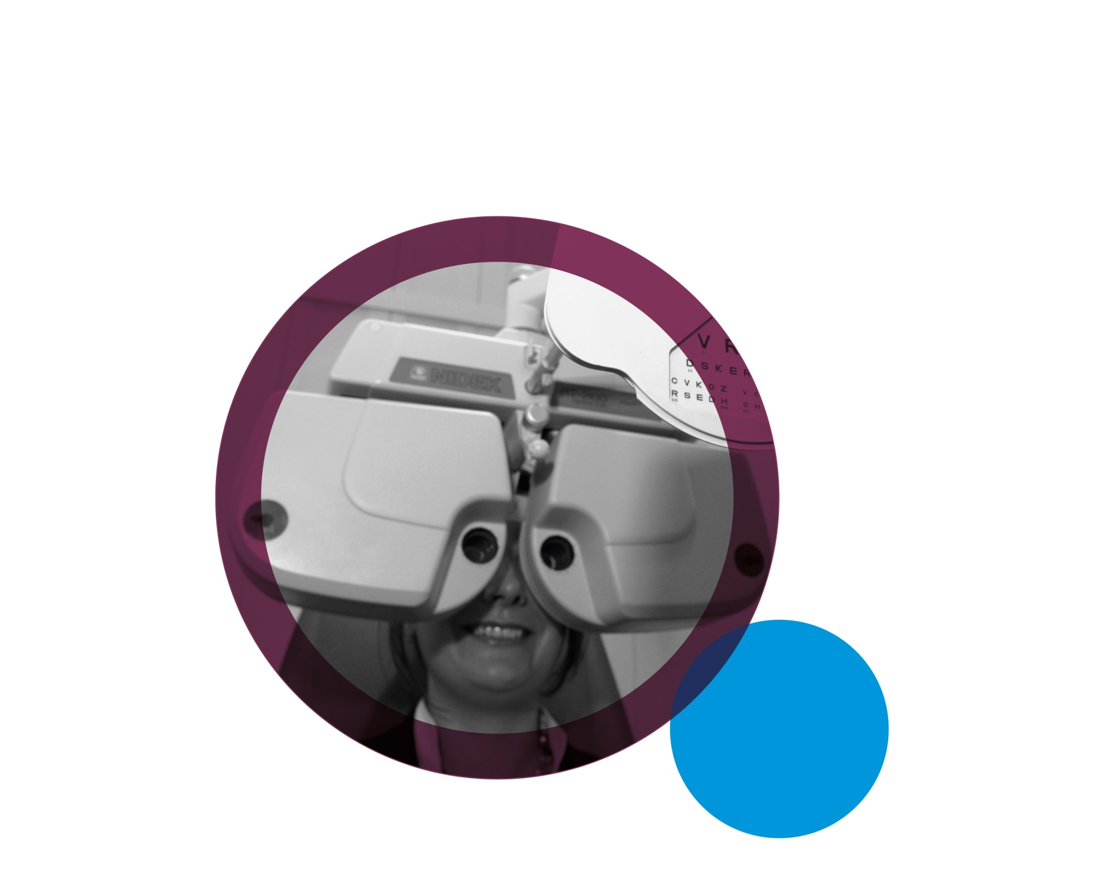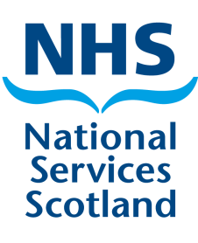

**Ophthalmic**

**Schedule**

**Communications**

**Welcome to the schedule communications, where you will find useful information and helpful tips!**

**July**

**2021**

**Practitioner Services Ophthalmic Website**

Our new, accessible [Practitioner Services Ophthalmic Website](https://www.nss.nhs.scot/browse/ophthalmic-services/)is now available. For all information, forms and guidance please use this [new site](https://www.nss.nhs.scot/browse/ophthalmic-services).

**Quick Links**

[COVID 19 Update](https://www.nss.nhs.scot/ophthalmic-services/coronavirus-covid-19-update/coronavirus-covid-19-update-for-ophthalmic-practices/): Providing updates on service provision and guidance for claiming during this pandemic.

[Ophthalmic claims and allowances](https://www.nss.nhs.scot/browse/ophthalmic-services/ophthalmic-claims-and-allowances): Links to adjustment and allowance forms, guidance on eye examination intervals and supplementary reason codes. The schedule close dates are published here.

[Primary Care Administration](https://www.nss.nhs.scot/ophthalmic-services/ophthalmic-claims-and-allowances/the-latest-primary-care-administration-pca-publications/): The latest Primary Care Administration (PCA) memorandums.

[Online reports-eSchedules](https://www.nss.nhs.scot/browse/ophthalmic-services/online-reports-eschedules): Guidance on how to register and use your online reports. You can view the monthly communication here.

**PCA(O)(2021)08**

The Scottish Government have issued PCA(O)(2021)08 which advises on the following:

• IPC guidance, including the use of gloves and aprons in the medium risk pathway;

• PPE funding;

• Staff wellbeing;

• Workforce Specialist Service;

• £500 non-consolidated payment – claims for locums and sessional paid staff;

• Patient / patient representative signatures;

• Patient exemption checking.

**Claim cut-offs Electronic Post (HES forms only)**

**Jul paid Aug ‘21 Tue 10 Aug ‘21 4pm Fri 30 Jul ‘21**

**Aug paid Sep ‘21 Thur 9 Sep ‘21 4.30pm Tue 31 Aug ‘21**

**nss.nhs.scot/browse/ophthalmic-services Telephone: 0131 275 6200 e-mail:nss.psdophthalmic@nhs.scot**

**Claim cut-offs Electronic Post (HES forms only)**

**Apr paid May TBA 4.30pm Wed 31 Mar ‘21**

**May paid Jun TBA 4pm Fri 30 Apr ‘21**

**nhsnss.org Telephone: 0131 275 6200 e-mail: nss.psdophthalmic@nhs.scot**