Document Title: | Advisory Note – Community Benefits & The Sustainable Procurement Duty in public procurement
Document Ref: | STS704-005
Department: | National Procurement
Approval: | Refer to Q-Pulse

Table of Contents:

Table of Contents: 2
1. Introduction 3
2. Background 3
3. Disclaimer 3
4. Executive Summary 3
5. Sustainable Procurement Overview based on the Reform Act 4
6. Key objectives for each of the requirements 5
7. Appendix A 8
8. Definitions 8
9. Associated Documented Information 9
10. Document Revision History 9

Introduction
Sustainable procurement, incorporating community benefits and social and environmental improvements can be quite difficult to fully comprehend within the context of application of the duties, especially when stacked against the many other objectives set for public procurement. This guidance attempts to present a simpler explanation of the subtle differences in approaching these concepts for procurement colleagues.

Background
The concepts of sustainable procurement and community benefits have been around for many years. However, the most significant source of guidance for action is, “The Procurement Reform (Scotland) Act 2014.” Which sets out the detailed requirements for public procurers in Scotland to achieve the Scottish Government aims to make the best use of public money and helping the government achieve its overarching purpose and strategic objectives.

Disclaimer
Please note this paper is not intended as a definitive review or legal advice but instead a summary review and positioning paper based on National Procurement’s understanding at the time of review. Parties interested in the full detail should read the appropriate regulations and associated statutory guidance.

Executive Summary
The following is a simple table showing the key difference between the Sustainable Procurement Duty and Community Benefits:
Sustainable Procurement Duty | Community Benefits
Applies across all regulated contracts (exc Framework call-offs) | Specifically applies to contracts (inc Frameworks) >£4M
less prescriptive in nature, only that contracting authority can act to, “improve the economic, social, and environmental wellbeing of the authority’s area.” | require pre-determination of required benefits (e.g. apprenticeships) or a clear steer on relevant and proportionate improvements to allow bidders to determine a delivery outcome and that monitoring compliance is required.

From the statutory guidance itself; “Community benefits may be viewed as a subset of the sustainable procurement duty. While the Act has a specific threshold at which community benefits must be considered, application of the sustainable procurement duty means that community benefits may be achieved below this threshold”.
The Act and associated guidance is not prescriptive which suggests that contracting authorities have the ability to specifically apply approaches that they believe will result in the achievement of their sustainable procurement duty.
It should be noted that NP frameworks and any Health Board contracts >£4M will fall under the Community Benefit, ‘prescriptive’ approach with anything below this value being under the less prescriptive Sustainable Procurement Duty approach.
Although community benefits approach is more prescriptive there is no definition of how prescriptive, only those requirements set out in the Community Benefits policy section which leaves room for contracting authorities to refine their approaches.

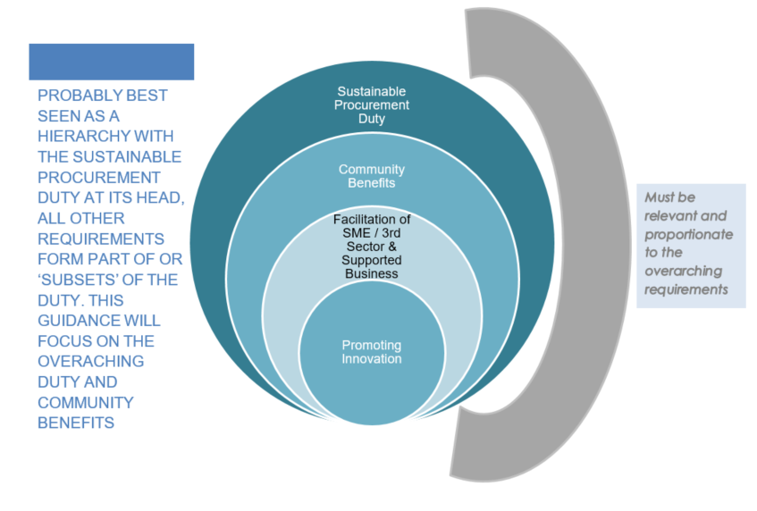
Sustainable Procurement Overview based on the Reform Act

Key objectives for each of the requirements
At the highest level the Act places emphasis on an overarching Sustainable Procurement Duty, this provides quite a level of flexibility for contracting authorities to meet the objectives. Note: Framework Call-Offs not in scope for Sustainable Procurement Duty

Definition of the Sustainable Procurement Duty:
“(1) For the purposes of this Act, the sustainable procurement duty is the duty of a contracting authority
(a) before carrying out a regulated procurement, to consider how in conducting the procurement process it can:
(i) improve the economic, social, and environmental wellbeing of the authority’s area,
(ii) facilitate the involvement of small and medium enterprises, third sector bodies and supported businesses in the process, and
(iii) promote innovation, and (b) in carrying out the procurement, to act with a view to securing such improvements identified as a result of paragraph (a)(i).
(2) The contracting authority must consider under subsection (1) only matters that are relevant to what is proposed to be procured and, in doing so, consider the extent to which it is proportionate in all the circumstances to take those matters into account”.

What does wellbeing mean?
- economic factors such as the availability of suitable and high quality jobs, measures to encourage local small businesses, efficient and effective transport links, lifelong learning, training and skills development, the provision of infrastructure and new information and communication technologies, etc.;
- social factors such as the promotion of good quality and affordable housing, safe communities, the encouragement of the voluntary sector, looking after the needs of children and young people (particularly the most vulnerable), access to the arts or leisure opportunities, access to education, etc.;
- health-related factors such as the promotion of good physical, social and mental health and developing and promoting policies which have a positive impact on health outcomes, especially on health inequalities;
- environmental factors such as the availability of clean air, clean water, clean streets, the quality of the built environment, the removal of objects considered hazardous to health, removal of disfiguring or offensive graffiti from buildings, protecting communities against the threat of climate change, freedom from a high risk of flooding, improving and promoting biodiversity and accessibility to nature.
As shown above there are many ways that Procurement can leverage spend through its supply chain to improve the local area.

How do I identify focus areas?
The statutory guidance highlights the sustainability tools as the primary source of developing a cohesive approach by; organisational, category and commodity level. The tools are outside the scope of this document and will be dealt with through other guidance.

Community Benefits
More specific guidance is provided on Community Benefits, there seems more of an emphasis in this section on pre-determination and pre-development activity of the benefit, from the guidance;
Community benefit requirements in procurement policy is outlined below:
- there is a presumption that where there is an opportunity to deliver community benefits, appropriate requirements will be included in public contracts and framework agreements;
- contract or framework suitability and capacity needs to be addressed on a case-by-case basis – value, duration, local factors and the nature of the supply base will all have an impact;
- requirements should be robust, relevant and proportionate so that they can be judged on objective and measurable outcomes;
- discrimination should be avoided in the wording of requirements; and
- monitoring of contract deliverables and outcomes is essential to ensure contract compliance.

When to use them
“…threshold value of £4 million…at or above which community benefit requirements must always be considered. Their use does not need to be limited to contracts and framework agreements of this value.”
Importantly the guidance goes on to state that. “Where contract or framework agreement requirements and clauses relating to community benefits are not evaluated as part of a procurement process, they may capture social and environmental considerations. Providing clarity to economic operators on what these requirements are, helps bidders understand and better respond to them”.

Factors to consider when deciding whether to include community benefit
requirements include opportunities such as:
- to generate employment and training opportunities for priority groups;
- vocational training;
- to up-skill the existing workforce;
- equality and diversity initiatives;
- to make sub-contracting opportunities available to SMEs, the third sector and
- supported businesses;
- supply-chain development activity;
- to build capacity in community organisations;
- educational support initiatives;
- to work with schools, colleges and universities to offer work experience; and
- to minimise negative environmental impacts, for example impacts associated
- with vehicle movements and/or associated emissions and impacts on protected
- areas, buildings or sites.
This is not an exhaustive list. There are tools that contracting authorities can use to identify disadvantaged groups in their local area.

Incorporating into the Procurement Process
- Where community benefit requirements are being used these are either included in the specification as conditions of contract performance or both.
- The requirements of a specific procurement may reflect wider organisational priorities.
- The requirements can be built into the specification. The appropriate requirements should be developed through stakeholder consultation, and
The community benefit requirement should be added into the contract notice e.g.
“Community benefits are included in this requirement. A summary of the expected community benefits has been provided as follows: [insert text].”
For NHS Scotland there is a general duty to improve the health of the population of Scotland, clauses that seek to improve employment opportunities for the population at risk of ill health (including: young people; those with a disability; and long-term unemployed) are likely to be relevant to them.
In addition to the established benefits listed above other benefits include:
- supply chain development;
- community engagement events; and
- professional advice to communities.
Appendix A presents a table from the statutory guidance on specific community benefits that link back to the Scottish Government national outcomes which link back to all NHS Board organisational objectives and may be used as a basis for community benefits.

Appendix A
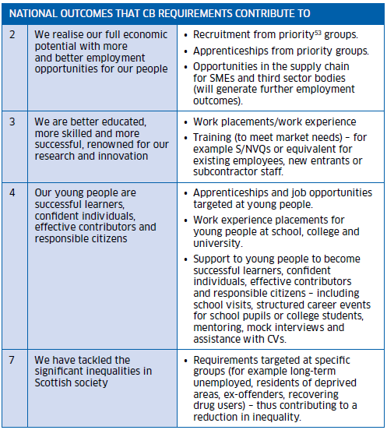

Definitions

Associated Documented Information

Document Ref Document Title

Document Revision History

For activation dates, refer to Q-Pulse.
Version | Description of Amendments
1 | Created and uploaded onto Q-Pulse
2 | Grammatical amendments

https://www.legislation.gov.uk/asp/2014/12/contents; https://www.gov.scot/publications/guidance-under-procurement-reform-scotland-act-2014/pages/1/
https://sustainableprocurementtools.scot/
https://www.gov.scot/collections/scottish-index-of-multiple-deprivation-2020/

