Research, Development and Innovation Strategy
2021-2024
Contents
Introduction and background 3
National context 3
Strategic alignment – Scotland 6
Strategic commissioners and partnerships 8
Vision and strategic aims 11
Vision 11
Strategic aims 11
Functions and services 13
Research and development functions and services 13
Innovation functions and services 14
Governance, principles and benefits 16
Governance 16
Principles 18
Benefits 19
References 20
Glossary 21

Introduction and background

National context
Research is a core function of health and social care. It’s essential for our health and wellbeing and for the care we receive. Research should improve the evidence base, reduce uncertainties and lead to improvements in care¹.

Why do research?
Research is a fundamental prerequisite to innovation and improvement in the health and care sector. By developing and testing hypotheses, we challenge accepted wisdom and ideas of best practice, and generate the fuel for innovation.
We must have a clear strategy to support our underpinning research activity to support NHS National Services Scotland (NSS) to realise its vision of working with others, to enable the transformation of health and care to help improve the health and wellbeing of the people of Scotland.
While research is fundamental in directing improvements in service delivery, there are other benefits to organisations with a robust research focus. There is evidence to suggest a strong association between the engagement of individuals and healthcare organisations in research, and improvements in healthcare performance².
This evidence suggests the quality of service delivery may be higher in organisations that take part in research, adopt a learning culture, and implement research findings^{2,3,4}.
The mechanisms of this association are still unclear, but go beyond the mechanistic improvement in service resulting from the application of research findings. They almost certainly include the ability of research-active organisations to recruit and retain highly engaged staff, and for those staff members to have increased capacity to adopt new ideas and respond to innovations^{5,6,7}.

Research and innovations
Concept development is a critical component to successful research, development and innovation. This step allows the research to be applied before concepts are developed and tested to identify strengths, weaknesses, opportunities and threats. This information will allow an informed decision to be made as to whether there is benefit in moving forward to product development.
Where innovation occurs within health and social care, its spread and adoption can be hugely variable. A recent report by the Kings Fund⁸ looked at the rapid adoption of statins within a decade, from approval to NHS England prescribing around eight billion daily doses each year. This was contrasted to the persistent struggle to implement basic hygiene protocols such as hand washing in hospitals, 150 years after Joseph Lister published his observations in the Lancet⁸.
The Kings Fund report identified the fragmented nature of healthcare delivery (in NHS England) as one of the key obstacles to widespread adoption of innovation. NSS has a key role and responsibility to reduce the impact of such fragmentation, promoting a ‘once for Scotland’ approach.
Research, development, innovation and widespread adoption not only offer the prospect of improved care but also the opportunity to grow the wealth, and hence improve the health, of the Scottish population.
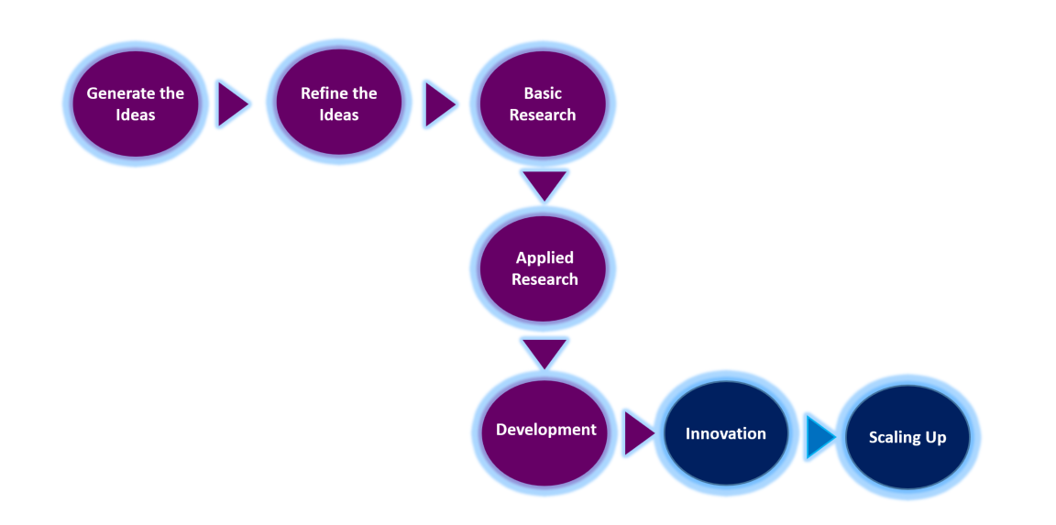
The research, development and innovation process

Innovation
Innovation has been identified as a key enabler of healthcare recovery and re-design and there is an aspiration to position Scotland as a global leader in the innovative delivery of health and social care.
Scotland already has a strong reputation for innovation. Health and social care in Scotland currently has a rich but uncoordinated landscape for innovation, with many players. Some are duplicating others and some are pulled in at the wrong point of the innovation pathway, which can slow down momentum. There isn’t a consistent approach to matching agreed priorities with research, development and innovation (RDI) activity, or to supporting programmes with high transformational potential into national adoption.

National Innovation Steering Group
In August 2020, a National Innovation Steering Group was established to:
Develop and implement an enhanced system for innovation across health and social care to ensure innovation activity is optimised to play a significant part in health and social care’s recovery and renewal, while fully supporting the aims of the National Performance Framework. ​
Developing a national innovation system will:
- provide a lean innovation pathway or pipeline, eradicating non-value added steps and condensing timescales
- encourage and coordinate programmes to improve innovation skills and capabilities across health and social care in Scotland
- expedite end-to-end priority-led innovation by connecting innovative solutions to our most challenging problems and enabling or driving service adoption
- create robust evaluation to support decision making and review of business cases to inform procurement
- publish clear criteria for adoption and requirements to demonstrate clinical, patient and economic benefit, and regulatory approvals
- harness development and funding of potential products or services and establish a compelling evidence base which informs a value case
- fail fast where solutions have not met expected end points.

On 25 August 2021, the NHS Recovery Plan was published. It outlines that:
Research, innovation and the redesign of services will be integral to the recovery of NHS services. There are a range of partner organisations that are central to research, innovation and service redesign – these include the new National Centre for Sustainable Delivery, NHS National Services Scotland, the Digital Health and Care Innovation Centre, Healthcare Improvement Scotland, and the Scottish Health Industry Partnership. ​
Currently the approach to RDI delivery across NSS is siloed with limited collaboration. The NSS Research, Development and Innovation Office will agree key strategic principles and objectives in relation to innovation activities that NSS undertake, and create a cohesive NSS innovation service to enable national innovations.

Strategic alignment – Scotland
Research, development and innovation sits in the context of many other NHS and national policies and strategies. The three main areas with which the NSS Research, Development and Innovation Office will align are:
- Life Sciences Strategy for Scotland (Accelerating Growth and Driving Innovation)
- NHS Recovery Plan
- Programme for Government

Life Sciences Strategy for Scotland (Accelerating Growth and Driving Innovation)
The strategy’s vision is to make Scotland the location of choice for life sciences businesses, researchers, healthcare professionals and investors, while increasing the contribution of life sciences to Scotland’s economic growth:
“Scotland has an invaluable resource for the data-driven approach to healthcare of the future, with all patients in NHS Scotland having a unique identifier and electronic health record. Through NHS Research Scotland (NRS) our health service has a single access point for industry, dedicated clinical research facilities and globally competitive approval and start-up times.
“We also encourage innovators within NHS Scotland to work with industry partners, both through the Health Innovation Partnership (HIP) and also through Scottish Health Innovations Ltd (SHIL) which supports the development, protection and appropriate commercialisation of innovative ideas arising from healthcare professionals.
“Scotland has a wealth of clinical expertise, a stable population actively engaged in clinical research and a growing registry of patients willing to share e-health records for the development of novel treatments and therapies. As income is a key determinant of health, supporting Research, Development and Innovation activities and their commercialisation has the potential to influence healthy life expectancy and health inequalities in Scotland.”⁹

NHS Recovery Plan
The NHS Recovery Plan for 2021-2026 sets out the headline ambitions and actions that will be developed and delivered over the next five years.
“While it is important to stress that recovery is the immediate task, this Plan is fundamentally about ensuring that the process of recovery also delivers long term sustainability. That is why service innovation and redesign – as well as creating additional capacity – is central to it.”

Programme for Government
The 2020-2021 Programme for Government set out numerous actions relating to promoting lifelong health and wellbeing, which have been further defined in the above strategies.
The 2021-2022 Programme for Government: A Fairer, Greener Scotland references innovation’s role in the response to the pandemic and innovation-led recovery including “…to support new opportunities in the use of Artificial Intelligence (AI) we will provide £20 million to develop an AI Hub for Life Science, NHS and Social Care to create AI Innovation and commercialisation capability in Scotland.”
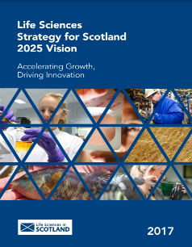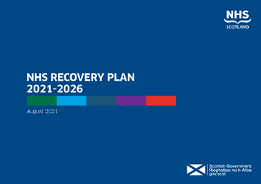

Strategic alignment – NSS
The NSS Strategy for 2019-2024 says that we will:
“Develop an innovation network with partners, harness our expertise to support innovators and support the scale up of key innovations across Scotland. We will enable stakeholders and partners in Scottish Government, territorial health boards, regions and integration authorities to deliver transformational change.”
NSS Objectives which will be achieved through the Research, Development and Innovation Office:
- Improve the way we do things
- Increase our service impact
- Customers at the heart
NSS Strategic Business Units are involved in RDI to varying degrees and in a range of ways. This strategy provides the framework and overarching governance within which business units’ own RDI strategies and activities are set.

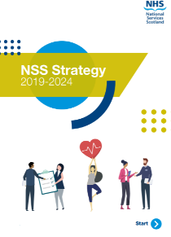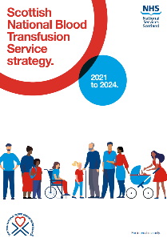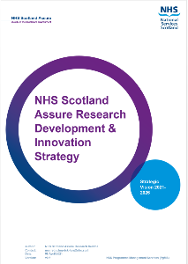

Scottish National Blood Transfusion Service (SNBTS)
One of the five key enabling themes for the SNBTS Strategy 2021-2024 is research and the ambition to be a leader in world class research and development, in particular in relation to tissues, cells and advanced therapies.

Procurement, Commissioning and Facilities (PCF)
Support for the procurement of innovation and facilitating industry access to innovation via the Health Innovation Assessment Portal (HIAP) is a key aspect of current PCF service provision which is supported by a recurring commission from the Scottish Government Chief Scientist Office (CSO). This will be further broadened and enhanced as a result of the implementation of this strategy.
The NHS Scotland Assure research strategy vision is that the NHS Scotland Assure research, development and innovation service will lead on the development and provision of a transparent direction and methodology for research which will address knowledge gaps and priority needs, whilst achieving maximum impact in confronting issues and managing healthcare built environment risk, both now and in the future.

Digital and Security (DaS)
Currently engaging with partners and stakeholders in other organisations involved in health and social care, DaS will further develop fully integrated roadmaps of secure digital solutions and services. They will support national, regional and local initiatives using a technology approach of data-driven insights to support cloud-first, secure, clinically safe and protected solutions.

Strategic commissioners and partnerships
The NSS Research, Development and Innovation Office will operate in this area to enable, underpin and assist research, development and national innovation. It will do this via a combination of strategic commissions and collaborative partnerships. The Scottish Government Chief Scientist Office/Scottish Health Industry Partnership will be a strategic commissioner and our partnerships will principally be within the Accelerated National Innovation Adoption (ANIA) Collaborative including the Centre for Sustainable Delivery, NHS National Services Scotland, Healthcare Improvement Scotland, NHS Education Scotland and NHS Innovation Test Beds.

Scottish Government Chief Scientist Office/Scottish Health Industry Partnership
Scottish Government Chief Scientist Office (CSO) is part of the Scottish Government Health Directorates. Their vision is to support and increase the level of high-quality health research conducted in Scotland. This is for the health and financial benefits of our population, so that Scotland is recognised globally as the place to come for health science.
The CSO’s five-year health research strategy was published in 2015. It anticipated a future where outstanding health science research is embedded within health systems as core business. It envisioned generating new knowledge based upon a myriad of qualitative and quantitative evidence. They foresaw a future where clinical information and samples are integrated with informatics of individual genomes and other omic datasets, eHealth records, imaging datasets, and personal health data to enable individualised therapy, and improved patient outcomes. A future where the NHS, patients, universities and business work closely together for mutual benefit.
Scottish Health Industry Partnership (SHIP) is a government initiative. It was announced in the 2020-2021 Programme for Government and is hosted by the Chief Scientist Office of the Health and Social Care Directorate and the Enterprise and Innovation Division of the Economy Directorate.
SHIP strengthens Scotland’s innovation activities in health and social care in order to solve real problems and improve quality, efficiency and sustainability of healthcare. SHIP will support Scotland’s economy through activities that strengthen its life sciences sector, attract investment into Scotland, develop large scale innovation projects and support the growth of robust businesses.

ANIA Collaborative
Hosted by NHS Golden Jubilee, the new national Centre for Sustainable Delivery (CfSD) will play a vital role in supporting Scotland’s national efforts to remobilise, recover and redesign towards a better healthcare system.
Building on significant progress and developments that have already been made through redesign and transformation, CfSD will orchestrate the rapid rollout of new techniques, innovations, and safe, fast and efficient care pathways for Scotland’s patients via the ANIA Collaborative, working in partnership with NHS National Services Scotland, Healthcare Improvement Scotland, NHS Education Scotland and NHS Innovation Test Beds.
Working in collaboration with NHS Boards, health and social care partners, third sector, patients, academia and industry, the ANIA Collaborative will ensure that the complimentary skills, capabilities and capacities of all the partners are brought together to implement best practice through a ‘once for Scotland’ approach, aligned with the priorities of the Scottish Government.
Working towards becoming a Global Centre of Excellence, the ANIA Collaborative will raise Scotland’s profile as leaders in the adoption of health and social care innovation.
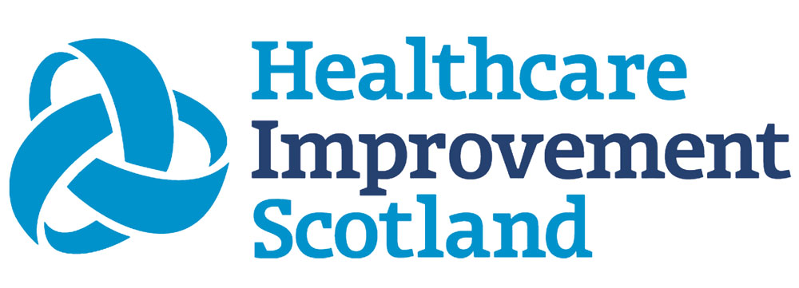

Vision and strategic aims

Vision
Our vision is that research, development and innovation will be integral to NHS National Services Scotland. RDI will enhance the quality, safety and efficiency of the products and services we provide. It will leverage our unique resources and capabilities to enable NHS Scotland to maximise its impact on the health and wellbeing of the people of Scotland.

Strategic aims

Become a recognised centre of research excellence
We will build and extend NSS research and development capability and profile in areas where NSS provides national expertise.

Enable national transformative change across health and social care in Scotland
We will develop an innovation network with partners, harnessing our expertise to support innovators and the scale up of key innovations across Scotland. We will enable stakeholders and partners in Scottish Government, territorial health boards, regions and integration authorities as outlined in the NSS Strategy.

Implement service adoption focussed approaches to RDI
We will ensure that initiatives move through the research, development and innovation processes ‘starting with the end in mind’, in contrast to ‘starting with the next step in mind’, therefore increasing the likelihood of adoption.

Maximise impact of NSS research, development and innovation
We will maximise the impact of our RDI activity by ensuring focus on priority areas and delivering outputs that have a positive impact on health and care, as well as supporting the broader Health and Wealth Agenda.

Build on our RDI capacity and capability
We will build on the existing RDI capability and capacity of our workforce, sharing best practice and supporting staff to develop their knowledge, skills and experience.

Functions and services
NSS RDI comes under two broad functions, each underpinned by five services as described below. These services will be delivered collaboratively by multiple areas of NSS which will support the end-to-end pathway for research, development and innovation across health and social care in Scotland. A work plan is in development for the creation of these functions and the delivery of this strategy.

Research and development functions and services
Elements of these services are already being delivered across NSS. Where this is the case, enhancements will be made. The creation of these services will allow the current elements to be coordinated to provide a unified and enhanced service.
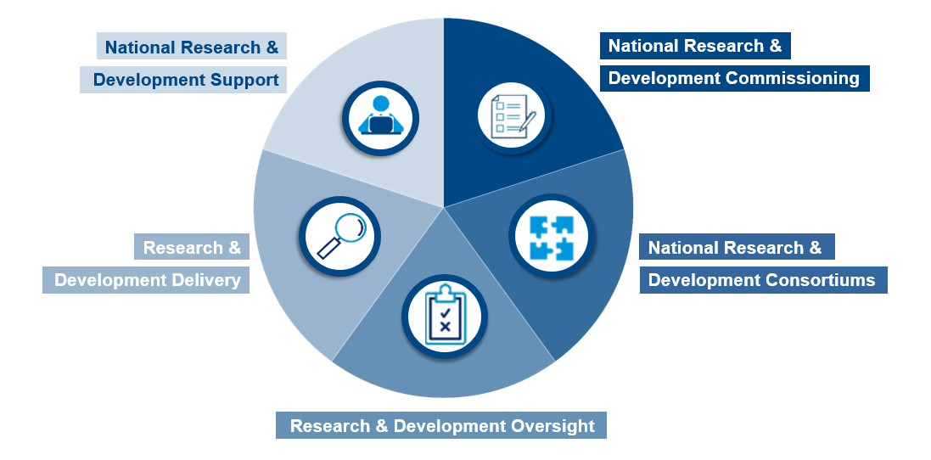
Research and development delivery
Enhanced service: undertake portfolios and our own research and development projects to support the strategic and operational priorities of the organisation, such as stem cell technology and expertise in Good Manufacturing Practice (GMP) compliant lab provision.

National research and development consortiums
Enhanced service: collaborate as part of national consortiums (Northern Alliance-Advanced Therapies Treatment Centre; Centre for Regenerative Medicine.)

National research and development commissioning
Enhanced service: commission and work with others to do research and development for us in areas of NSS remit, such as NHS Scotland Assure, to inform current and future guidance and expert advice needs.

National research and development support
Enhanced service: support others to do research, for example DaS support for Artificial Intelligence (AI), and research on national Picture Archiving and Communication System (PACS) radiology images.

Research and development oversight
Enhanced service: facilitate, oversee and make decisions on research activity in a specific domain under NSS remit, such as the National Screening Oversight Research and Innovation Group.

Innovation functions and services
There are a number of new innovation services to be created through the RDI Office. Where elements of these services are already in delivery across NSS, enhancements will provide a unified and improved service.
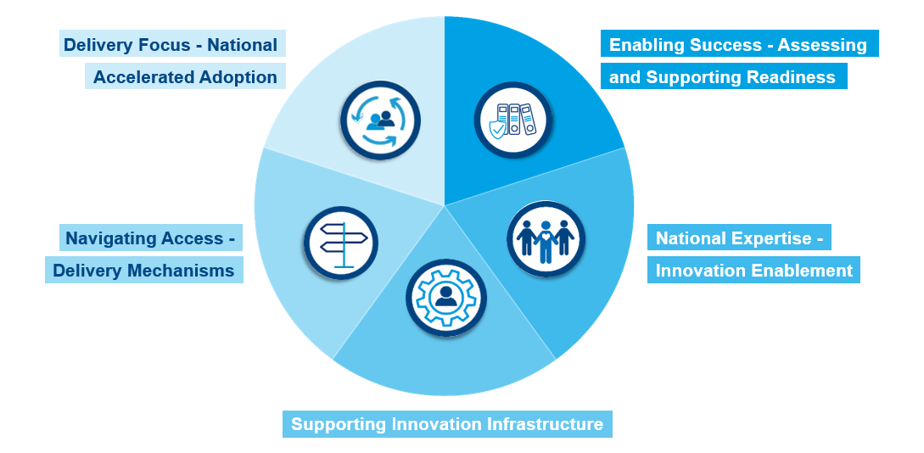

Delivery focus – national accelerated adoption
Enhanced service: provide key resources, knowledge and infrastructure to enable and deliver adoption of prioritised national health and social care innovation projects.

Enabling success – assessing and supporting readiness
New service: advise and support early stage innovation projects and formally assess mid-to-late stage innovations in aspects where NSS provides national expertise and their service adoption readiness as a critical input to business cases.

National expertise – innovation enablement
Enhanced service: develop national guidance and provide assurance, advice and compliance support related to technology, information, clinical and regulatory governance, alongside procurement and contracting.

Supporting innovation infrastructure
Enhanced service: provide national hosting and cloud infrastructure for innovation, partnering in AI projects and support for adopted solutions.

Navigating access – delivery mechanisms
New service: develop, maintain and facilitate the Innovation Navigator and Playbook on behalf of health and social care and the wider public sector in Scotland.

Governance, principles and benefits

Governance

Internal to NSS

NSS RDI Office
An NSS Research, Development and Innovation Office will be established within the NSS Clinical Directorate and report to the NSS Executive Management Team via the Medical Director (NSS Executive Lead for Research, Development and Innovation).
The Research, Development and Innovation Office will be underpinned by a portfolio delivery model and Portfolio Management Office (PMO). This will give NSS a shared, clear understanding of research, development and innovation activity across the organisation, as well as associated funding.
An annual research, development and innovation governance report will be provided to the NSS Clinical Governance and Quality Improvement Committee.

NSS Research Steering Group
The current NSS Research Steering Group will continue with refreshed strategic level Strategic Business Unit membership. It will oversee the development of a detailed action plan to achieve the strategic objectives of the research and development function, and will monitor progress. This will be led by the NSS Director of Healthcare Science.

NSS Innovation Steering Group
An NSS Innovation Steering Group will be established with strategic level membership from Strategic Business Units who are key to innovation delivery.
This group will monitor the five innovation services, ensuring that services are delivering as detailed within Service Level Agreements (SLAs). This will be led by the NSS Innovation Programme Director.

Scottish Government and other commissioning bodies
The NSS RDI office will be accountable to commissioners for delivery against the agreed SLAs.
This model will allow us to work towards a position whereby we agree an annual plan of work provided by NSS covering business as usual and core funded activity. It will also cover work specifically commissioned or separately funded by CSO, CfSD and any other commissioning body. This will allow us to have a shared, clear understanding of activity being delivered by NSS.
Any additional work requests and/or new work proposals for NSS in the year would be agreed through this route and added to the work plan and SLA as appropriate.

NHS Boards
The NSS Research, Development and Innovation Office will establish robust relationships with organisations with subject matter expertise and assessor roles. These include the Scottish Health Technologies Group in Healthcare Improvement Scotland and the Public Benefit and Privacy Panel for Health and Social Care supported by Public Health Scotland.
Steps will ensure their expertise feeds into the service adoption readiness assessments as appropriate.

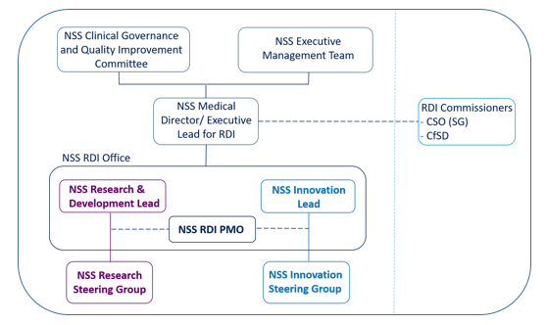
NSS RDI governance structure

Principles
The RDI Office will follow a set of principles that will support the achievement of the NSS research, development and innovation vision.

Align RDI activities to key NSS objectives or initiatives and strategic themes.

Provide coordination and ensure a joined up approach in relation to RDI across NSS.

Provide strategic direction for research and development activities across NSS, through appropriate governance, oversight and alignment.

Consolidate management of innovation commissions and funding across NSS, managing these activities as a consolidated package with full visibility and agreement from the NSS Medical Director.

Implement an RDI delivery model that supports NSS and health and social care in Scotland.

Provide a focussed understanding of the NSS innovation portfolios, ensuring an overview of projects and their outputs as well as how they support the innovation strategic intent.

Coordinate stakeholder engagement and management to ensure consistent messaging. Present a joined up, informed NSS to stakeholders.
Provide horizon scanning to maintain effective intelligence and visibility of the RDI landscape and how NSS can add value.

Benefits

Shared, clear understanding of NSS RDI activity
The NSS RDI Office will allow collaborative working and oversight of RDI activity across the organisation, therefore allowing:
- early insight into future change within coordinated internal systems and processes
- knowledge sharing and pipeline management
- coordinated resources with space to work on RDI
- robust lessons learned approach to reduce unwarranted variation
- organisational awareness and transparency
- clear, fast and agile processes and customer navigation that supports automation and innovation.

Visibility of NSS research, development and innovation and, in turn, of NSS’s RDI profile
Through coordinated and collaborative approaches of the NSS RDI Office, there will be an increased national understanding and visibility of NSS’s role in RDI, ultimately positioning NSS as a key national partner.

Positive RDI partner experience
The link between research, development and innovation partners and health and care service delivery can be challenging. NSS will work more cohesively around an agreed set of research, development and innovation services, providing a positive experience for those with whom we support and partner.

Increased national adoption of innovative solutions at pace
A ‘once for Scotland’ approach with focus on service readiness will close the current gap between product readiness and service readiness, in turn supporting adoption of solutions.
With the focus from the outset moving towards ‘service readiness’ rather than ‘product readiness’, scaling projects will be easier and quicker.

References
Number | Reference
1 | UK Policy Framework for Health and Social Care Research (2017) https://www.hra.nhs.uk/planning-and-improving-research/policies-standards-legislation/uk-policy-framework-health-social-care-research/
2 | Does the engagement of clinicians and organisations in research improve healthcare performance: a three-stage review, Boaz et al (2015)  https://bmjopen.bmj.com/content/bmjopen/5/12/e009415.full.pdf
3 | High hospital research participation and improved colorectal cancer survival outcomes: a population-based study. Downing et al (2016) https://gut.bmj.com/content/gutjnl/early/2016/10/14/gutjnl-2015-311308.full.pdf
4 | Research Activity and the Association with Mortality. Ozdemir et al (2015) https://journals.plos.org/plosone/article/file?id=10.1371/journal.pone.0118253&type=printable
5 | Cohen W, Levinthal D. Innovation and Learning: The Two Faces of R&D. Economic J 1989;99:569-96.
6 | Greenhalgh T, Robert G, Bate P, et al. Diffusion of Innovations in Health Service Organisations: A Systematic Literature Review. Oxford: Blackwell Publishing, 2005.
7 | Rogers E. Diffusion of Innovations. 5th edn. New York, NY: Free Press, 2003.
8 | Adoption and spread of innovation in the NHS. Collins (2018) https://www.kingsfund.org.uk/sites/default/files/2018-01/Adoption_and_spread_of_innovation_NHS_0.pdf
9 | Income-based policies in Scotland: how would they affect health and health inequalities? Health Scotland (2018) http://www.healthscotland.scot/media/2465/briefing-paper-income-based-policies-health-and-health-inequalities.pdf

Glossary
Term | Definition
ANIA | Accelerated National Innovation Adoption framework.
GMP Compliant Lab | Good Manufacturing Practice Compliant Lab.  This is a system for ensuring that pharmaceutical products are consistently produced and controlled according to quality standards. GMP labs are used for many purposes, including supporting translational research projects, participating in clinical trials, ramping up commercialisation, etc. Any lab involved in commercialising a product or doing clinical trials must be GMP compliant.
HIAP | Health Innovation Assessment Portal.  NHS Scotland’s single-point resource which provides potential suppliers with information and guidance to develop innovations into products and technologies.
NA-ATTC | Northern Alliance-Advanced Therapies Treatment Centre.  The NA-ATTC’s vision is to increase patient access to advanced therapy medicinal products (ATMPs) regionally and nationally by growing a cost-effective clinical delivery pathway which meets the needs of the providers of advanced therapy products.
NRS | NHS Research Scotland.  NRS promotes and supports excellence in clinical and translational research in Scotland so that patients can benefit from new and better treatments. This is an Innovate UK-funded consortium in which NSS is a partner.
PACS radiology images | Picture Archiving and Communication System.  PACS is a medical imaging technology which provides economical storage, retrieval, management, distribution and presentation of medical images. Electronic images and reports are transmitted digitally via PACS systems. This eliminates the need to manually file, retrieve, or transport film jackets. It allows a healthcare organisation to capture, store, view and share all types of images both internally and externally.
PBPP | Public Benefit and Privacy Panel.  The PBPP for health and social care has a formal mandate to scrutinise requests to use NHS Scotland-controlled data, as well as the NHS Central Register, which is controlled by the Registrar General for research, healthcare planning, audit, or other well-defined and bona fide purposes. It’s supported by Public Health Scotland.
PfG | Programme for Government.  The Programme for Government is published every year at the beginning of September and sets out the actions we’ll take in the coming year and beyond.
PMO | Portfolio Management Office.  A PMO is a centralised organisational unit that caters to the demands of various stakeholders by performing specialised tasks.
SHIP | Scottish Health Industry Partnership.  SHIP is an initiative hosted by the Scottish Government Chief Scientist Office of the Chief Medical Officer Directorate and the Enterprise and Innovation Division of the Economic Development Directorate. It aims to strengthen Scotland’s innovation activities in health and social care in order to solve real problems and improve quality, efficiency and sustainability of healthcare.
SHTG | Scottish Health Technologies Group.  SHTG are part of Healthcare Improvement Scotland (HIS) and provide advice to NHS Scotland on the use of new and existing health technologies (excluding medicines), which are likely to have significant implications for people’s care.

