Guidance Notes

National Screening Oversight Research and Innovation Group
The National Screening Oversight Research and Innovation Group (NSO RIG) is a subgroup of the National Screening Oversight Board (NSOB), established to enhance research into screening, and ensure that screening research projects have the support of the relevant NHS screening programmes.
NSO RIG will work closely with screening programmes, service delivery partners and academic organisations on an ongoing basis, to identify research priorities to guide future research into screening.
The Group will provide investigators a single entry point to the research pathway, enabling early input from relevant screening programmes, helping to identify potential challenges that may arise at a later stage.
If a proposal achieves NSO RIG endorsement, the endorsement can be included in applications to the research funder(s) identified by investigators. Investigators should note that this endorsement does not constitute a recommendation for funding or remove the need for other approvals, as necessary. Advice should be sought from the relevant Health Board or University Research & Development office regarding the necessary approvals.

Submitting a Research Request
To download a research application form please visit the NSS website.
Completed forms should be returned to the NSO RIG mailbox nss.nsoresearch&innovation@nhs.scot
Please also use this mailbox if you would like to speak to someone about your application.
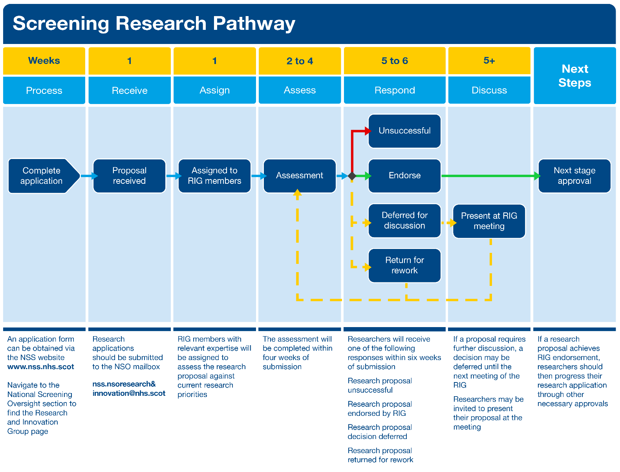

Completion Guidance
The RIG application is designed to capture enough information for an initial assessment. If a proposal is endorsed by RIG, researchers will need to provide more detail to funders and other approvers, as necessary.
Researchers are asked to minimise the use of technical language and undefined abbreviations when completing the form.
The RIG application form asks for:

- Researcher’s details
- Name
- Contact details
- Participating organisation’s details
- Lead organisation
- Any other participating organisations
- Title
- A suitable title for your research project
- Timeframe
- Proposed start date and duration of the project
- Any key milestone dates
- Funding
- Details of proposed research funder(s) which you have identified
- Research and innovation category
Researchers are asked to indicate if their proposal belongs to any of the following categories:
  - Research relating to an existing national screening programme
  - Research that utilises the screening cohort
  - Research that utilises data from an existing programme
  - Research that utilises the ‘by-products’ of the screening programme
  - Research related to an existing programme but does not fall into categories 1-4
  - Research into national screening programmes for conditions for which there are currently no national screening programmes
- Outline of proposal
One page summary of research proposal to include:
  - Justification for the research and the potential impact of research for screening
  - Aim(s)
  - Research Question(s)
  - Methods
- Impact
Description of any potential effect of the conduct of the project on the screening programmes e.g. possible implications on uptake, safety, burden on the screening programme(s) whilst the research is being conducted
- Resource implications
Description of any resource implications on the screening programme(s) whilst the research is being conducted
- Prior Engagement
Researchers should outline any engagement they have already had with the relevant screening programme(s) in respect of the proposal

Assessment
RIG members will be assigned to assess applications, based on their area of expertise. Researchers will receive a response within six weeks of submission.
The assessment will be informed by:

- The proposals alignment with current research priorities.
- Research priorities can be found on the NSS website
- The likely health benefits and added value of the research to the respective screening programme(s)
- The potential implications for screening resource whilst the research is being conducted, i.e. any increased demand on screening centre staff
Applications will be assessed by RIG within six weeks of submission
If endorsed, proposals should progress through additional approvals, as necessary
Researchers are asked to provide regular updates on any active research projects
- The potential impact of the research on the respective screening programme(s) whilst the research is being conducted, e.g. possible implications on uptake, safety, burden on the screening programme(s) whilst the research is being conducted
- The general feasibility of the research, the practicality of the proposal and likelihood it will secure funding

Contact
NHS National Services Scotland
National Screening Oversight
Research and Innovation Group
nss.nsoresearch&innovation@nhs.scot
www.nss.nhs.scot/national-screening-oversight/national-screening-oversight-board/nso-research-and-innovation-group/

