NSS WORKFORCE PLAN

April 2022 to March 2025

Version: | V1.0 (Final)
Document Type: | NSS Workforce Plan
Owner: | Jacqui Jones, Director of HR&WD
Author: | Jane Fewsdale/Aileen Stewart
Review Date: | October 2023
DOCUMENT CONTROL SHEET

Key Information:

Title: | NSS Workforce Plan
Date Published/Issued: | 25 October 2022
Date Effective From: | 25 October 2022
Version/Issue Number: | Version 1.0
Document Type: | Plan
Document Status: | Final
Author: | Jane Fewsdale/Aileen Stewart
Owner: | Jacqui Jones, Director of HR&WD
Approver: | NSS Staff Governance Committee
Approved by and Date: | 25 October 2022
Contact: | Jane Fewsdale/Aileen Stewart
File Location: | J;/HRBCS/Corp Gov/Strategic Planning/Business Plan/HR Workforce Planning/NSS Workforce Plan

Revision History

Version: | Date: | Summary of Changes: | Name: | Changes Marked:
Version 0.8 | 09/09/22 | Revised wording financial challenges and efficiency | J Jones
Version 0.9 | 12/09/22 | Additional narrative in relation to Modern Apprentices | A Stewart
Version 0.9 | 12/09/22 | Additional appendix added to include AfC pay scales | J Fewsdale
Version 0.9 | 12/09/22 | Additional paragraph added to include Retire and Return | J Fewsdale
Version 0.9 | 28/09/22 | Rationale for increase in Support Services | J Fewsdale
Version 0.10 | 13/10/22 | Updated turnover figures and narrative to remove NCC staff, so figures are reflective of pre-pandemic levels. | M Gunn
Version 1.0 | 13/10/22 | Final version

Distribution:

Title/SBU: | Date of Issue: | Version:
Executive Management Team | 18 July 2022 | V0.5 (draft)
NSS Board (Board Development Session) | 19 August 2022 | V0.7 (draft)
NSS Staff Governance Committee | 9 September 2022 | V0.7 (draft)
NSS Partnership Forum | 22 September 2022 | V0.9 (draft)
NSS Staff Governance Committee | 25 October 2022 | V1.0 (final)

Linked Documentation:

Document Title: | Document File Path:

Contents

 | Page Number
- Introduction | 4
- Step 1: Defining the Plan | 4
- National Context | 5
- Overview of NHS National Services Scotland | 6
- Our Strategic Business Units | 7
- Step 2: NSS Strategic Plan and Vision | 11
- Internal and External Drivers for Change | 16
- Understanding NSS Workforce | 22
- Step 3: NSS Workforce Journey | 31
- Step 4: Three-Year Workforce Projections | 50
- Step 5: Action Plan | 56
- Step 6: Implement, Monitor and Refresh | 57
Appendices

Appendix A – Great Place to Work Plan | 58
Appendix B – NSS 5 Pillars Action Plan | 67
Appendix C – NHS Circulars | 72

1.0 Introduction

The NHS National Services Scotland (NSS) workforce plan is aligned to the NHS Scotland Workforce Strategy, Scottish Government’s Care and Wellbeing Portfolio, and the NHS Scotland priorities building on the success of our previous remobilisation plans.

It incorporates our strategic aims of enabling health and care transformation, underpinning NHS Scotland services and assisting more widely in health and care. Importantly, the plan ensures we continue to support NHS Scotland as it seeks to stabilise, reform and transform.

NSS Strategic Aims

Internal
 | Financial Sustainability | Future Ready | Digital First
External
 | COVID-19 Response | NHS Scotland Recovery | National Care Service

2.0 Step 1: Defining the Plan

The NSS Workforce Plan is the responsibility of the Chief Executive and Executive Management Team Directors, with support from dedicated HR Business Partners. The Director of Human Resources and Workforce Development provides leadership to drive the development of the workforce plan and to identify the talent required to deliver services now and, in the future, to understand the gaps and plan accordingly. HR will work closely with the Chief Executive, EMT Directors, the Trade Unions/Professional Organisations, Planning Leads and NSS Board Committees to develop and deliver action plans aligned to the overall workforce strategy and Strategic Aims, to improve the performance of the organisation and for NSS to remain a great place to work.

Effective workforce planning should describe the required workforce, based upon the strategic aims of NSS and the goals and objectives of the Strategic Business Units. This requires utilising accurate and quality data on the existing workforce and identifying key workforce trends. To maintain the quality of this data, NSS has fully implemented the Electronic Employee Support System (eESS) and Job Train.

NSS workforce planning is structured around the Scottish Government workforce planning guidance CEL (2011)32, and the nationally agreed six step workforce planning methodology.

- Step 1: Defining the Plan
- Step 2: Visioning the Future / Mapping Service Change
- Step 3: Defining the Required Workforce
- Step 4: Understanding Workforce Capacity and Capability
- Step 5: Developing an Action Plan
- Step 6: Implement, Monitor and Refresh

Our aim is to make workforce planning more interactive, enabling challenges to be identified and address on a continual rather than an annual basis.

To complement the workforce plan, NSS has an established workforce reporting tool utilising the tableau platform to provide real time information across a range of people metrics including sickness absence, workforce demographics, turnover, learning and development, case management and health and safety. This provides evidence-based insights that measure the performance of our workforce.

Our HR, Trade Union, Finance and Planning colleagues are all key enablers providing input and assurance to ensure planning and delivery within the parameters of organisational policies and procedures to provide consistency, equity and transparency to our workforce and that planning is aligned to the strategic/operation delivery plan and affordable.

3.0 National Context

The national Health and Social Care Workforce Strategy was published by Scottish Government on 11 March 2020 and should be read alongside the NHS Recovery Plan published in August 2021.

The Strategy sets out a national framework to achieve our vision of sustainable skilled workforce with attractive career choice where all are respected and valued for the work they do.

Furthermore, the Strategy sets out actions at national level and 5 pillars of workforce which supports recovery, growth and transformation of services and the workforce.

The 5 pillars of the workforce journey are:

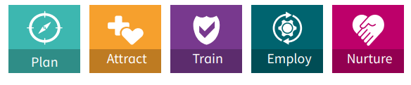

The NSS Workforce Plan is aligned to delivery of the pillars of the national strategy.

Staff Governance Strategic Framework
The NHS Reform (Scotland) Act 2004 requires NHS Scotland employers to deliver the key strategic agenda of ensuring the fair and effective management of staff. A number of strategic workforce policies, initiatives and agreements are in place including those on best employment practice and policy, and workforce development and planning. Implementation of these policies, initiatives and agreements will support NHS Scotland employers in meeting the requirements of the Staff Governance Standard and ensure modernisation of the workforce through pay, partnership, and good employment practices.
Staff Governance is firmly established as one of the strands of the NHS Scotland governance framework for which all Boards are held accountable.
The Standard requires all NHS Boards to demonstrate that staff are:

- Well informed
- Appropriately trained and developed
- Involved in decisions
- Treated fairly and consistently, with dignity and respect, in an environment where diversity is valued; and
- Provided with a continuously improving and safe working environment, promoting the health and wellbeing of staff, patients and the wider community.

4.0 Overview of NHS National Services Scotland

NSS continue to provide a national infrastructure that is integral to NHS Scotland, offering a range of clinical and non-clinical services, such as the safe supply of blood, tissues and cells, through to providing essential digital platforms and cyber security for health and care.

We have shown that we are able to create new services and adapt our existing services to meet the changing needs and demands of health and care. Our flexibility and track record for delivery means we are well placed to support NHS Scotland achieve both its immediate priorities and longer-term vision.

Our workforce across NSS underpins many of the services provided throughout NHS Scotland. With around two-thirds of our people working from home we have developed programmes to ensure that all staff are supported whether they are working from home or on site.

4.1 Our Strategic Business Units (SBUs)

NSS deliver its services through six Strategic Business Units, a clinical directorate and three support business units which predominately provide corporate services across NSS and its shared service partners. The purpose of each of the SBUs is described below:

Central Legal Office (CLO)
The Central Legal Office (CLO) provides NHS Scotland with legal advice and assistance on every area of law relevant to the NHS - Litigation, Employment, Commercial Contracts and Commercial Property. In all these fields, we provide far more than specialist legal knowledge. Advising NHS Scotland covers a range of matters from human issues to commercial ventures. Our practical experience of working with staff at all levels of the health service gives us an exceptional ability to guide NHS Boards through such issues. CLO also provides legal advice and assistance to a few Public Bodies in the wider Public Sector.
Digital and Security Services (DaS)

DaS are driving forward the agenda to ensure that NSS DaS is NHS Scotland’s first choice for trusted, secure national digital solutions. We operate as a center of excellence for digital, security, data and technology in Scotland, collaborating with public sector partners.
By developing, managing, and delivering secure digital solutions, we make public services simpler and more efficient for the people who need them. From future-proofing our digital estate to providing technology tailored for different needs, we support the infrastructure that allows NHS Scotland to succeed. Our customers also include local authorities, the Scottish Government and the third sector.
Challenges in health and social care are complex. Intelligent data, cyber security, innovation, automation, and more are helping us solve them.
Procurement, Commissioning and Facilities (PCF)

PCF provides specific services and expert advice across our portfolio of activity including:

- Clinical – Specialist services commissioning, National Screening programmes, Antimicrobial Resistance and Healthcare Associated Infection (ARHAI)
- Procurement – Centre of Expertise for national contracting, logistics, procurement systems and service improvement support
- Facilities – Centre of Expertise in relation to Health build environment property, facilities, operational facilities, management in NSS and other health boards’ construction and equipment.

These services are delivered through three Directorates:

- National Procurement
- NHS Assure
- National Services Division

Practitioner and Counter Fraud Services (P&CFS)

P&CFS provides a wide range of services to support health professionals in Scotland. There are five Service Areas within P&CFS:

- Contractor Finance – Calculating and processing payments to all NHS Contractors – GPs, Pharmacists, Dentists and Opticians on behalf of NHS Boards. Making SIBSS / CNORIS / MESH payments to patients.
- Counter Fraud Services (CFS) – is a Specialist Reporting Agency working in partnership with all Health Boards in Scotland to prevent, detect and investigate fraud, bribery, and corruption in the NHS. CFS provides a full service to the NHS in Scotland through a centrally based, professionally qualified team of specialists, dedicated only to counter fraud work. They are also responsible for checking patient exemptions in respect of NHS Scotland patient charges and collecting payments for incorrectly claimed exemptions.
- Planning, Performance and Business Support – Providing centralised business support and planning services across the SBU including staff, information and clinical governance, business planning, risk, resilience, customer engagement, sustainability and quality.
- Service Delivery – Patient Registration and Medical Records Transfer Services. Dental Prior Approval and advisory function, SDRS (Scottish Dental Reference Service) and support to the Public Dental Service. Pharmacy patient registration, prescription processing and scanning services and customer helpdesks (Dental & Pharmacy).
- Digital and Service Improvement – Supports engagement with Scottish Government, primary care contractors, their representative bodies and internal (NSS DaS) and external suppliers (ATOS) to support the delivery of integrated, resilient and sustainable digital systems and solutions that support national primary care services and internal digital services requirements, enabling safe, secure and successful primary and community care transformation in Scotland.

Scottish National Blood Transfusion Service (SNBTS)

The Scottish National Blood Transfusion Service (SNBTS) is the specialist provider of safe high-quality blood, tissues and cells, products, and services in Scotland. SNBTS works with communities, hospitals, and professionals to ensure that the donor’s gift is used wisely and effectively for the benefit of patients.

As well as being the specialist service for the provision of blood components, SNBTS also has a responsibility to support regulatory compliance in all NHS Scotland’s hospital blood banks. Furthermore, SNBTS has developed extensive skills and an international reputation as a manufacturer of Advanced Therapies, leveraging its expertise in blood, plasma, tissue and cell product manufacturing and its vertically integrated supply chain.

Clinical Directorate (CD)

The Clinical Directorate provide trusted leadership, assurance and expertise in clinical and care matters. Working collaboratively with teams across NSS, the health and care system in Scotland and wider partners, ensuring that NSS services deliver for Scotland’s citizens, patients and clinical community. This includes being Senior Responsible Officer for several national, clinically-related change programmes.

Within NSS, CD has overall responsibility for the following areas:

• Clinical Governance
• Quality Improvement
• Research, Development and Innovation
• Healthcare Associated Infection
• Caldicott Guardian/ patient confidentiality
• Whistleblowing
• Medical Device Regulation

Corporate Services – Support Business Units:

Finance

The Finance team supports the SBUs in the delivery of their services. Providing a range of financial support services to Healthcare Improvement Scotland (HIS), NHS 24, National Education Scotland (NES), State Hospital and Public Health Scotland (PHS).​

The new operating model has changed the way in which the Finance team provides advice and support to each Strategic Business Unit (SBU), replacing the existing Financial Planning and Analysis service with a new Business Finance function. The new operating model also transforms the way finance is delivered to NSS and our NHS Scotland partners, promoting a digital first approach to simplify, standardise and automate core finance processes.

Finance comprises of the following service areas:​

Business Finance​  - Business Partnering ​  - Business Control ​  - Management Accounting ​  - Corporate Planning & Reporting | Finance Operations​  - Transaction Services ​  - Financial Control ​  - Payroll ​  - BI & Analytics

Human Resources and Workforce Development (HRWD)

HR provides services to the whole of NSS and provides a corporate HR shared service to Public Health Scotland, along with Occupational Health Services under a Service Level Agreement to the Scottish Ambulance Service, National Education Scotland and Health Improvement Scotland.

The HR function comprises of five internal NSS service areas:

- People Solutions & Experience (PS&E) including Recruitment Services; Case Management & Advisory Services and HR Assist (Front of House)
- Organisational Effectiveness including Employee Engagement and Experience, Learning & Development, Organisational Development, Redeployment, Organisational Change and Pay, Terms and Conditions
- Healthy Working Lives, including Occupational Health and Health and Safety
- People Insights, Performance & Systems
- HR Business Partners

Strategy, Performance and Service Transformation (SPST)

SPST is a complex SBU consisting of four very different Directorates in terms of the services provide, the professional skills, knowledge and experience required of the workforce, the size of the workforce in each Directorate and the funding models they have in place. The National Contact Centre (NCC) also has a supplementary workforce supply consisting of a Staff Bank and two Third-Party Contractors which enables the NCC to quickly fill gaps in resources and to surge when increased demand requires it.

The four Directorates are:

- Programme Management Services and Service Transformation (PgMS)
- Strategy, Performance and Communications (SPC)
- Customer Solutions and Experience (CX)
- COVID Response Directorate (CRD) (NCC and Test) – to end of March 2023

5.0 Step 2: NSS Strategic Plan and Vision

Our vision recognises what we need to achieve over the next five years.

“To be integral to a world-leading national health and care service”
NSS Vision

Our purpose reflects why we exist and guides everything we do.

“We provide national solutions to improve the health and wellbeing of people of Scotland”
NSS Purpose

NSS has aligned the organisation’s strategic objectives to focus on the achievement of NHS Scotland’s ambitions and priorities. This is further supported by our three-year Operational Delivery Plan (Recover and Remobilise) and our Annual Delivery Plan.

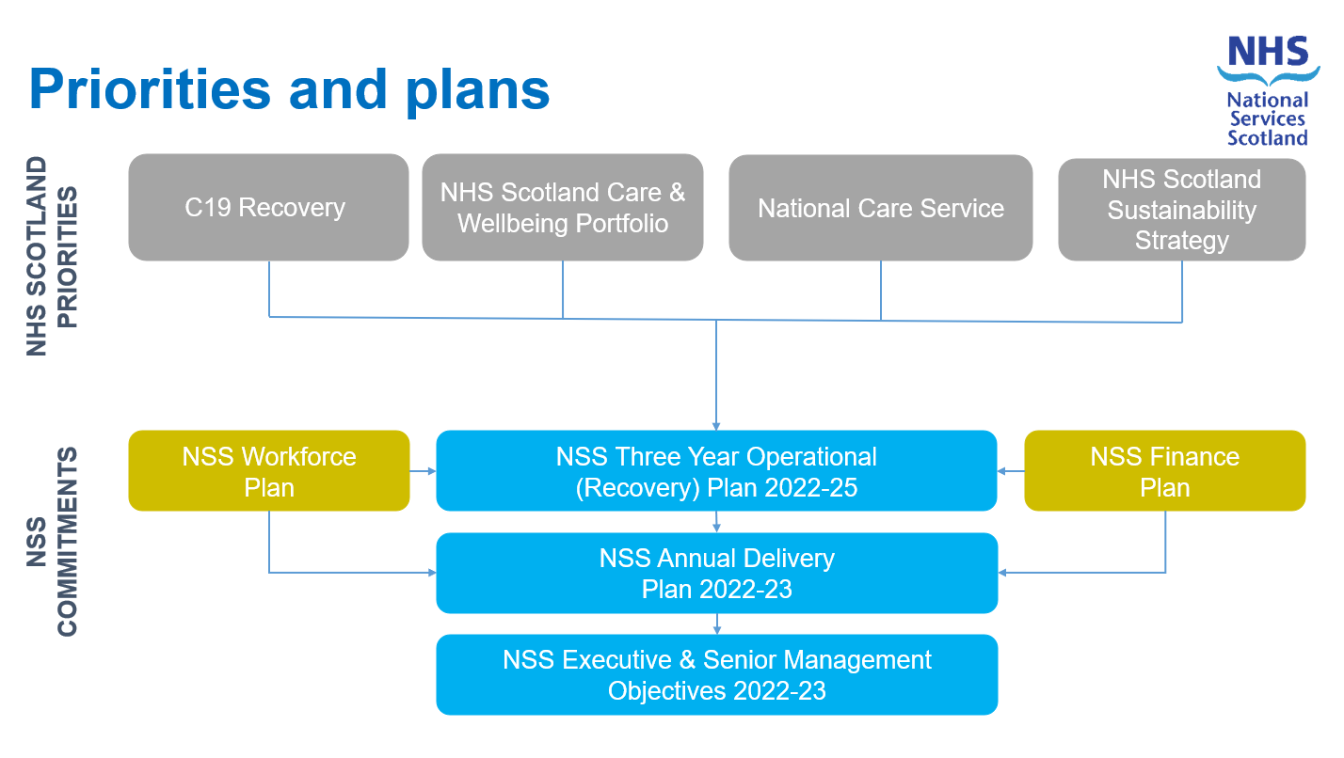

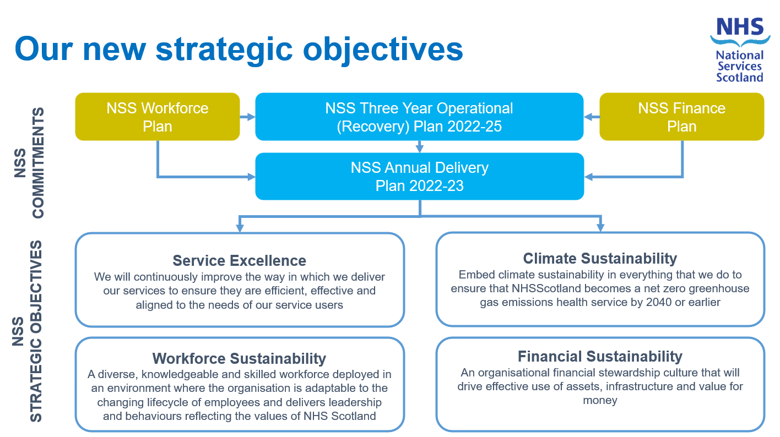

Our Objective – Workforce Sustainability

NSS workforce will be flexible and adaptable with the ability to mobilise to support the organisation to remain resilient and responsive to service need. All local workforce plans, and projections will be revisited and resubmitted on an annual basis to reflect business as usual and new service requirements in line with our three-year Operational Delivery Plan (remobilisation and recover) and annual delivery plans.

NSS will continue to utilise flexible resourcing models to support our workforce, and those of our partner organisations, in being responsive and effective around service need and workforce capacity and capability. Our workforce planning will consider new ways of working as agreed by the Executive Management Team and the NSS Partnership Forum.

Service redesign and change will be enacted in line with the NSS Strategy and will take into account full consideration of impact on workforce capability and capacity to deliver effective and efficient core services. Workforce plans including all service redesign and any subsequent organisational change will be taken forward in full partnership between management and trade unions/professional organisations, with staff engagement plans as part of the process.

Our NSS Workforce Plan is aligned with the NHS Scotland Workforce Strategy and will put workforce wellbeing at the heart of everything we do, along with equality of opportunity, increased diversity of our workforce and inclusion as being key to our workforce planning process.

NSS Three-Year Plan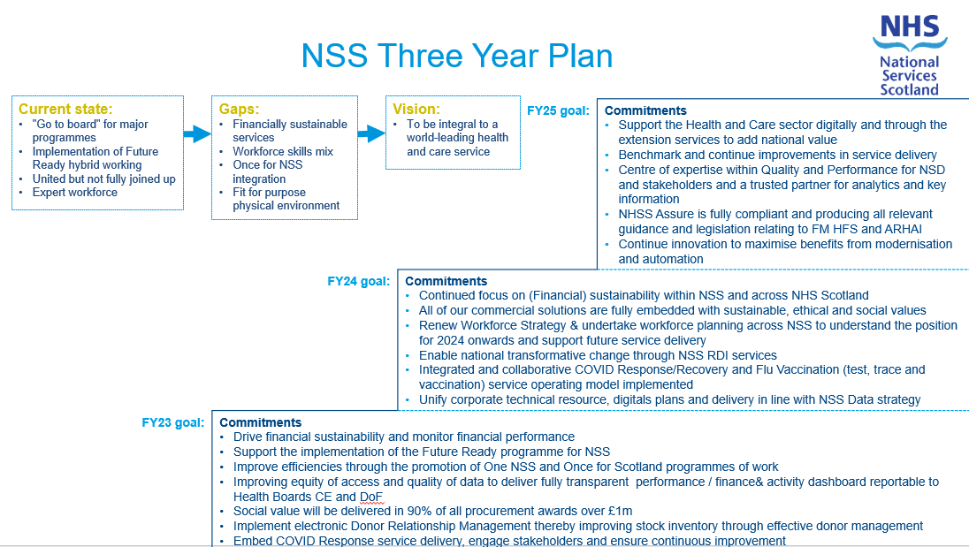

To support the delivery of our three-year Plan our SBUs have highlighted the following commitments.

NSS Delivery Plan Commitments
(PCF) National Procurement will:
- Work with stakeholders to develop sustainable product solutions and build in social value.
- Produce a procurement transformation T-Map to net zero by 2025 and 2035.
- Community benefits will be built into all contracts over £1m.
- Implement Scan for Safety to improve patient safety and treatment efficiency.
- Drive the Next Generation Project through service review and redesign.
(PCF) NHSScotland Assure will:
- Develop an Assure Strategy to improve quality in the built environment.
- Produce all relevant guidance and legislation in relation to FM HFS and ARHAI.
- Embed a data driven quality improvement approach across health and social care.
- Play a lead role in Climate Sustainability solutions.
(PCF) National Services Division will:
- Redesign the commissioning process to make it more agile, efficient and patient focussed.
- Implement an agile strategic network model that supports health and social care.
- Ensure all breast screening centres have action plans to reduce round length to 36 months.
- Develop bi-directional dashboard report to enhance quality assurance in real time using O365.

(P&CFS) Practitioner Services will:
- Implement the new Community Health Index (CHI) to improve patient services.
- Deliver benefits from automation and modernisation in primary care payments services.
(P&CFS) Counter Fraud Services will:
- Drive the roll out of the Government Counter Fraud Standards nationally.
- Work in partnership with the 22 health boards to agree Standard Statements and Fraud Action Plans.

(DaS) Digital and Security will:
- Transform its operating model, improve IT maturity, embed the data strategy and Cyber Services.
- Promote a digital first approach developing Artificial Intelligence solutions across NSS.
- Integrate services into the national architecture and continue to deliver national capabilities to transform operational processes.

(CLO) Central Legal Office will:
- Deliver a CLO data strategy in line with digital transformation.
- Play an active role in the COVID-19 public inquiry.

(SNBTS) Scottish National Blood Transfusion Service will:
- Implement occult hepatitis B testing and look-back exercise.
- Deliver a corneal procurement service for Scotland.
- Improve our stock inventory through effective donor management.
- Consider the community session/fixed site strategy for blood and plasma collection.

(SPST) Programme Management Services will:
- Continue to support Scottish Government with test, protect, vaccinate.
- Be the strategic partner to SG in the delivery of the care and wellbeing portfolio and emerging National Care Service.
- Expand our Service Transformation and Design Hub.

(SPST) COVID response will:
- Implement an integrated and collaborative COVID-19 response/recovery and Flu vaccination service operating model.
- Extend service offering across Health and Social Care to maximise value.
- Support the COVID-19 public enquiry and implement recommendations.
(CD) Clinical Directorate will:
- Implement in-GP practice digital prescribing and Community Pharmacy dispensing.
- Establish a National Screening Intelligence Platform.
- Embed COVID-19 sequencing as part of the Pathogen WGS service.

(HR) Human Resources will:
- Implement a renewed workforce strategy.
- Continue to enable NSS be a Great Place to Work through evidence based and principles led based approach.

Finance will:
- Implement the South East Payroll service.
- Support the implementation of key systems including Blackline, e-Rostering, Pro-Lease and e-Financials upgrade.
- Deliver a balanced budget by March 2023 and financial sustainability by 2025.

6.0 Internal and External Drivers for Change

The following Pestle chart provides information on a range of external factors identified by NSS in respect to workforce plans.

Political | Economic | Social
- Scottish Govt Independence Policy Campaign  - Scottish Govt Health and Social Care Strategy  - Establishment of National Care Service  - The Fairer Scotland Duty  - Changes in legislation impacting on workforce as a result of Political policy  - Emerging Political agendas and the requirement to look at workforce implications | - Reduction in Covid funding to Scottish Govt from UK Govt  - Reduction of Covid function to NHS Scotland budgets  - NHS Scotland Pay Negotiations  - Workforce ‘market’ competition for specialist skills  - Increase of cost of living, interest rates and fuel | - Aging population  - Scotland’s Health Inequalities  - Scottish Govt – shifting the balance of care from acute to primary care settings including homes  - Work life balance, home and Hybrid working  - Projected shortage in younger generation to attract into key workforce roles  - Changes in Pension
Technology | Legal | Environment
- Increasing level of digitalisation and automation  - Maturing technologies  - Requirement for increased Digital skills across a wide demographic  - Aging workforce population | - Changes in and compliance with UK and International Employment law  - TULCRA Act 1992 and changes to this  - Impact of Brexit on the UK employment law long term  - Changes in Home Office Immigration rules  - Health and Care (Staffing)(Scotland) Act 2019 | - NHSS Climate Emergency and Sustainability Strategy 2022-2026  - NSS Sustainability Strategy and Action Plan

There are a range of internal drivers for change which have been identified as:

Equality and Inclusion

NSS aims to be a leading organisation for promoting equality, diversity, human rights and inclusion within our workplace and in the wider NHS Scotland. NSS has a vision for equality and diversity which goes beyond establishing policy and processes to achieve change. We will monitor our progress towards meeting our equality objectives as part of our interaction with our donors, customers and suppliers to:

- Work towards eliminating unfair treatment and discrimination through a wide range of human resource policies and procedures. This applies to areas of recruitment, training, learning and development and career progression as well as monitoring the adherence to equality and diversity in everything we deliver.
- Recognise that our staff have rights as employees to work in a safe and bullying and harassment free workplace.
- Support our staff to recognise that they have individual and collective responsibility to value and respect each other’s contributions.
- Promote an environment where standards of conduct are of the highest level and to ensure that no one is harassed, bullied or victimised.
- Take clear and decisive action if discrimination occurs.
- Carry out equality and socio-economic impact assessments on the services we deliver.

We are committed to ensuring that all our services are accessible to everyone by removing real and perceived barriers. It means that we will deliver services that will meet the needs of donors, patients and service users.

Excellent equality and diversity practice means that everybody is treated with dignity and respect leading to improved outcomes for all.

Pension Reform

NSS are committed to implementing any pending changes proposed by the NHS Superannuation and Pension Schemes (Miscellaneous Amendments) (Scotland) Regulations 2022 following the outcome of the consultation which took place in March 2022.

These reforms may encourage some staff to seek early retirement in order to access their pensions, which may have a detrimental impact on the workforce requirements over the term of the NSS three-year plan. This is particular of concern in relation to the following:

- SNBTS – 26% of employees are aged 55 years and over
- DaS – 22% of employees are aged 55 years and over
- Nursing – 45% of employees are aged 55 years and over and 18% are aged between 50-55

Tax implications on pensions, predominantly with Medical and Dental staff, also increases risk to all our NSS Medical & Dental workforce as 33% of this workforce are over the age of 55. When tax implications are applied to employees who have reached their maximum salary pay point in this job family, employees may again decide to retire from service earlier than planned.

Health and Care (Staffing) (Scotland) Act 2019

The purpose of the Act is to ensure that at all times suitably qualified and competent individuals, from such a range of professional disciplines as necessary, are working in such numbers as are appropriate for the health, wellbeing and safety of patients, the provision of safe and high-quality health care, and in so far as it affects either of those matters, the wellbeing of staff.

In order to serve that purpose, the Act implements 10 new duties on Health Boards in Scotland, including NSS, (who are referred to as ‘the Agency’ with reference to our legal name of the Common Services Agency).

NSS will be required to report on all the duties of the Act with the exception of no 10. Common Staffing Method as this does not apply to NSS.

NSS will develop and implement guidance which sets out the NSS operational processes for clinical workforce planning and delivery of the Act. It will define the duties and responsibilities to ensure that clinical staffing levels enable safe, effective, high-quality care, and where risk is identified there is a clear escalation process for the management of staffing and actions to be taken in order to mitigate against the risk. It will also set out the principle of workforce planning required of all professional leads and managers in the organisation.

Service Transformation and Organisational Change

There is a requirement for NSS to respond to changes in the economic climate, the requirements of Scottish Government and NSS strategy and to redesign and re-align services in a way that will be sustainable for the future. The NSS of the future must have the capability to be flexible and agile in service delivery, and be able to adapt as an organisation and with pace.

In enacting the six step methodology, NSS has a number of transformation and change programmes which are likely to impact on workforce during the three-year planning cycle. These will range from those affecting the increasing and decreasing of WTE on the NSS establishment with potential changes to terms and conditions including employee location. Given the direct links with the NSS Financial Sustainability objectives, there is an imperative for all change programmes to demonstrate savings.

NSS is however committed to the implementation of the Scottish Government’s No Compulsory Redundancy Policy and that staff will face no detriment as a result of changes which may be implemented. This poses a challenge when considering the requirement of NSS to ensure our workforce is reduced to a level within the overall budget position. NSS will ensure appropriate HR Policies are implemented to support all change programmes including the NSS Organisational Change Definition and Process.

Staff Wellbeing

NSS employees worked tirelessly throughout the pandemic at all levels. There has been a welcomed increase in demand for our services, which in turn means our workforce have had to adapt at pace to new ways of working.

Two thirds of our staff are now either working from home or in a hybrid model, with other key services requiring staff to continue to work from a range of locations across Scotland.

Our key absence reason has consistently remained anxiety/stress/depression throughout the pandemic with a recognition that musculoskeletal reason also being reported.

Wellbeing remains a key requirement and delivery to ensure we have the right support provision in place to ensure our workforce remain resilient and adaptable to change and continue to enjoy a healthy work/life balance.

Ageing Workforce Profile

Section 7 provides details of our current workforce in relation to the breakdown of age, which shows an ageing workforce profile for NSS.

This presents several key workforce challenges including retirements, which results in a loss of knowledge, skills and expertise, the requirement to support older workers in any health-related matters and the need to support staff in more manual related posts to adapt to alternative roles to allow them to continue to work when they want to.

NSS require to have a focus on recruitment and retention of younger employees, whilst accepting that they may not have the experience or knowledge that can directly replace those who have left through retirement and long service.

A robust approach to talent management and succession planning, particularly in key specialist posts will also be required along with clarity in workforce plans of the potential skills and knowledge gaps to ensure planned mitigation of the learning, development and recruitment challenge.

Recruitment and Retention

In some of the SBUs in NSS there are particularly challenges in recruiting into specialist roles and/or Subject Matter Expert posts. This is of most concern in early career posts in DaS and PgMS. Therefore, the intention is to focus on working with third parties to widen the scope for attraction and engagement, and to look at options to grow our own or have direct access to talent pools.

Another area of impact is in relation to Architect roles in DaS, which face competition for limited skills sets against the private sector. Infection Prevention Control nursing posts in SNBTS also need to be considered because of the limited availability of these skill sets and the remote locations we are seeking to recruit into e.g., Inverness / Dundee.

A more recent but recurring challenge recruitment face is the limited timelines required for some bespoke recruitment campaigns, where there is an expectation and demand for additional resource within limited timelines.

Financial Challenge & Improved Efficiency

Workforce Sustainability cannot be considered in isolation - it must be integrated with Service Excellence; Climate Sustainability; and Financial Sustainability. Future workforce plans will therefore be considered in this regard.

The current NHS Scotland financial landscape is challenging – with financial pressures from the pandemic and rising inflation.

As an organisation NSS will need to generate further efficiencies, reduce costs and make savings in order to achieve financial targets and support the wider system. Indeed, the need to control and reduce costs has never been more important, with workforce a significant and increasing element of NSS’ cost base.

Whilst NSS’ workforce has remained fairly static in recent years, there has been a significant increase in actual pay costs through various pay settlements:

Financial Year | WTE | Pay Bill | Average Gross Charge per WTE
2016/17 | 3,326 | £148.4m | £44.7k
2022/23 (Projected) | 3,352 | £174.0m | £51.9k

As the table summarises, since 2016/17 there has been a 0.8% increase in WTE (excluding NCC Bank Staff) but a 17% increase in pay costs (including the assumption that the FY22/23 settlement will be agreed at 5%).

Finance and HR continue to work collaboratively to integrate financial and workforce sustainability requirements through integrated planning and focus, ensuring appropriate governance and controls are in place and enforced through Standing Financial Instructions (SFIs). The NSS Change Oversight Group (COG) has the remit to make decisions on Organisational Change Proposals, whilst increased grip, control and scrutiny is applied to any new posts that are requested.

It is also recognised that whilst there is the on-going need to reduce expenditure, prioritised investment in the right areas also has to be made to ensure service sustainability – by developing the workforce and maximising return on the investment of scarce funding.

7.0 Understanding NSS Workforce

Staff in Post

Table 1 presents the total workforce (WTE) as at 31 March 2022 by Job family and gender. In total 3,352.1 WTE are employed within NSS, this excludes the Bank for the National Contact Centre. Overall, 67% of staff are within the Administrative Services group, 12% of staff reside in Healthcare Sciences with Nursing /Midwifery approximately 8.7%. On average 92% of staff within Healthcare Sciences and Nursing/Midwifery support the operation of SNBTS. Support Services accounts for 9.56% of workforce in NSS predominantly within our Procurement Service division (PCF) with 92% of the Support Services family, SNBTS equates to 8% for Support Services.

Table 1
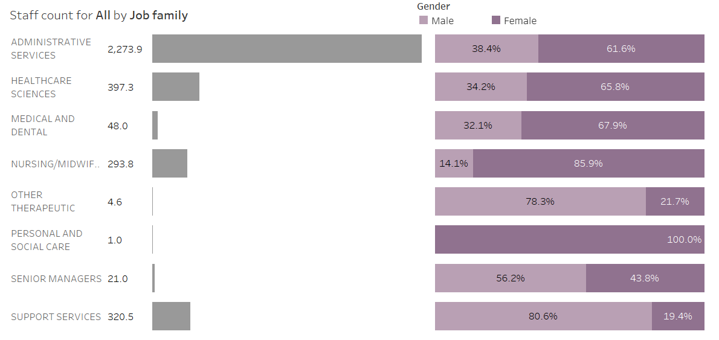

Staff Home Base

Table 2 presents an overview of the home locations of our workforce within National Services Scotland.

Table 2
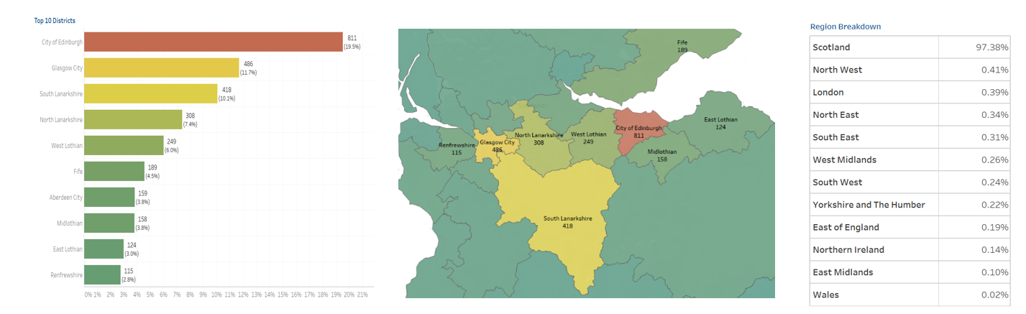
In the main 19.5% of the workforce reside in Edinburgh with 811 Staff. A total 11.7% 486 Staff in total in Glasgow. South Lanarkshire is the third most populated with 10.1% (418 Staff), North Lanarkshire 308 equating to 7.4% of the workforce. West Lothian represents approximately 6% (249 HC) and Fife 4.5% with workforce numbers of 189. Aberdeen, Midlothian, East Lothian, and Renfrewshire range from 3-3.8% with an average of 140 People. 97% of Workforce Home base is in Scotland. Approximately 2.6% of staff are based in England with 0.02% in Wales.

During the COVID-19 pandemic, two thirds of our employees had to work remotely/at home. This has created further opportunities for NSS to expand recruitment beyond Scotland to deliver their services. The Future Ready Programme was established to enable staff and teams to choose how and where they work so they can deliver what is required in the right place and at the right time. For many employees, this supported their work life balance and improved overall employee wellbeing.

Agency and Fixed Term Resources

As at the end of the 2021/22 fiscal year, there are 197 agency employees across NSS, with a WTE of 197. The majority of these are within PCF (98), SPST (46) and DaS (28). 144 (73%) of agency contracts are due to end within the first six months of the new fiscal year.

There are a total of 689 employees on fixed term contracts, with a WTE of 561.6. The majority of these are within NCC (472), DaS (63), PCF (50) and SNBTS (39). 504 (73%) of fixed term contracts are due to end within the next six months, 462 of these within September - 95% of which are NCC fixed term contracts.

As at the end of the 2021/22 fiscal year there are 33 fixed term employees and 10 agency employees who have been with NSS for more than four years.

Table 3
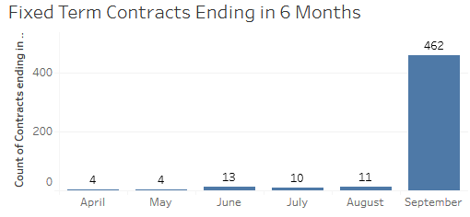
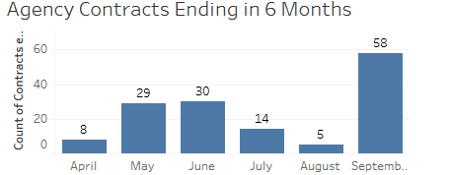

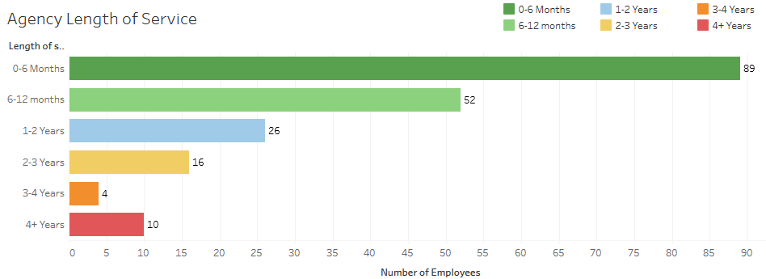
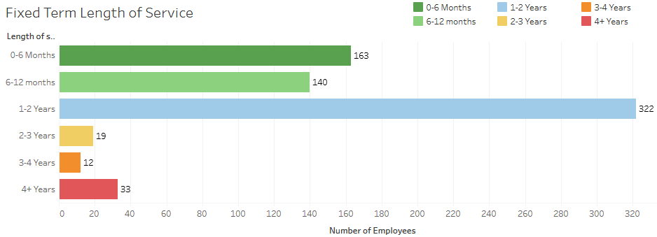

Age Demographics

Table 4 presents the workforce breakdown for age demographics in NSS as at 31 March 2022. Of the current workforce, approximately 11% of staff are age 60+ years old, 26% of staff are above 50 years old. The mean for age group is within the 50-54 age category with 18% of the workforce. Age group 30-49 range from 10% to 14% with approximately 47% of the workforce within this category. The age group of 24 and under relates to 3% of the workforce with 25-29 relating to 7%.

Within the nursing midwifery job family average workforce range predominantly consists within the 50-60+ category with 57% of this workforce in this age group, the mean of 24% within the 50-54 age group.

Table 4
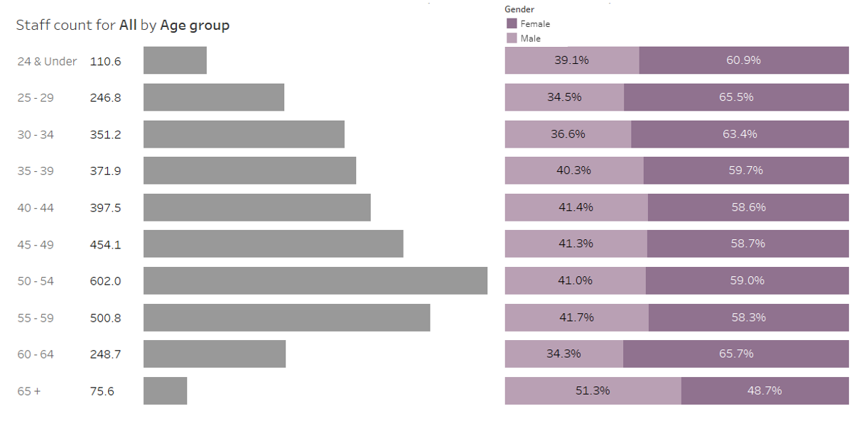
The most significant change has occurred within the age profile for the 20-24 category, which has increased by approximately 60% in comparison to 2020/21 and by 72% from 2019/20. We have also seen a reduction of 15% in age group of 60+. Age group of 50-54 has remained the mean for the last three years.

Female has consistently remained the highest category for the last three years with 61% of the workforce on average. On average Female represents the majority within all job families with the exception of Support Services which is within our Warehouse services and Doner Drivers categories. Within our Administrative Services, Female represents 61% of the workforce with Male 39%. Senior Managers is the most balanced Job category with 45% Female to 50% Male.

The NSS Equal Pay Gap report is published on the NSS website in line with requirements.

WTE of Job Family by Band

Table 5 details the workforce distribution by service area and by pay band both in terms of headcount and WTE.

- Support Services is predominately within the Band 3 pay category representing 68% of this service area. Band 2-4 overall equates to 86%. Band 5-7 is approximately 11%, with Band 8 and above 3%.
- Administrative Services approximately 56% of the workforce are Band 5-7. Band 8A – Band 9 equates to 19% of the workforce, with Band 2-4 representing 24% of Admin staff.
- Nursing Band 2-4 represents 58% of the service area, 32% within the Band 5-7 category and 9.5% Band 8A and above.

Table 5

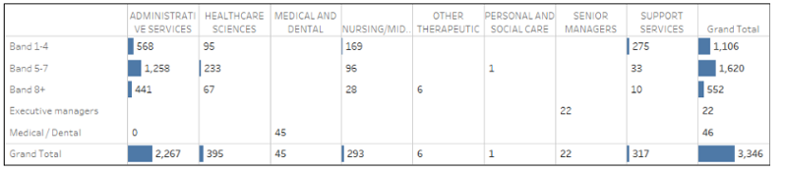

Impact of Staff Absence

The NSS sickness absence rate has increased across this fiscal year compared to the previous year, ending the year on 3.76%, down from 2.60% at the end of the 2020/21 fiscal year. The YTD figure is sitting just above the Mean, which has been calculated at 3.69%.

As demonstrated in the SPC Chart, NSS Sickness Absence Rates have been much lower than average since the first COVID-19 lockdown at the end of March 2020. Although sickness absence rates have been steadily increasing from the beginning of the second quarter of this year (July had a rate of 3.38%), they are still lower than those reported pre-pandemic. The 2018/19 fiscal year had a YTD rate of 4.16% and 2019/20 a rate of 4.21%.

CLO, DaS, PCF, SNBTS and SPST have finished the year with sickness absence rates between the Mean and Upper Limit, while Clinical, Finance HR, and P&CFS are between the Mean and Lower Limit.

The year end position for all SBUs is considerably higher than the previous year, with only HR ending the 2021/22 fiscal year on a sickness absence rate lower than that recorded in March 2021 - 0.99% this year, compared to 1.25% at the end of 2020/21.

Table 6
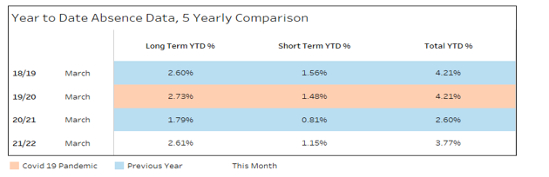

Table 7

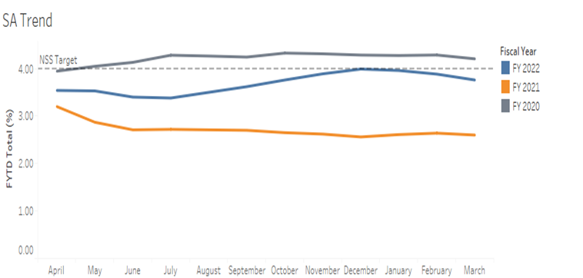

Table 8

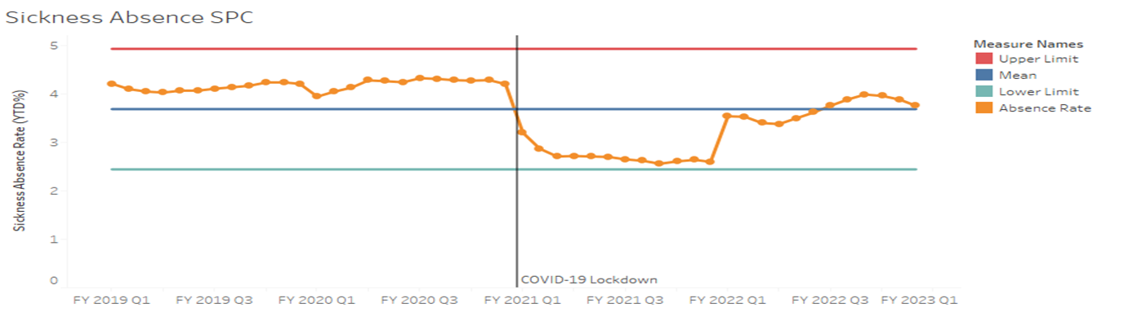

Annual Leave

Maintaining the wellbeing of our staff during the pandemic was essential and all efforts were made to enable staff to take annual leave. All staff were encouraged as much as possible to fully utilise their leave entitlement due to the importance of taking time away from work in order to rest and recuperate.

However, there were occasions where it was not possible for staff to take leave as planned, due to critical business need as we provide our continued response to the COVID-19 pandemic.

The Annual Leave position as at the end of 2021/22 indicates that overall, approximately 6% of Annual Leave was outstanding from our workforce at the end of year March 2022, and to date 16,477 hours have been approved to be carried over into 2022/23 which is a decrease of 32% from last year.

In the main Business Reason equates to 42% of leave carried over in 2021/22, with 29% of leave (4,834 hours) approved in line with the Annual Leave Buy Back policy.

Table 9

Annual leave planning and monitoring will continue over the coming year across NSS and is featured in the Chief Executive and Directors objectives to ensure annual leave is being fully utilised, and an emphasis of any annual leave carryover to be taken within the first quarter of 2022/23.

Overtime Analysis

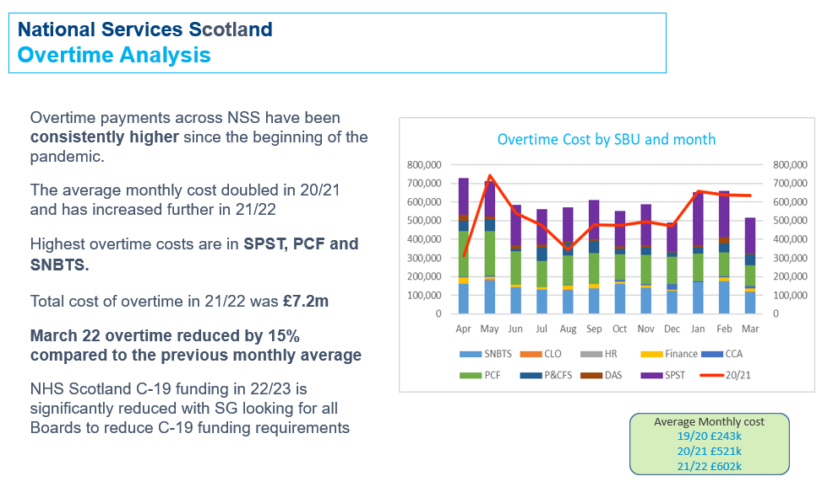
As highlighted in the table above overtime costs have been consistently higher since the beginning of the pandemic. This has in the main been generated from those SBUs who have played a key role in supporting our response to COVID-19. However, going forward as we now recover and re-mobilise we are asking SBU Directors to review overtime within their individual areas. This is not only from a financial affordability perspective, but from a Health and Wellbeing, working time regulations and service sustainability perspective. Our objective is to ensure overtime is managed back to pre-pandemic levels and will continue to be monitored.

Staff Turnover

NSS turnover indicates a year end position of 10.31%, which exceeded the 7% target. The National Contact Centre (NCC) has been removed from the Turnover calculations due to the abnormal impact NCC has on the turnover due to the nature of the business unit and it’s unique staffing and contract situation. Additionally, the Turnover calculation provided excludes bank workers. NCC had a turnover of 43.39%.

Included within the 10.31% year end position, the areas with the most significant turnover for 2021/22 are:

- SNBTS – 13.98% (against 8.5% target, an increase from previous year end rate of 8.75%). Overall 35% of the turnover within SNBTS was in relation to Retirement, with 24% to start employment with another NHS Board.
- SPST – 12.23% (against 6% target, an increase from previous year end rate of 5.98%).
- Clinical – 16.67% (against 7% target, an increase from previous year end rate of 5.88%)
- HR & Workforce Development – 12.06% (against 7% target, an increase from previous year end rate of 5.46%)

Table 10

Of the employees who left in the 2021/22 fiscal year, 235 were on Permanent Contracts equating to 84.2% of leavers. There were 42 employees who left that were on Fixed Term contracts, equating to 15% of leavers in the 2021/22 fiscal year.

Turnover by Age

Turnover categorised by age shows high level of turnover in the ’20-24’, ‘25-29’, ‘60-64’ and ’65+’ age groups. The age group ’60-64’ shows a turnover of approximately 20% and ‘65+’ year categories notes approximately 31%. This suggests staff are leaving at the beginning and/or end of their career, whereas the middle age brackets are of expected levels and relative distribution. These turnover figures exclude the National Contact Centre staff.

Further analysis of the age groups ’20-24’ and ‘25-29’ showed that 19.1% of staff in these age cohorts left for ‘New employment with NHS Scotland’ and 8.5% for ‘New employment out with NHS Scotland’. The ‘End of fixed term contract’ reason was present for 8.5% of the age cohort, whilst ‘Other’ and ‘Voluntary resignation – Other’ (similar definition to ‘Other’) accounted for the leaving reason for 60% of the staff members.

Table 11

Turnover by Job Family

Turnover within service area indicates high volume within Personal & Social care, however it should be noted that this only represents one leaver. Within Administrative Services turnover is only 8.7%. In 2021/22 Senior Manager turnover increased to 29.6% and Nursing/Midwifery Services 20.65% of the overall volume.

Table 12

8.0 Step 3: NSS Workforce Journey

Plan

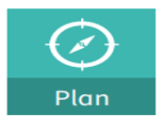 | Workforce  Our workforce planning is about developing an understanding of the internal and external environment and how those factors will affect our current and future workforce. It is about taking this understanding and generating intelligence to measure and compare our current workforce (supply) with our future workforce (demand) and translating this into actions that will develop and build the workforce needed to meet current and future demand.

NSS has incorporated the Six Steps Methodology to Integrated Workforce Planning approach which was developed by the Skills for Health – Workforce Projects Team. It is a practical approach that helps guide and support managers to carry out sustainable and evidence-based workforce planning. It is a process that documents the direction in which the organisation or business area within the organisation is heading and helps inform current and future workforce decisions.

HR Business Partners are aligned to individual SBUs and help to lead and drive SBU workforce planning at a local level. Local SBU workforce plans which are supported by an action plan are regularly reviewed by SBU Senior Management teams and are formally submitted and reviewed annually to ensure these are aligned to both strategic and national priorities. It should also be noted that there is also currently work on-going to ensure that clinical workforce planning is being properly undertaken as part of the wider SBU workforce planning and this will be brought together to inform an overall NSS Clinical Workforce plan.

To support our managers with workforce planning we have a range of interactive reporting functionality available through the tableau platform, which provides managers with insights into their workforce including sickness absence, L&D, Agency and Fixed Term Contracts/agency staffing and demographics to assist with workforce planning.

HR Connect, our HR portal, provides a range of content which is easily accessible including:

- Workforce planning templates, action plans and guidance documents
- Workforce planning checklist to ensure plans are aligned and signed off by SBU Directors
- Roles and responsibilities
- Planning cycle and timeframes
- Process for developing a skills Matrix and links to Future skills: Skills Development Scotland

We also provide support to Managers through a series of Podcasts with sessions undertaken by Subject Matter Experts, and will continue this throughout 2022/23, along with a dedicated Management hub located within the Teams channels for additional support. Whilst we also have access to e-learning workforce planning content available from the NHS England website, this year we are focused on developing our own e-learning content based on each of the six steps which will rolled out to all managers and planning leads, along with associated reporting.

Workforce Planning Actions:

- SBUs will submit local workforce plans aligned to National Priorities and Strategic Objectives of NSS
- Reviewed and refreshed overall NSS Workforce Plan aligned to National Priorities and Strategic Objectives of NSS
- External publication of NSS Workforce Plan and workforce projections
- Development of NSS Clinical Workforce Plan
- Development of e-learning Workforce Planning content which is based on the six steps

Attract

The age profile of the NSS workforce projects an increase in the number of potential employee retirals over the next 10 years+. This indicates a requirement to prioritise the attraction, recruitment and retention of young people to create future workforce sustainability.

Recruitment

Contrary to previous workforce expectations, which advised a decline in the number of vacancies expected, NSS has seen a higher than average demand for recruitment in the past year. This on average has been between 15 and 20 vacancies per week.

NSS will focus the early part of 2022/2023 on supporting continued volume recruitment for PgMS, specialist recruitment for DaS and Executive and Senior Management Recruitment.

Recruitment Actions:

- Develop a suite of selection tools, potentially through Job Train functionality aimed initially at enhancing the delivery of volume recruitment services
- Development of the NSS Career Website as a key attraction and candidate information tool
- Review and development of HR Connect content as a self-help tool for Hiring Managers and Candidates
- Enhancement of Social Media strategy and presence as an employer of choice
- Enhancing NSS as a diverse and inclusive employer through our attraction strategy with an immediate focus on
  - Achieving Disability Leader accreditation
  - Developing stronger links with Veteran recruitment
  - Increasing number of appointments for candidates with a disability by working closely with GCIL and other disability inclusion partners
  - Implementation of the NSS Attraction Strategy
- Continuing to roll out Values Based recruitment
- Implementing changes to Home Office requirements for visa and immigration

There will be a continued focus on the needs of the Hiring Manager by developing the recently launched Hiring for Success e-module with a stronger focus on the softer skills.

Finally, the success of the Hiring Manager feedback questionnaire (2021/2022) will be built on through our engagement with candidates to gather their feedback on the candidate experience, as a continued lessons learnt exercise.

Early Careers

NSS are, and will continue to be, forward-thinking, growing for the future by supporting and developing the innovation potential of our workforce in their early careers.

NSS want our early careers employees, working and studying across our organisation, to have the best possible learner-centred support that is needed to ensure their future skills development and support our succession planning ambitions.

NSS can, and will, play an important role in supporting them and planning for future skills to meet our business needs and help mitigate future skills gap risks. Over the next three years we will put a learner-centred approach in place and put mechanisms in place to guide, develop and support our early careers pathways. This shall further build upon a high-quality learning environment, whilst promoting a lifelong learning culture and developing a focus on ‘growing your own’. Thereby embedding mainstream thinking in developing existing staff talent, finding, and growing new talent.

Our Early Careers plan will support:

- Promoting wider understanding of the NSS career pathways and career opportunities.
- Attracting and retaining new people to NSS to ensure the sustainability of our future services.
- Recruitment through apprenticeships and employability programmes.
- Promoting National Services Scotland as an employer of choice.
- Helping to address recruitment and retention issues where these are identified.

NSS has five key objectives for delivery of our Early Careers plan:

- Align the strategy to the Scottish Government’s national initiative – Young Persons Guarantee in Scotland for 16 to 24 year olds.
- Support business needs and support the wider organisation in identifying and closing future skills gaps.
- Unlock emerging talent, create a culture of lifelong learning from early on and provide a high-quality learning experience.
- Collaborative working – provision of an integrated professional learner -cantered support service.
- Become a Centre of Excellence for Early Careers.

Graduate Placement Scheme

To support retraining and staff development across a range of professions, NSS will continue to link with University Graduate Placement Programmes. This work will continue to grow and link to career pathways with accessibility for all those who require support to be considered.

NSS are committed to developing career pathways for all skill sets and helping improve youth employment in Scotland. Career pathways are important for all staff, but particularly for the younger workforce, where skills development is a key factor in attracting them to work for any organisation.

Modern Apprentices

As part of our Early Careers Programme, NSS will build on the work currently underway at a local level, to establish a corporate framework for the employment of Modern Apprentices. This will support the development of our future workforce and bridge any gaps in future skills and capabilities.

The framework will deliver a more coordinated approach of support through Apprentice incentive schemes and key providers, with roles being highlighted as part of our workforce plans through the next three years.

At a national level, as active members within the NHS Scotland Employability and Apprentice network, we will support the implementation of best practice across NSS and connect to wider NHS Scotland initiatives.

Train

Effective Leadership

"I am pleased to welcome you to our Leadership Development Programme. By investing in you, our leaders, we are investing in our vision to be integral to a world-leading health service. Strong leadership has never been more important for us given the demands upon Health and Social Care services and the need for NSS to be at the forefront of responding to current and future challenges. Exemplary leadership skills form an essential part of our ambitions, and we are committed to valuing our Leaders by further strengthening our own capacity for collaborative, values-based and resilient leadership. I look forward to meeting you at the some of the Leadership Events in the coming year." Mary Morgan, CEO

The NSS Leadership Programme consists of four key pillars which describe how we can address and respond to leadership development needs at both an individual and team level.

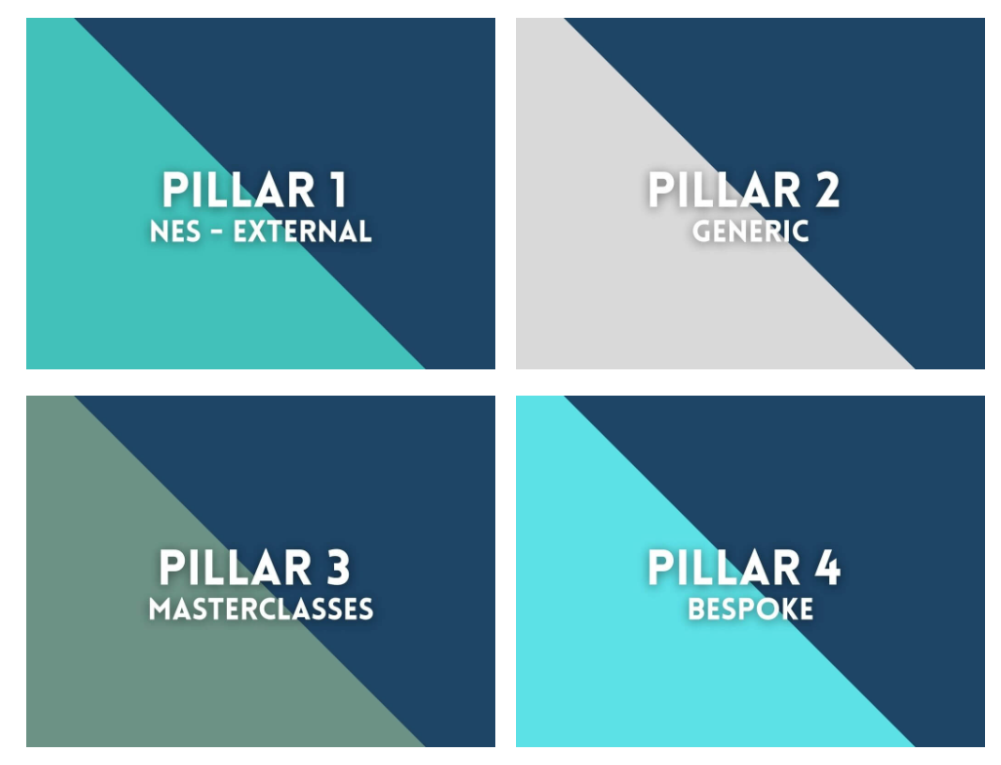

Pillar 1 – Project LIFT

NHS Scotland has identified a clear need for transformational change and fundamental to its success is the capacity and capability of our Leaders to meet the opportunities and challenges they may face.

Project LIFT is an NHS Scotland wide approach to identifying, supporting, enhancing and growing leadership capabilities at all levels to improve the experience of our people to transform NHS Scotland and its services.
This approach across NHS Scotland will be supported via NHS National Education for Scotland (NES). Their Project LIFT team will work with NHS Scotland Boards to create a shared focus on the key leadership attributes needed by NHS Scotland which will create the skills, behaviours and culture to realise the ambitions of the Health & Social Care Delivery Plan.

The ask of leaders through Project LIFT is:

People at the heart of everything we do

Demonstrate humility, curiosity, compassion, accountability

Show vision, self-leadership, creativity and innovation

Empower, motivate and inspire; positively influencing pathways

Be collaborative and strategic

Pillar 2 – Generic

This pillar is aimed at all leaders across NSS and covers six capabilities, their definition and a range of development options aligned to each capability.

- Collaborating and Influencing
- Creativity and Innovation
- Empowering
- Motivating and Inspiring
- Self-Leadership
- Vision

Pillar 3 – Masterclasses

This pillar is aimed at all leaders and are speciality classes in which learning objectives are achieved through practice accompanied by instruction. This pillar also includes a Strategic Influencing Programme.

Pillar 4 – Bespoke

This pillar is for executive level senior individuals/teams and next tier individuals/teams. It offers commissioned development interventions for both individuals and teams which are tailored to customer requirements. Included are bespoke psychometric tools such as MBTI and 360 process and self-development courses such as Covey 7 Habits.

Competency Frameworks

NSS Board

At a strategic level the NSS Board will undertake the Board Diagnostic tool, which assesses performance against competencies and will continue to build in Board development throughout 2022/23 and beyond.

Agenda for Change – Knowledge and Skills Framework (KSF)

NSS applies KSF across all staff employed under Agenda for Change (AfC) Contracts. This provides the broad framework which supports a fair and consistent approach to Personal Development Planning and reviews.

This in turn is used by NSS as part of our approach to performance management and is key to delivery of the TURAS Appraisal process in identifying knowledge, skills, learning and development needs of our workforce.

Given the change in workforce over recent years, there is recognition that we need to educate our managers and staff on the specific requirements, process and benefits of KSF ensuring that staff are aware of the competency levels and that they are working to them for the roles we have in place.

All AfC staff are required to have a KSF outline linked to their post, NSS have made available generic outlines which are published on the HR portal, HR Connect.

Medical and Dental Staff

NSS fully complies with the Scottish Medical Appraisal Scheme which is an opportunity for focused reflection on maintaining the personal and professional wellbeing of these staff. The competencies required are specific to role and need and as required through the appropriate professional regulatory body.

Executive and Senior Managers

NSS implements fully the mandatory requirements for the appraisal of Executive and Senior Managers performance review cycle. This includes alignment with the NHS Scotland Values and the NHS Scotland Leadership Qualities Framework and is included in Project Lift and the NSS Leadership Programme.

We have established the Enhancing Leadership Capability framework within NSS to support the process of performance appraisal, competencies and development for our Executive Cohort. NSS will undertake a review and refresh of the approach to this framework during 2022/23 and will drive the approach throughout the hierarchy of the organisation.

The NHS Scotland Leadership Qualities Framework remains the basis for solutions for the NSS leadership programme and management development which is also based around the NSS 22/23 strategy. This framework provides clarity about effective leadership and management, what is expected of individuals, teams and organisations in terms of delivering effective leadership and management which has been incorporated into all NSS programmes, including continuing to use the NHS Scotland 360 competency tool.

Clinical Staff

NSS continue to ensure our specialist clinical staff use professional career and competency frameworks produced through National Education for Scotland (NES), the regulators and the Royal Colleges.

NSS is in the process of preparing for the Nursing, midwifery and allied health professionals (NMAHP) development framework which will introduce the Healthcare Support Workers Learning Framework and the NMAHP Post – Registration Framework across NHS Scotland.

The post registration framework will include four levels of practice:

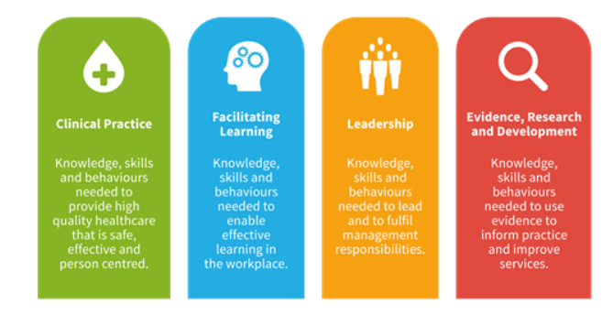

Management Development Programme

A key aim of our workforce strategy is that NSS values its employees as its greatest asset.

NSS Management Development is a blended learning programme consisting of online learning and interactive webinars. We have split the content into online modules which can be accessed through an on-line platform. The online learning is also supported by digital events, designed to provide you with the opportunity to explore the topics further through discussions with colleagues.

NSS have also developed a Management Hub through the TEAMS system where existing or aspiring line managers can provide a range of supporting tools. There are four channels for the hub:

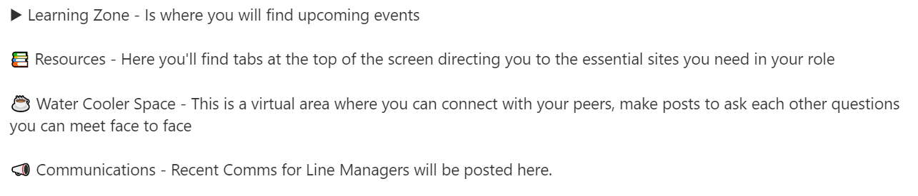

The programme is aimed at all managers with line management responsibility and is tailored to meet the needs of the individual with a range of modules provided through a blended approach of both online and face to face events.

The programme covers:

The Big Picture  The Role of the Line Manager  Effective Team Working  HR Policy Training for Line Managers | Communication and Feedback Skills  - Developing your Team  Coaching for Line Managers  Managing Change, Transition and Resilience

Mandatory for All and Statutory Training Compliance

NSS has agreed a range of training programmes which are ‘mandatory for all’ and are monitored for compliance monthly through the NSS People Report. The programmes cover:

Equality and Diversity

Health and Safety Induction

Freedom of Information

Risk and Resilience
- Standing Financial Instructions
- Whistleblowing for Managers and Staff

Freedom of Information

Manual Handling Passport

Counter Fraud Services
- Information Governance in Action
- *Cyber Security

*NSS is also in the process of launching an additional ‘mandatory for all’ e-learning module on Cyber Security, this will form part of a three year cycle of training and will be monitored for compliance.

Within NSS, there is a legal requirement, endorsed by the NSS Fire Safety Group, which stipulates that all staff must complete fire safety awareness training as a statutory for all training requirements. This means that all new staff, regardless of role, must complete this training at induction, and all existing staff must complete this training at least once in every two-year period.

A fire safety awareness e-learning training package has been developed by NSS Facilities Management which reflects the legislative requirements and NSS approach to delivery of fire safety training.

TURAS Learn Transition

As part of the NHS Scotland Business Systems vision for a single systems approach the decision was taken by CEOs that all National Boards would move their Learning Management System (LMS) provision to the NHS National Education for Scotland (NES) platform TURAS Learn.

The LMS that NSS currently uses is LearnPro therefore a programme has been established in conjunction with NES to enable a full transition to the TURAS Learn system by March 2023.

TURAS Learn Actions:

- Review of eLearning modules to TURAS Learn and prioritisation for migration of key modules where these aren’t compatible currently with the Turas platform
- Training sessions and knowledge transfer from NES to NSS Administrators, names submitted to NES
- Developing Turas Learn Board homepages for NSS
- Engagement and communication to NSS Staff, communication plan likely to commence during quarter three.
- Creation of user guides and delivery of training for NSS users once system developments are delivered by NES
- Dependency on interface between eESS and TURAS Learn to update joiners, movers and leavers within NSS
- Migration of corporate compliance reporting for mandatory and statutory learning

Digitalisation of the Skills Gaps Analysis and Frameworks

The workforce plans across the SBUs in NSS have all indicated the requirement to have frameworks in place to support workforce skills gap analysis and training needs assessment. This will provide NSS with the ability to provide greater clarity on future learning and development needs of individual and groups of employees.

The frameworks will be developed and rolled out using a digital approach in 2022-23.

Employ

Applying Pay, Terms and Conditions Consistently and Fairly

NSS supports the principle of equality of opportunity in employment and believes that staff should receive equal pay for the same or broadly similar work, or work rated as equivalent and for work of equal value, regardless of age, disability, gender reassignment, marriage and civil partnership, pregnancy and maternity, race, religion and belief, sex or sexual orientation, in accordance with the Equality Act 2010.

NSS understands that the right to equal pay between women and men is a legal right under both domestic and European law. In addition, the Equality Act 2010 (Specific Duties) (Scotland) Regulations 2012 requires NSS to publish pay gap information on a bi-annual basis.

It is good practice and reflects the NSS Values that pay is awarded fairly and equitably. NSS recognises that in order to achieve equal pay for employees doing the same or broadly similar work, work rated as equivalent, or work of equal value, it should operate pay systems which are transparent, based on objective criteria and free from unlawful bias.

NSS are expected to comply with all pay, terms and conditions arrangements agreed at either a UK or Scottish level relating to the categories of contracts across our workforce.

- Medical & Dental Staff
- Agenda For Change
- Executive and Senior Managers

The current Agenda for Change National Pay Scales are detailed in Appendix C.

Once for Scotland Polices

NSS will continue to implement the Once for Scotland policies, which will include the Implementation of the Flexible Location Policy as and when issued.

Performance Management

Good performance management at all levels of the organisation is essential to ensure we meet not only this aim but delivery against the NSS strategic direction. Our managers must ensure that all staff have objectives which are set against the NSS strategic objectives, that staff personal development plans are in place and delivered and that meaningful performance appraisals take place with feedback in line with the performance cycle.

NSS Executive Management Team regularly review the key performance indicators relating to objective setting, development plans and appraisals as part of the monthly HR People Report.

A range of development opportunities relating to performance management are available as part of the NSS leadership and management development programmes.

Hybrid Working

During the COVID-19 pandemic, the majority of employees had to work remotely/at home. The Future Ready Programme was established to enable staff and teams to choose how and where they work so they can deliver what is required in the right place and at the right time. For many employees, this supported their work life balance and improved overall employee wellbeing.

The following principles have been designed to underpin and help guide the decision-making process:

- We trust our staff and teams to make the right choices for how, where and when they work.
- We ensure staff health, safety and wellbeing at work.
- We embrace, encourage and support flexible and hybrid ways of working.
- We work on a digital-first basis, grounded in inclusivity and our values.
- We take decisions that value financial, environmental and social sustainability.
- We focus on quality and continuous improvement, learning from what works.

NHS Scotland organisations are required to do more with less, the pressures for higher performance and better quality emanate from a range of sources and are entirely appropriate, but a clear implication of this is that existing ways of working are not sustainable and significant service redesign and change in existing working patterns is needed.

Career Pathways

NSS recognise the opportunity career pathways play within the retention of our existing workforce and is key to succession planning and talent management. This is not an area however that has been given priority in recent years therefore work has begun across a range of posts to consider and build career pathways.

Initially consideration is being given to how best to bridge the vertical growth and enhancement for our current roles however this will in time be considered in terms of potential sideways movement across our organisation.

Rewards and Recognition

As part of our NSS Great Place to Work Plan NSS have agreed to review the current offering of Reward, Recognition and Benefits package for our workforce. Key deliverables will be:

- An NSS Attraction Strategy
- Reviewed Staff benefits package
- Long Service Awards and Retirement recognition
- Excellence Awards
- Retirement Programme

Key deliverables will be overseen through the NSS Partnership Forum and are linked to our delivery plan during 2022/23.

Retire and Return

The NHS workforce is increasingly multigenerational with a desire for greater opportunities to work flexibly, even after retirement.

Employees have indicated that while they may wish to enjoy the benefits of retirement, they would like to have the option to return to employment within the NHS more easily.
To support the NHS as it continues to recover and remobilise from the pandemic, it is more important than ever we retain experienced employees with the skills we need to provide high quality care to the people of Scotland.

Enabling multi-staged and multi-dimensional careers can support employees, the NHS and ultimately enhance patient care.

The NHS Scotland Interim National Arrangement on Retire and Return has been developed by the ‘Once for Scotland’ Workforce Policies Programme. These arrangements have been established on an interim basis pending consultation on the full NHS Scotland Retirement Policy in the coming year. While there is no automatic right for an employee to return to work, these arrangements support retiring employees by offering an accelerated process to return on a part-time basis to the same job or a different role within the same job family at the same or a lower grade.

The process enables retiring employees to continue in employment that is suitable to them and the service. It takes a person-centred approach that supports and manages retirement in a tailored and individual way.

NSS will be implementing the Interim National Arrangements and has processes in place to support the delivery.

Nurture

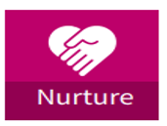 | Our Values  The NSS values guide everything we do and ensure we fulfil our purpose and make our vision a reality. There is recognition that we have further work to do to be clear on how we will position ourselves with customers, stakeholders and our staff. This will focus on what type of organisation we want to be in terms of attitude and aspiration. In relation to staff, NSS will consider how we continue to make NSS an attractive place to work, one that encourages people to both join and stay and this builds on our Great Place to Work approach.

This common set of values, endorsed by NSS Staff Governance Committee, helps us all create a better NSS community, whilst honouring the traditions and good work of our Strategic Business Units and Directorates.

The NSS Values are:

- Committed to each other  - Customer focus  - Integrity | - Openness  - Respect and care  - Excel and improve

Great Place to Work Plan

In line with our Workforce Plan, we demonstrate that NSS delivers the ambition of the NHS Scotland Staff Governance Standard through developing and monitoring the delivery of an annual action plan, this is delivered through the Great Place to Work Plan (Appendix A).

The GPTW plan covers an initial period of 12 months; 1 April 2022 to 31 March 2023 only and has been endorsed in partnership through the NSS Partnership Forum and Staff Governance Committee, with the feedback from the NSS iMatter results from staff informing the key areas of delivery and our targets for the year.

Whilst aiming to maintain the levels of experience across all of the key aims in respect to the Staff Governance Standard, for 2022/23 there will be a focus on development and improving the areas of Well Informed and Involved in Decisions.

The key aims of the Plan are as follows:

- Actively encourages engagement and involvement of all employees
- Trains and supports all employees to do their role whilst providing development opportunities
- Treats all employees with dignity and respect
- Promotes a culture of safety health and wellbeing for all
- Consistently applied workforce policies, people treated fairly
- An attractive benefits package which supports retention of a highly skilled workforce

The latest iMatter Survey which was undertaken during July 2022, along with a range of staff feedback from across the organisation will be used to measure the success of the plan, in particular against the targets we have set.

NSS focus on areas relating to a positive staff experience; making sure staff are healthy, well and safe; that we have a sustainable workforce; and provide inclusive working opportunities to encourage a more diverse workforce. We measure our success through the annual iMatter staff survey and other staff surveys as needed.

The goal of the Great Place to Work Plan is: “NSS will remain a great place to work.”

Our Staff Governance Targets

The targets agreed in respect to the outcome of iMatter and Staff Governance Standards has been agreed in partnership as follows:

Key Outcomes 2022/23  Response Rate 74%  Employee Engagement Index 78%  % of Action plans completed 90% | Staff Governance Standard 2022/23  Well informed 80%  Appropriately trained and developed 80%  Involved in decisions 73%  Treated fairly and consistently; with dignity and respect, in an environment where diversity is valued 79%  Provided with a continuously improving and safe working environment, promoting health and wellbeing of staff etc 79%

NSS have agreed a range of focussed actions to support the delivery of the above targets and these are identified under the Staff Governance key areas. It should be noted that a more detailed action plan is attached within Appendix A.

Partnership Working

As an employer NSS is committed to working in partnership with our colleagues in the Trade Unions and Professional Organisations to jointly find solutions to challenges and to ensure that NSS continues to be a great place to work. NHS MEL(1999)59 lays out a Framework for Local Partnership Agreements between NHS Boards and recognised Trade Unions/Professional Organisations as the approach to employee relations within NHS Scotland.

Staff Wellbeing

NSS staff are our most important asset and supporting them to manage their health and wellbeing and ensure they have a positive experience of work are priorities for us.

Wellbeing is part of the Great Place to Work Plan and as such the governance is through EMT, Partnership Forum and the Staff Governance Committee. The focus on wellbeing is broad and diverse and will move away from a primary focus on physical and mental health towards developing a wider range of dimensions of wellbeing. NSS have developed and are implementing a Wellbeing Framework which covers eight key themes. Implementation of the framework is supported through an Executive Sponsor, and a NSS Wellbeing Champion.

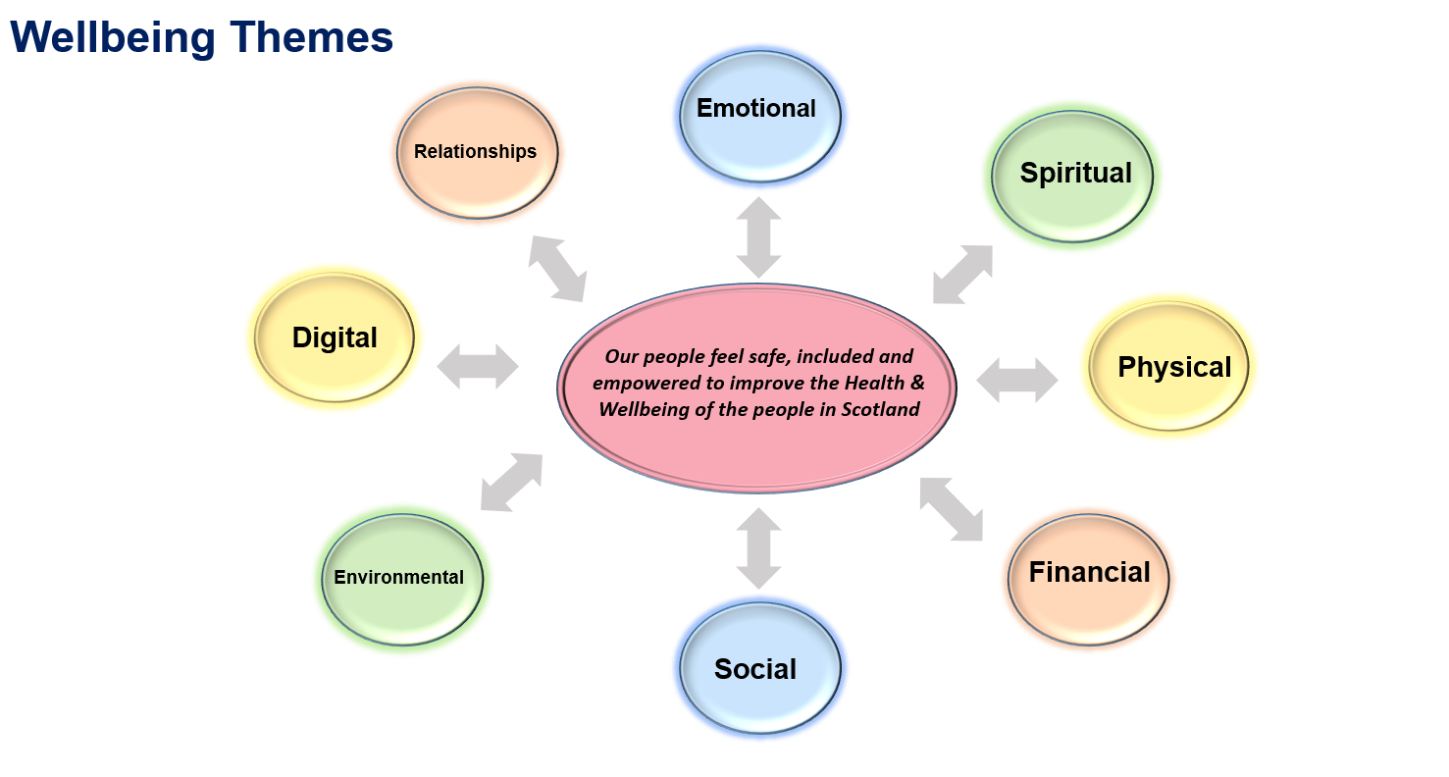
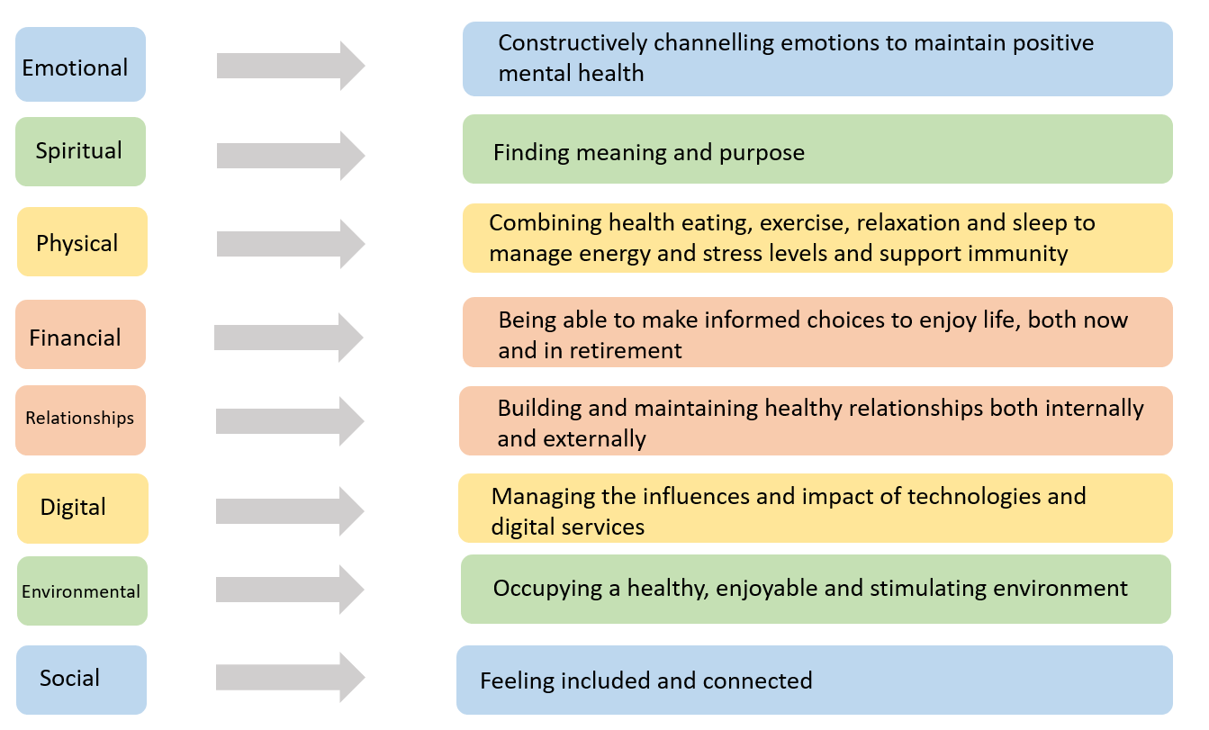
In order to deliver against each of the eight themes, a dedicated staff group will be formed for each theme and led by an SBU Lead. The Executive Sponsor will provide oversight to ensure that the actions within the developed framework are delivered.

The Executive Management Team receive regular reports from HR and the Occupational Health and Safety Advisory Committee on the health, safety and wellbeing of the workforce. They regularly discuss the aspects of wellbeing in relation to delivery of the NSS Business Plans.

Implementation and delivery of The Great Place to Work Plan forms part of the objectives of the Chief Executive, the Director of HR and is included in the objectives of all Directors. The delivery of the plan is overseen by the Executive Management Team and the NSS Partnership Forum. The wellbeing elements of the Great Place to Work Plan are overseen by the NSS Occupational Health and Safety Committee which is chaired by the NSS Employee Director. NSS has a Wellbeing Champion in place.

HR Connect, our staff portal will continue to be utilised and includes support, guidance and links available for all staff at all times. A new NSS Wellbeing Hub was launched on TEAMs in December 2020 which provides staff access to Mental Health First Aiders and a safe space to go should this be required. The Hub also currently signposts staff to the additional support available to them from 2021-22.

The NSS approach to wellbeing will be taken forward to ensure equality and inclusion, flexible working, support and development opportunities for staff and managers. Consideration will be given to best practice and professional guidance.

Equality and Diversity

NSS aims to be a leading organisation for promoting equality, diversity and inclusion within the workplace and in NHS Scotland.
The NSS vision for Equality & Diversity goes beyond establishing processes to achieve change. As part of our interaction with customer and suppliers, we will monitor progress made towards meeting objectives to:
- Encourage diversity and eliminate unfair treatment and discrimination through a full range of human resource and contracting policies and procedures. This applies not just to areas of internal recruitment, training and development and promotion, but also monitoring the adherence to the equality and diversity legislation and principles by our suppliers and contractors.

- Recognise that staff have rights as employees to work in a supportive, safe and harassment free environment and that staff have individual and collective responsibility to value and respect each other’s contributions.

- Promote an environment where standards of conduct are of the highest level and to ensure that no one is harassed, bullied or victimised.

- Take decisive action when discrimination occurs.

As detailed within this plan there are a wide range of workforce demand and supply pressures that need to be planned for. The Action Plan (see Appendix B) which has been aligned to the 5 pillars approach as defined in the NHS Scotland Workforce Strategy is a consolidation of local plans developed around and informed by NSS plans to address strategic issues. It is intended that the NSS Workforce Action Plan will set out those tasks that need to be carried out at NSS level to create and develop the workforce which will be necessary for future service demands.

9.0 Step 4: Three-Year Workforce Projections

The current plan indicates a budgeted workforce of 3,510.66 WTE by 2024/25 with Pay Budget of £181m however it should be noted that this only assumes a 2% pay award, and is still being finalised and is with the exclusion of National Contact Centre (NCC) staff as the future of this workforce is still to be determined. NCC equates to approximately 390.15 WTE.

Overall indicates an increase in workforce of (+40.02) WTE over the three-year planning cycle, approximately 1.14%.

Three Year Workforce Summary

3 Year Workforce Summary by Job Family

The main reduction in workforce will be within the Admin & Clerical Job Family with an overall reduction of 127.39 WTE equivalent of 6.1%. The key area of increase will be within the Nursing & Midwifery Service area with a projected increase of 37.14 WTE (+10.7%).

Job Family | 22/23 WTE | 23/24 WTE | 24/25 WTE
Admin & Clerical | 2329.05 | 2219.63 | 2201.66
Healthcare Sciences | 446.49 | 434.79 | 432.49
Medical & Dental | 52.72 | 52.49 | 53.34
Nursing & Midwifery | 345.13 | 357.55 | 382.27
Other Therapeutic | 5.00 | 5.00 | 5.00
Personal Social Care | 2.00 | 2.00 | 2.00
Senior Managers | 26.00 | 26.00 | 26.00
Support Services | 377.16 | 411.26 | 407.91
Grand Total | 3583.54 | 3508.71 | 3510.66

Please note, our workforce projections are based on current establishment and planning assumptions which were undertaken during October to February of the previous year, and is aligned to our current financial plan. Any projected increase in workforce is subject to appropriate funding being secured. This is particularly relevant within the Nursing & Midwifery Job Family, where this will be addressed through future plans and therefore future projections are likely to change. Support services are also noting an increase, whereby they are seeking to reduce the number of Warehouse Operatives employed via agencies and recruit to more permanent roles.

Breakdown Job Family Band

The table below presents the three-year position for workforce by Service Area and Band.

Job Family | Grade | Baseline Establishment | 22/23 WTE | 23/24 WTE | 24/25 WTE
Admin & Clerical | Band 2-4 | 545.29 | 556.16 | 480.97 | 463.99
Admin & Clerical | Band 5-7 | 1217.41 | 1250.45 | 1224.75 | 1223.75
Admin & Clerical | Band 8-9 | 510.50 | 522.44 | 513.92 | 513.92
Admin & Clerical Total |  | 2273.20 | 2329.05 | 2219.63 | 2201.66
Healthcare Sciences | Band 2-4 | 99.90 | 105.80 | 104.10 | 105.80
Healthcare Sciences | Band 5-7 | 259.49 | 268.69 | 258.69 | 255.69
Healthcare Sciences | Band 8-9 | 69.00 | 72.00 | 72.00 | 71.00
Healthcare Sciences Total |  | 428.39 | 446.49 | 434.79 | 432.49
Medical & Dental | Medical | 49.43 | 52.72 | 52.49 | 53.34
Medical & Dental Total |  | 49.43 | 52.72 | 52.49 | 53.34
Nursing & Midwifery | Band 2-4 | 167.03 | 183.35 | 189.54 | 203.02
Nursing & Midwifery | Band 5-7 | 109.38 | 125.38 | 131.61 | 142.85
Nursing & Midwifery | Band 8-9 | 36.40 | 36.40 | 36.40 | 36.40
Nursing & Midwifery Total |  | 312.81 | 345.13 | 357.55 | 382.27
Other Therapeutic | B 8-9 | 6.00 | 5.00 | 5.00 | 5.00
Other Therapeutic Total |  | 6.00 | 5.00 | 5.00 | 5.00
Personal Social Care | Band 5-7 | 1.00 | 1.00 | 1.00 | 1.00
Personal Social Care | Band 8-9 | 1.00 | 1.00 | 1.00 | 1.00
Personal Social Care Total |  | 2.00 | 2.00 | 2.00 | 2.00
Senior Managers | Other | 25.68 | 26.00 | 26.00 | 26.00
Senior Managers Total |  | 25.68 | 26.00 | 26.00 | 26.00
Support Services | Band 2-4 | 324.47 | 328.50 | 362.60 | 359.25
Support Services | Band 5-7 | 38.66 | 38.66 | 38.66 | 38.66
Support Services | Band 8-9 | 10.00 | 10.00 | 10.00 | 10.00
Support Services Total |  | 373.13 | 377.16 | 411.26 | 407.91
Grand Total |  | 3470.64 | 3583.54 | 3508.71 | 3510.66

Administrative Services
Overall reduction of 71.54 WTE, the main reduction is within Admin & Clerical Band 2-4 indicating a reduction of 81.29 WTE with an indicated increase within Band 5-7 6.34 WTE and 3.42 WTE for band 8-9. This would highlight natural progression within this area.

Healthcare Sciences
Healthcare Sciences presents an overall increase of 4.10 WTE. Increasing Bands 2-4 by 5.9 WTE as well as an increase within Band 8-9 Category of 2.0 WTE. A Reduction within Band 5-7 of 3.8 WTE.

Medical & Dental
Medical & Dental indicates an overall increase of 3.91 over the three-year planning cycle.

Nursing & Midwifery
Nursing & Midwifery projects an overall increase of 69.46 WTE. Band 2-4 equates to +35.99 WTE with Band 5-7 +33.47 WTE.

Support Services
Support Services presents an overall increase of 34.78 WTE all within the Band 2-4 Category. This is likely to reduce the Agency Staffing.

Currently there is no change within Senior Manager Service Area or Personal & Social Care.

Year 1 – 2022/23 indicates an increase in workforce of 112.90 WTE up (+3%) which consists within administrative services (+55.84 WTE) approximately 51% of the overall increase. This is in relation to the TUPE transfer of Payroll Staff with the delivery of the National Payroll Shared Service.

Nursing & Midwifery projected increase is +32.32 WTE in Year 1 accounting for 28% of the total. Healthcare Sciences is approximately 16% of the increase with +18.2 WTE.

Year 2 – 2023/24 highlights a reduction in workforce of -74.8 WTE. In the main this decrease is in relation to a reduction of Administrative Services Staff. Practitioner & Counter Fraud has highlighted a reduction of 64.81 (78%) of this reduction. Digital Services has indicated a reduction of -18.98 WTE equating to 23% of this reduction in workforce.

Year 3 – 2024/25 Workforce Numbers – Job Family

2024/25 presents an overall increase of 1.95 WTE. The main increase within this year is within Nursing Service Area with an overall increase projected of 24.72 WTE. Reduction of a further -17.97 Administrative Staff as well as -3.35 WTE Support Services workforce and -2.3 WTE within Healthcare Sciences summaries the change in Year 3.

10.0 Step 5: NSS 5 Pillars Action Plan

Our workforce journey describes the key activities and actions we are taking as an organisation to address the workforce challenges identified from both within this plan, and from our local SBU workforce plans. We have taken the key activities to help inform our overall NSS 5 Pillars action plan (see Appendix B). The final section of this plan advises how we intend to implement and monitor delivery of the identified actions.

11.0 Step 6: Implement, Monitor and Refresh

The actions outlined in the NSS 5 Pillars action plan will be monitored and reported throughout the three-year cycle to the appropriate NSS Board governance committees and Executive Management Team.

In order to monitor progress against actions as set out in this plan, this will also be undertaken via the following methods:

- HR People Report which monitors key workforce performance targets monthly.
- Mid-Year and End of Year Reviews which measure key workforce objectives.
- Quarterly progress updates from Subject Matter Experts on actions identified in Appendix A.
- Regular updates and reporting via NSS Plans – Operational Plan (Recover and Remobilise), NSS Annual Delivery Plan.
- The Annual iMatter Webropol report which will provide the final outcomes of the iMatter survey (we typically use iMatter survey targets and measures to determine staff experience and performance against the staff governance standard and linked to our Great Place to Work Plan).
- Scottish Government Staff Governance Monitoring Report.
- Regular review of an update on actions via the HR Senior Management and Operational Management team.

Specialist Reporting Agency status allows CFS to report criminal cases directly to Crown Office and Procurator Fiscal Service.

