Document Title: | NHSS Procurement Community Benefit Gateway: Guidance for 3rd Sector Organisations
Document Ref: | STS703-003
Department: | Strategic Sourcing
Approval: | Refer to Q-Pulse

Table of Contents:

1. Introduction 3
2. Background 3
3. How does it work? 4
4. How do I enter a need? 5
5. Review stage 8
6. Receiving a bid 8
7. Delivery phase and closure 9
8. Appendix A – Community Benefit definition 10
9. Definitions 11
10. Associated Documented Information 11
11. Document Revision History 11

Introduction
Please note this guidance is designed for 3rd Sector Organisations: defined as; -
Third Sector: The third sector includes community groups, voluntary organisations, charities, social enterprises, co-operatives and individual volunteers that exist wholly or mainly to provide benefits for society or the environment.

In September 2021 NHS National Procurement, a division of NHS National Services Scotland in conjunction with the NHSScotland Procurement community launched the Community Benefits Gateway; an online space at https://nhsnss.service-now.com/community_benefit to connect community needs with NHSScotland suppliers in order to identify true community needs and help deliver against them.
It should be noted that the Gateway itself is not a funding platform and should not be viewed as such, thus, it would be recommended third sector organisations to avoid using direct request for funding and/or financial support when submitting their ‘needs’; that said there may be offers of funding that suppliers may make against specific needs.

Background
Public procurement has a responsibility to support its local communities through its contract spend and is obligated to deliver benefits through public procurement regulations. One of the main routes that we achieve this is through Community Benefits. These could be local initiatives that support the social or environmental wellbeing of a local area. We include the need for community benefits delivery in most of our contracts. However, much of the time we do not have a fixed idea of what these benefits are at the time we award these contracts, so we know there is a gap.
The Community Benefits Gateway is our solution to get the community benefit ‘needs’ from those organisations who are best placed to identify them; 3rd Sector Organisations. The third sector includes community groups, voluntary organisations, charities, social enterprises, co-operatives that exist wholly or mainly to provide benefits for society or the environment. These organisations can submit a need and we will encourage our suppliers to bid against the need and support its delivery.

How does it work?
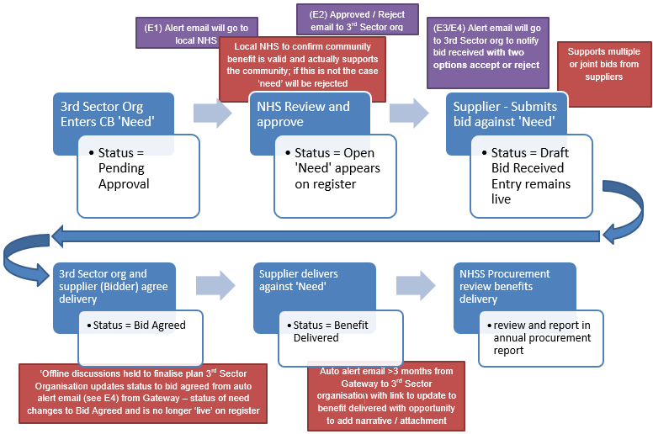
Figure 1 Gateway Process Flow

EMAILS:
E1 – Alert to Local NHS Triage – “Please note a new community need <sys generated #> has been submitted for approval. Can you review and approve or reject the submission? If you are rejecting the submission a reason will be required to be entered into appropriate field that will be issued to the community organisation.
E2 - Approved / Reject email to 3rd Sector org – If Approved – “Congratulations! Your submission of need has been accepted on to the Gateway and is now available for viewing and possible bids from our supplier base, please look out for potential bid notification alerts from suppliers”.
If rejected – “Unfortunately your submission of need has been rejected, this is due to <text from appropriate field>, please respond to this email if you need further clarification”.

E3 – Supplier confirmation – “Congratulations! Your bid has been submitted to <community org name> in support of <sys generated #>, a representative from <community org name> should be in touch soon to discuss your bid.
E4 – 3rd Sector Org Alert – “Hi, please be aware a supplier has bid against your need. Bid & contact details are as follows; <detail from supplier bid>
Please review the bid and contact the bidder to agree the next steps. Important! Your ‘need’ will remain visible on the register until you agree a bid which means other suppliers may also bid against your need.
If you agree to the bid, you will need to click the Accept button below as this will remove your need from the register and maintain the correct status of your need within the system. If you do not agree to the bid, please click the ‘Reject’ button which will keep your need visible on the register. Accept & Reject buttons.
E5 - Reminder email to 3rd Sector Org and Supplier – An email will be sent to you after 3 and 6 months to confirm if the benefit has been delivered and with link to a feedback form to give you the opportunity to provide feedback.

How do I enter a need?
It’s very simple! First though your organisation will have to register – by navigating to https://nhsnss.service-now.com/community_benefit and completing the registration form. Similar to other online platforms, you will receive a confirmation email with a temporary password. Go back to the Gateway’s page, introduce the temporary password and then the system will prompt you to create a new one of your choice.
HINT: We would suggest that a generic email address is added to ensure any alerts are not reliant on any one individual.
Once you register you will see a screen to the following (Figure 2);
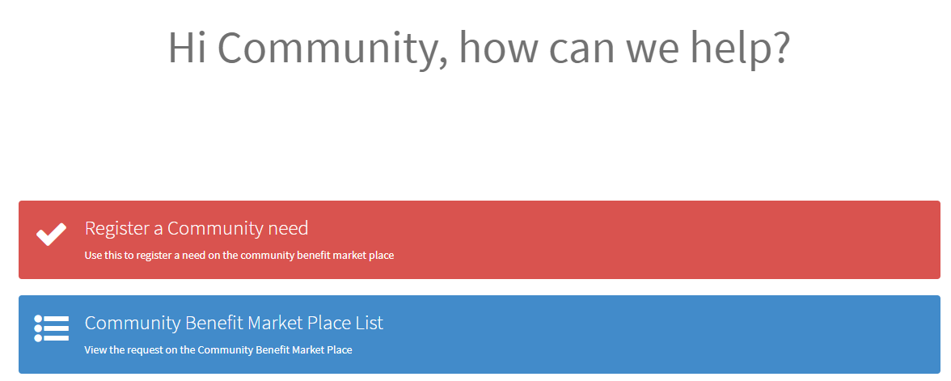
Figure 2 Main Screen
Click on the red bar to enter your ’need’. The Gateway form will appear; the fields are as follows;
Field | Field Type | Description
Name | Auto insertion from registration details
Organisation | Auto insertion from registration details
Organisation details | Free text | Please provide a brief description of your organisation's profile (i.e. activities, mission, goals).
Location | Dropdown List (single choice) | Please select the Health Board area where the project is located
Project Name / Title | Free text | Please provide the name of your project/community need.
Project Aim(s) / Specifics of support needed | Free text | Please enter a summary of what your project is aiming to achieve and detail of what your proposed community need is
Beneficiaries | Dropdown List (multi choice) | Specific groups whom you believe will directly benefit from your project
Support Category | Dropdown List (multi choice) | What benefit to the local community will the project return
What evidence is there to support the need for your project? | Free text | Summary of your knowledge of available evidence
What impact will your project have? | Free text | Summary of overarching impact
How will you measure the success of your project? | Free text | Can you identify any measures i.e. number of people supported?
Project Target Start Date | Date Field | Select date when you would like project to start
Project Target Delivery | Date Field | When do you hope to complete
Project Delivery Deadline Date (if applicable) | Date Field | Is there an absolute end date when the project must be completed
Project Location (Postcode) | Postcode Field | Delivery location for reporting purposes mandatory field.
Table 1 Entry form Fields

At the bottom of the form there is the option to add attachments, where you can add more detail about your organisation and the project, the free text fields in the table relating to the project can reference the attachment if required.
Click submit and…that is it!

HINT: When describing the support required, try to keep it simple and clear for what you are asking for and if possible, provide examples (i.e., equipment, volunteers, mentoring opportunities, etc.).
And remember, the Gateway is not a funding platform, therefore, when submitting your need try to avoid using direct request for funding and/or financial asks.
! Please note that if a need has reached 1 year on the Gateway it will be removed from the site. You will receive an email alerting of your ‘need’ being removed and you will be able to submit a replacement ‘need’ if you wish so.

Review stage
After you submit your need your local public health or procurement team will review the need to ensure it aligns with local or national health improvement priorities. We aim to have your need reviewed within a few days of submission. See appendix A for further detail on community benefits.
If approved, you will receive a notification similar to the following;
“Congratulations! Your submission of need has been accepted on to the Gateway and is now available for viewing and possible bids from our supplier base, please look out for potential bid notification alerts from suppliers”.
You will be able to see your need on the register by returning to the landing page in Figure 2 and clicking the blue bar.
If rejected, you will receive a notification similar to the following:
“Unfortunately, your submission of need has been rejected, this is due to <reason from reviewer>, please respond to this email if you need further clarification”.

Receiving a bid
Once your need has been approved it will appear on the Gateway register and will be available for NHSS suppliers to review and, possibly submit a bid to meet your need.
If a supplier decides to bid against your need as detailed in Figure 1 you will receive a notification by email to the email address registered in the system. Which will be similar to the following:
“Hi, please be aware a supplier has bid against your need. Bid & contact details are as follows; <detail from supplier bid>
Please review the bid and contact the bidder to agree the next steps. Important! Your ‘need’ will remain visible on the register until you agree a bid which means other suppliers may also bid against your need.
If you agree to the bid, you will need to click the ‘Accept’ button below as this will remove your need from the register and maintain the correct status of your need within the system. If you do not agree to the bid, please click the ‘Reject’ button which will keep your need visible on the register.
Note clicking ‘Accept’ will open up an email link, simply click send on this email to trigger the status update.
The email itself will have two links or buttons to either accept or reject the bid. It is important that you engage with the supplier who has bid to understand their offer fully and to decide whether you wish to accept. If you accept you must click the accept button or link in the email to remove your requirement from the register and to move the project into ‘Bid Accepted’ status. If you do not accept, please click the reject button to keep your need on the register for other potential bids. If it is a partial bid, you may defer clicking the buttons and await additional bids to completely fulfil your need.
! It is important that you initiate the contact with the supplier in order to negotiate the terms of the bid (e.g., discuss the offer from supplier, dates, milestones…etc.). If you experience issues in getting back to the supplier, please click the “Need Assistance?” button at the top of the Gateway page and a member of the CB Gateway National Team will be back in touch with you.
After agreement, you and the supplier can move into delivery phase.

Delivery phase and closure
Our expectation is that you and your chosen supplier will work together to deliver against the need and to hopefully meet your timescales. However, in order to maintain integrity of the Gateway we must ensure that projects are finalised. To this end an automated email will be sent to you after 3 months and 6 months to allow you to enter a completion note. The email will look something like this:
“Hi, as it’s been 3/6 months since you agreed the supplier bid, just a reminder for you to update the outcome of your need as follows:
1) Please reply to nss.combenstriage@nhs.scot informing of whether Outcome successful or Not yet completed or Unsuccessful Outcome and add some additional detail to inform NHSS of the outcome of your project and
2) Additionally, if the outcome of your project has been successful, please complete the attached form as we would love to hear about your experience using the Community Benefits Gateway. Your feedback helps us create a better experience for other organisations using the portal.”
Clicking the button or link will take you to a form where you can enter some additional detail to inform NHSS of the outcome of your project.
It is very important that you confirm the delivery of the community need – including if there have been any changes to the nature of ‘need’ request – and complete the form; this allows NHSS to understand what has been achieved and where benefits have been delivered.

Appendix A – Community Benefit definition
What do we mean when we talk about community benefits?
Specifically, we are talking about improving the economic, social, and environmental wellbeing of our local area.
What is wellbeing?
- economic factors such as the availability of suitable and high quality jobs, measures to encourage local small businesses, efficient and effective transport links, lifelong learning, training and skills development, the provision of infrastructure and new information and communication technologies, etc.;
- social factors such as the promotion of good quality and affordable housing, safe communities, the encouragement of the voluntary sector, looking after the needs of children and young people (particularly the most vulnerable), access to the arts or leisure opportunities, access to education, etc.;
- health-related factors such as the promotion of good physical, social and mental health and developing and promoting policies which have a positive impact on health outcomes, especially on health inequalities;
- environmental factors such as the availability of clean air, clean water, clean streets, the quality of the built environment, the removal of objects considered hazardous to health, removal of disfiguring or offensive graffiti from buildings, protecting communities against the threat of climate change, freedom from a high risk of flooding, improving and promoting biodiversity and accessibility to nature.
In addition to the established benefits listed above other benefits include:
  - supply chain development;
  - community engagement events; and
  - professional advice to communities
Specifically, for NHS Scotland there is a general duty to improve the health of the population of Scotland, it is likely that measures that are seen to improve public health will be highly regarded in any assessment. These may include for instance seeking to improve employment opportunities for the population at risk of ill health (including: young people; those with a disability; and long-term unemployed).

Definitions

NHSS |  | NHSScotland

Associated Documented Information

Document Ref Document Title

Document Revision History

For activation dates, refer to Q-Pulse.
Version | Description of Amendments
1 | Created to provide guidance and uploaded onto Q-Pulse
2 | Hyperlink edited in section 4 as it was incorrectly linking to the test site
3 | Replacing references to marketplace with gateway
4 | Added note to section 6
5 | Grammatical amendments
6 | Updated text

