Document Title: | NHSS Procurement Community Benefit Gateway: Guidance for Suppliers / Bidders
Document Ref: | STS703-004
Department: | Strategic Sourcing
Approval: | Refer to Q-Pulse

Table of contents
1. Introduction 3
2. Background 3
3. How does it work? 4
4. How do I view the needs? 5
5. Placing a bid 7
6. Delivery phase and closure 8
7. Appendix A – Community Benefit definition 8
8. Definitions 10
9. Associated Documented Information 10
10. Document Revision History 10

Introduction
In September 2021 NHS National Procurement, a division of NHS National Services Scotland in conjunction with the NHSScotland Procurement community launched the Community Benefits Gateway; an online space at https://nhsnss.service-now.com/community_benefit to connect community needs with NHSScotland suppliers in order to identify true community needs and help deliver against these needs.
It should be noted that the Gateway itself is not a funding platform and should not be viewed as such, that said there may be offers of funding that suppliers may make against specific needs.

Background
Public procurement has a responsibility to support its local communities through its contract spend and is obligated to deliver benefits through public procurement regulations. One of the main routes that we achieve this is through Community Benefits. These could be local initiatives that support the social or environmental wellbeing of a local area. Under our obligations as part of the Sustainable Procurement Duty we include the need for community benefits delivery in most of our contracts. However, much of the time we do not have a fixed idea of what these benefits are at the time we award these contracts, so we know there is a gap. Where we are clear on the community benefit to be delivered, this will be detailed in the tender documents.
The Community Benefits Gateway is our solution to get the community benefit ‘needs’ from those organisations who are best placed to identify them; the 3rd Sector organisations. Third Sector: The third sector includes community groups, voluntary organisations, charities, social enterprises, co-operatives that exist wholly or mainly to provide benefits for society or the environment. These organisations can submit a need and we will encourage you as our suppliers to bid against the need and support its delivery as part of your contractual obligations.

How does it work?
Approved community benefit ‘needs’ will appear on the register (to find out more about community benefits please see Appendix A – Community Benefit definition The flowchart on the following page presents an overview of the process.

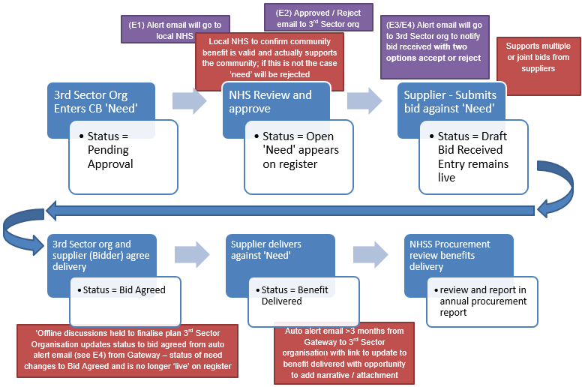
Figure 1 Gateway Process Flow

EMAILS:
E1 – Alert to Local NHS Triage – “Please note a new community need <sys generated #> has been submitted for approval. Can you review and approve or reject the submission? If you are rejecting the submission a reason will be required to be entered into appropriate field that will be issued to the community organisation”.
E2 - Approved / Reject email to 3rd Sector org – If Approved – “Congratulations! Your submission of need has been accepted on to the Gateway and is now available for viewing and possible bids from our supplier base, please look out for potential bid notification alerts from suppliers”.
If rejected – “Unfortunately your submission of need has been rejected, this is due to <text from appropriate field>, please respond to this email if you need further clarification”.
E3 – Supplier confirmation – “Congratulations! Your bid has been submitted to <community org name> in support of <sys generated #>, a representative from <community org name> should be in touch soon to discuss your bid”.
E4 – 3rd Sector Org Alert – “Hi, please be aware a supplier has bid against your need. Bid & contact details are as follows; <detail from supplier bid>”.
Please review the bid and contact the bidder to agree the next steps. Important! Your ‘need’ will remain visible on the register until you agree a bid which means other suppliers may also bid against your need.
If you agree to the bid, you will need to click the Accept button below as this will remove your need from the register and maintain the correct status of your need within the system. If you do not agree to the bid, please click the ‘Reject’ button which will keep your need visible on the register. Accept & Reject buttons.
E5 - Reminder email to 3rd Sector Org and Supplier – An email will be sent to you after 3 and 6 months to confirm if the benefit has been delivered and with link to a feedback form to give you the opportunity to provide feedback.

How do I view the needs?
It’s very simple! First your organisation will have to register on the Gateway – by navigating to https://nhsnss.service-now.com/community_benefit and completing the registration form. Similar to other online platforms, you will receive a confirmation email with a temporary password. Go back to the Gateway’s page, introduce the temporary password and then the system will prompt you to create a new one of your choice.
Once you register you will see a screen similar to the following (Figure 2);
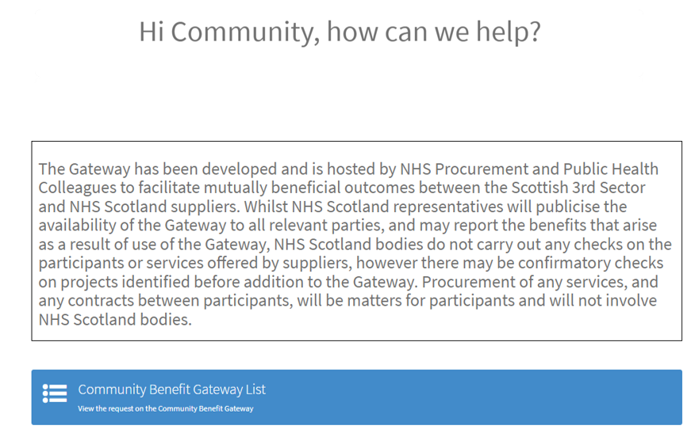
Figure 2 Main Screen

Click on the blue bar shown above to view the Gateway register of community needs. Which will appear as follows (Figure 3);
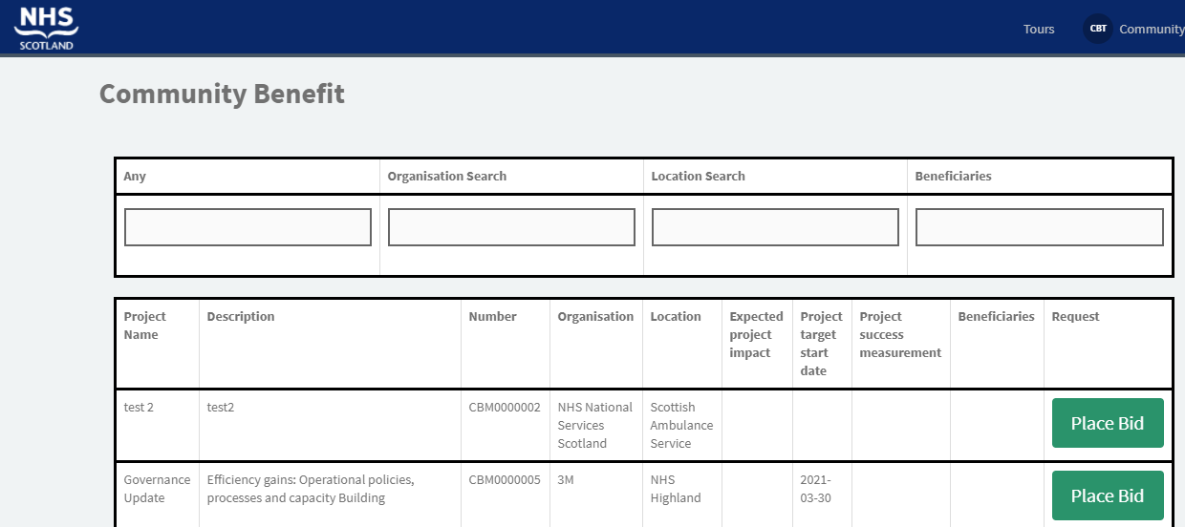
Figure 3 Community Benefit Gateway Register
As shown above, you can scroll through the entire list or you can use the filter boxes at the top of the register to refine your search.

Placing a bid
Once you identify a need that you are interested in supporting, click, ‘Place Bid’. A bid form will appear with the following fields:
Field | Field Type | Description
Name | Auto insertion from registration details
Project ID | Auto insertion from bid selection
Reason for selection | Dropdown List (single choice) | Please select the reason from the list
Outline of offer | Free text | Please summarise your offer against the need for the community organisation to review
Offer expiry date | Date Field | Please enter a date of expiry of your offer
Related contract or tender | Free text | Important that this is accurate to enable NHSS Procurement teams to link to contract or tender offer
Lead name | Free text | Important to enter as details will be sent to community organisation to contact you
Telephone | Free text | Important to enter as details will be sent to community organisation to contact you
Email | Free text | Important to enter as details will be sent to community organisation to contact you
Table 1 "Bid" Entry Form
After you submit your bid, an alert will go to the community organisation that placed the need. They will then review and should contact you using the contact information on the form in Table 1.
If you have not heard from the 3rd sector organisation after a week of placing your bid, please click the “Need Assistance?” link at the top of the Gateway page and a member of the CB Gateway National Team will be back in touch with you.
If you both come to agreement the community organisation will update the status of the project to ‘Bid Agreed’ and the requirement will be removed from the register. If you do not come to an agreement the bid will be rejected by the community organisation and the requirement will remain on the register for other potential bids. If your bid is a partial bid, the community organisation may defer accepting the bid and await additional bids to completely fulfil the need, however this should hopefully not stop the progress of your bid.
After agreement, you and the community organisation can move into delivery phase.

Delivery phase and closure
Our expectation is that you and your chosen community organisation will work together to deliver against the need and to hopefully meet the timescales outlined in the original ‘need’. However, in order to maintain integrity of the Gateway we must ensure that projects are finalised. Thus, after a certain time that the bid was agreed with the community organisation, an automated email will be sent to you saying something like this:
“Hi, as it’s been 3/6 months since you placed your bid, just a reminder for you to update the outcome of the bid as follows:
1) Please reply to nss.combenstriage@nhs.scot informing of whether Outcome successful or Not yet completed or Unsuccessful Outcome and add some additional detail to inform NHSS of the outcome of your bid and negotiation process
2) Additionally, if the outcome of the project has been successful, please complete the attached form as we would love to hear about your experience using the Community Benefits Gateway. Your feedback helps us create a better experience for other organisations using the portal.”

Clicking the link will take you to a form where you can enter some additional detail to inform NHSS of the outcome of your support.
It is important that you complete the feedback form, as it allows NHSS to understand what has been achieved and where benefits have been delivered and to verify that you, as a diligent and valued supplier, have been delivering against your community benefit commitments.

Appendix A – Community Benefit definition
What do we mean when we talk about community benefits?
Specifically, we are talking about improving the economic, social, and environmental wellbeing of our local area.
What is wellbeing?
- economic factors such as the availability of suitable and high quality jobs, measures to encourage local small businesses, efficient and effective transport links, lifelong learning, training and skills development, the provision of infrastructure and new information and communication technologies, etc.;
- social factors such as the promotion of good quality and affordable housing, safe communities, the encouragement of the voluntary sector, looking after the needs of children and young people (particularly the most vulnerable), access to the arts or leisure opportunities, access to education, etc.;
- health-related factors such as the promotion of good physical, social and mental health and developing and promoting policies which have a positive impact on health outcomes, especially on health inequalities;
- environmental factors such as the availability of clean air, clean water, clean streets, the quality of the built environment, the removal of objects considered hazardous to health, removal of disfiguring or offensive graffiti from buildings, protecting communities against the threat of climate change, freedom from a high risk of flooding, improving, and promoting biodiversity and accessibility to nature.
In addition to the established benefits listed above other benefits include:
- supply chain development;
- community engagement events; and
- professional advice to communities
Specifically, for NHS Scotland there is a general duty to improve the health of the population of Scotland, it is likely that measures that are seen to improve public health will be highly regarded in any assessment. These may include for instance seeking to improve employment opportunities for the population at risk of ill health (including: young people; those with a disability; and long-term unemployed).

Definitions

NHSS |  | NHS Scotland

Associated Documented Information

Document Ref Document Title

Document Revision History

For activation dates, refer to Q-Pulse.
Version | Description of Amendments
1 | Created to provide guidance and uploaded onto Q-Pulse
2 | Updated to remove references to marketplace and refer to gateway
3 | Grammatical amendments
4 | Updated text

