Document Title: | NHSS Procurement Community Benefit Gateway: Guidance for Health Board Triage Owners
Document Ref: | STS703-005
Department: | Strategic Sourcing
Approval: | Refer to Q-Pulse

Table of Contents:

1. Introduction 3
2. Background 3
3. How does it work? 4
4. How do review a need? 5
5. Housekeeping 9
6. Appendix A – Community Benefit definition 9
7. Definitions 11
8. Associated Documented Information 11
9. Document Revision History 11

Introduction
Please note this guidance is designed for Health Board Triage owners, whose role it is to review and approve or reject submissions to the Community Benefit Gateway from 3rd Sector Organisations: defined as; -
Third Sector: The third sector includes community groups, voluntary organisations, charities, social enterprises, co-operatives and individual volunteers that exist wholly or mainly to provide benefits for society or the environment.

In September 2021 NHS National Procurement, a division of NHS National Services Scotland in conjunction with the NHSScotland Procurement community launched the Community Benefits Gateway; an online space at https://nhsnss.service-now.com/community_benefit to connect community needs with NHSScotland suppliers in order to identify true community needs and help deliver against them.
It should be noted that the Gateway itself is not a funding platform and should not be viewed as such, that said there may be offers of funding that suppliers may make against specific needs. It would be recommended for third sector organisations to avoid using direct request for funding and/or financial support when submitting their ‘needs’.

Background
Public procurement has a responsibility to support its local communities through its contract spend and is obligated to deliver benefits through public procurement regulations. One of the main routes that we achieve this is through Community Benefits. These could be local initiatives that support the social or environmental wellbeing of a local area. We include the need for community benefits delivery in most of our contracts. However, much of the time we do not have a fixed idea of what these benefits are at the time we award these contracts, so we know there is a gap.
The Community Benefits Gateway is our solution to get the community benefit ‘needs’ from those organisations who are best placed to identify them; 3rd Sector Organisations. The third sector includes community groups, voluntary organisations, charities, social enterprises, co-operatives that exist wholly or mainly to provide benefits for society or the environment. These organisations can submit a need and we will encourage our suppliers to bid against the need and support its delivery.

How does it work?
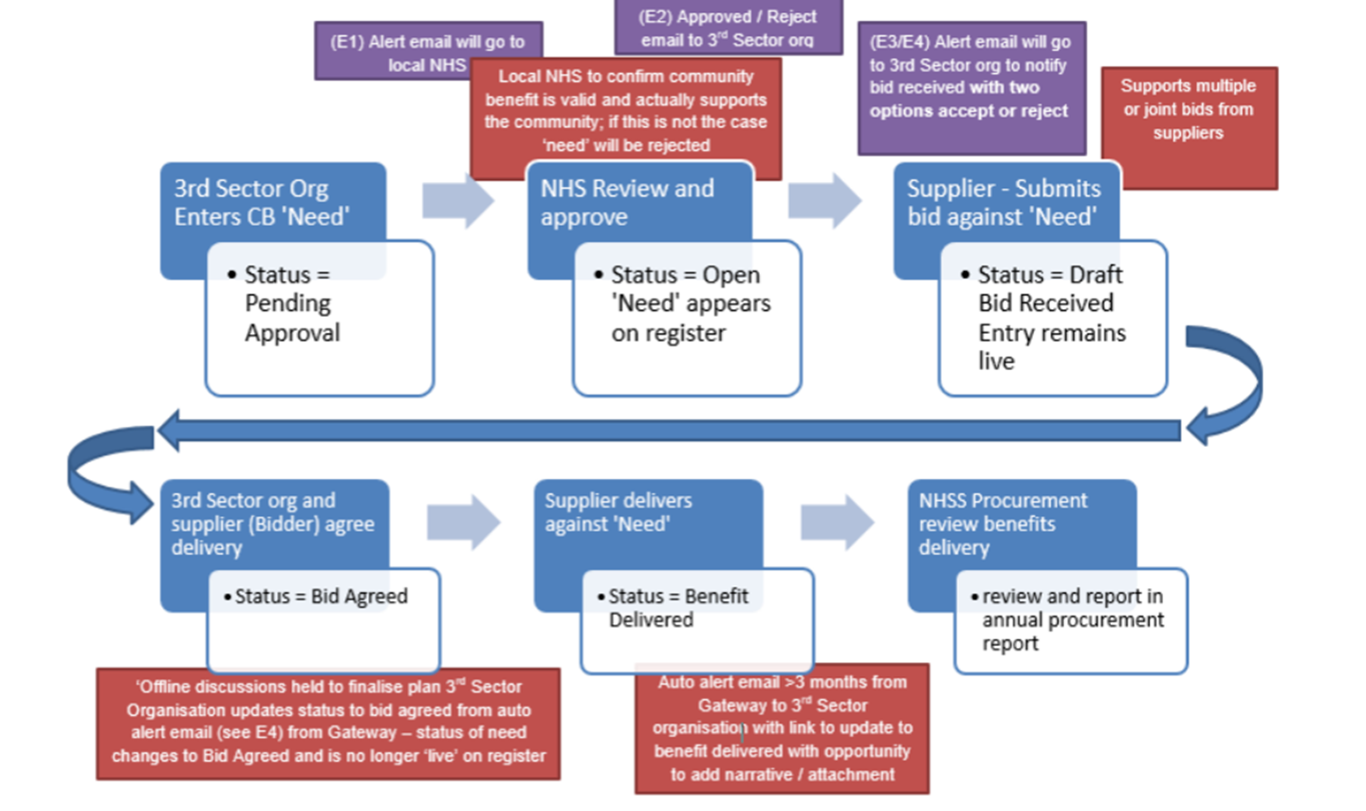
Figure 1 Gateway Process Flow

EMAILS:
E1 – Alert to Local NHS Triage – “Please note a new community need <sys generated #> has been submitted for approval. Can you review and approve or reject the submission? If you are rejecting the submission a reason will be required to be entered into appropriate field that will be issued to the community organisation.
E2 - Approved / Reject email to 3rd Sector org – If Approved – “Congratulations! Your submission of need has been accepted on to the Gateway and is now available for viewing and possible bids from our supplier base, please look out for potential bid notification alerts from suppliers”
If rejected – “Unfortunately your submission of need has been rejected, this is due to <text from appropriate field>, please respond to this email if you need further clarification”

E3 – Supplier confirmation – “Congratulations! Your bid has been submitted to <community org name> in support of <sys generated #>, a representative from <community org name> should be in touch soon to discuss your bid.
E4 – 3rd Sector Org Alert – “Hi, please be aware a supplier has bid against your need. Bid & contact details are as follows; <detail from supplier bid>
Please review the bid and contact the bidder to agree the next steps. Important! Your ‘need’ will remain visible on the register until you agree a bid which means other suppliers may also bid against your need.
If you agree to the bid, you will need to click the Accept button below as this will remove your need from the register and maintain the correct status of your need within the system. If you do not agree to the bid, please click the ‘Reject’ button which will keep your need visible on the register. Accept & Reject buttons.
E5 - Reminder email to 3rd Sector Org and Supplier – An email will be sent to you after 3 and 6 months to confirm if the benefit has been delivered and with link to a feedback form to give you the opportunity to provide feedback.

How do review a need?

Suitability of Needs
NHS Scotland makes it clear to 3rd Sector Organisations at the ‘need entry’ stage that needs must align to our values. All organisations will see the following statement before proceeding to enter their need.
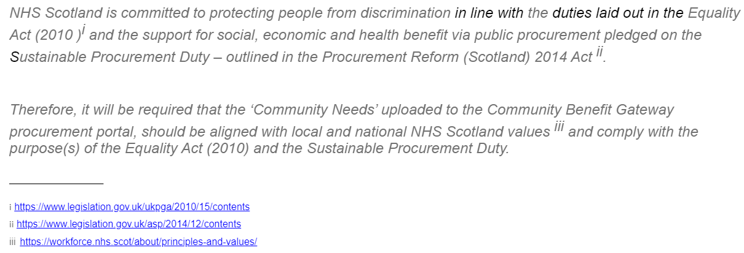
Figure 2 NHSS Values Statement
! NHSS Disclaimer – We have inserted a statement on the main Gateway page making it clear that any arrangements, contractual or otherwise are between the supplying organisation and the 3rd sector organisation who have placed the need on the Gateway. NHS Scotland will play no part in the relationship between the two parties.

Reviewing a need from an alert

Firstly, you will need to be added to your Health Board’s Triage group; this can be requested via email to nss.combenstriage@nhs.scot
! Note: There is no limit on the number of people that could be part of your HB triage group. However, please bear in mind that if the group is too large, this might affect the turnaround timings of the decision process to accept / reject a submitted ‘need’. Please do communicate any changes to the individuals that are form your triage group to nss.combenstriage@nhs.scot
Your Health Board may also choose to have a shared mailbox where the alert email – denoted as E1 in the previous section – is sent, or by individual email from a group of staff. The email alert will appear as follows as soon as a need for your Health Board area is submitted:
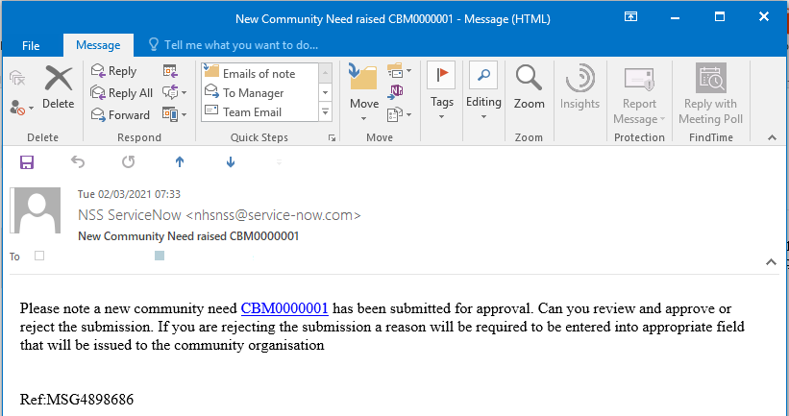
Figure 3 Alert Email
Click on the link in the email starting with, “CBM” to navigate to the review and approvals page;
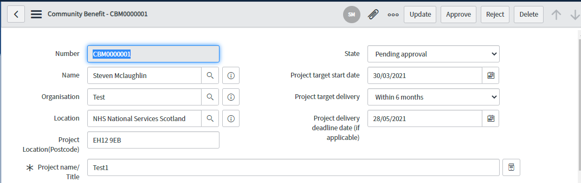
Figure 4 Community Benefit Triage Review Form
The full submission should be reviewed against the guidance presented in Appendix A,
If the submission is to be rejected the triage owner should select the ‘State’ dropdown circled above and select ‘Rejected’, a new field, ‘Reject Reason’ will appear as follows;
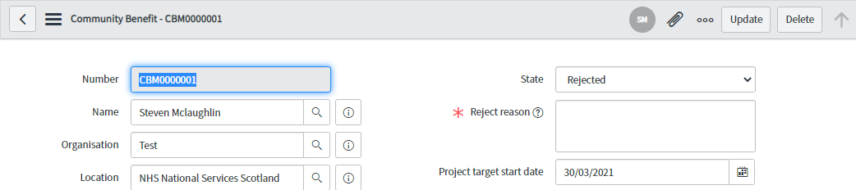
Figure 5 Entering a reason for rejection

The Triage owner should enter the reasons in this field the click the update button on the top right hand corner of the form. The reasons are then included as part of the rejection email to the submitting 3rd Sector Organisation; denoted as E2 in the previous section.
If the decision is to approve the submission, simply click the approve button at the top of the form and an associated ‘Success’ email denoted as E2 in the previous section will be sent to the submitting 3rd Sector Organisation advising them of the outcome. Their need will now appear on the register.
It is recommended for the triage group members to reach a decision of approval / rejection within a week since the submission of the ‘need’.
! If a ‘need’ has been ‘pending for approval’ for more than 10 days, the National team may assess the ‘need’ and approve / reject on your behalf taking into consideration the request and your local priorities.

Accessing the list of needs
If you are named i.e., you have submitted your organisational email address on the triage group list you will have direct access (via the portal’s backend) to all of the needs within the Gateway as follows:
- If NHSS you can access through this link: https://nhsnss.service-now.com/
- If non-NHSS you should use this link https://nhsnss.service-now.com/login.do then navigate using the left hand bar to the community benefit list as follows.

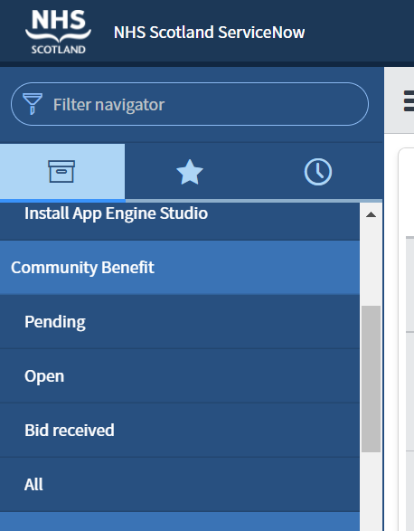
Figure 6 Backend access to Community Benefit List

Start by clicking Community Benefit to expand the list, then select any of the states to access those needs of interest, clicking all will then list all of the needs to date.
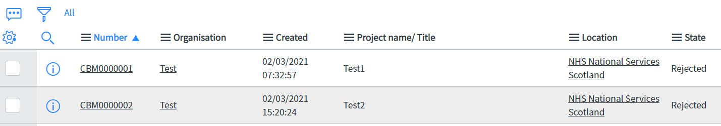
Figure 7 List of 'Needs' by All
Simply select the ‘CBM’ number of interest to access the record. Once in the record you can review the entry and status, you can also view any supplier bids associated with the record by scrolling down the page;
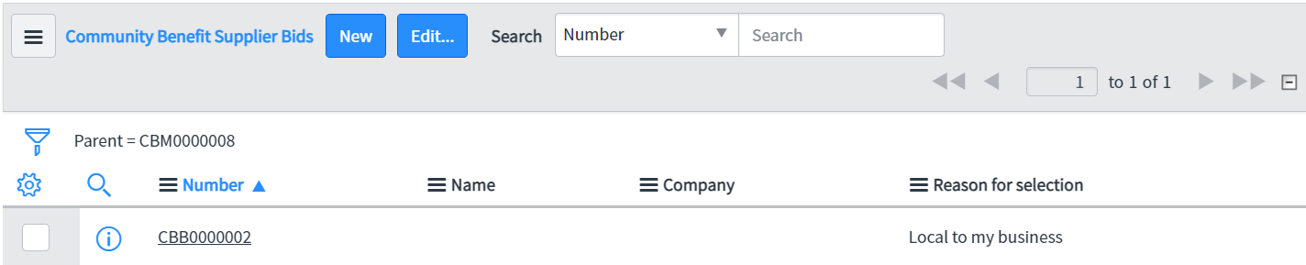
Test Supplier

Test Supplier
Figure 8 Supplier bids associated with record
This access also supports amendment and update of records although care needs to be taken to ensure the integrity of the record remains intact. ‘New’ records can also be added on behalf of 3rd Sector / supplier if necessary, although it is advised that this is best left to these parties.

Housekeeping
As detailed in the flowchart in, Figure 1 Gateway Process Flow an email l will be sent to the submitting 3rd Sector Organisation to ask if the benefit has been delivered; denoted as E5 email in section 3. It is quite important for the integrity of the Gateway that we have a closed loop process, as these benefits are subject to reporting within Health Board Annual Procurement reports. Therefore, reports will be set up for each Health Board Triage group to confirm that all benefits entered and agreed have reached an end stage for reporting.
! Please note that if a need has reached 1 year on the Gateway it will be removed from the site. The 3rd Sector Organisation will receive an email alerting them of their ‘need’ being removed and they will be informed that they can raise a replacement ‘need’ if they wish so.

Appendix A – Community Benefit definition
What do we mean when we talk about community benefits?
Specifically, we are talking about improving the economic, social, and environmental wellbeing of our local area.
What is wellbeing?
- economic factors such as the availability of suitable and high quality jobs, measures to encourage local small businesses, efficient and effective transport links, lifelong learning, training and skills development, the provision of infrastructure and new information and communication technologies, etc.;
- social factors such as the promotion of good quality and affordable housing, safe communities, the encouragement of the voluntary sector, looking after the needs of children and young people (particularly the most vulnerable), access to the arts or leisure opportunities, access to education, etc.;
- health-related factors such as the promotion of good physical, social and mental health and developing and promoting policies which have a positive impact on health outcomes, especially on health inequalities;
- environmental factors such as the availability of clean air, clean water, clean streets, the quality of the built environment, the removal of objects considered hazardous to health, removal of disfiguring or offensive graffiti from buildings, protecting communities against the threat of climate change, freedom from a high risk of flooding, improving and promoting biodiversity and accessibility to nature.

In addition to the established benefits listed above other benefits include:
  - supply chain development;
  - community engagement events; and
  - professional advice to communities

Specifically, for NHS Scotland there is a general duty to improve the health of the population of Scotland, it is likely that measures that are seen to improve public health will be highly regarded in any assessment. These may include for instance seeking to improve employment opportunities for the population at risk of ill health (including: young people; those with a disability; and long-term unemployed).

Definitions

NHSS |  | NHSScotland

Associated Documented Information

Document Ref Document Title

Document Revision History

For activation dates, refer to Q-Pulse.
Version | Description of Amendments
1 | Created to provide guidance and uploaded onto Q-Pulse
2 | Removal of references to marketplace replacing them with gateway
3 | Grammatical amendments
4 | Content update
5 | Content update

