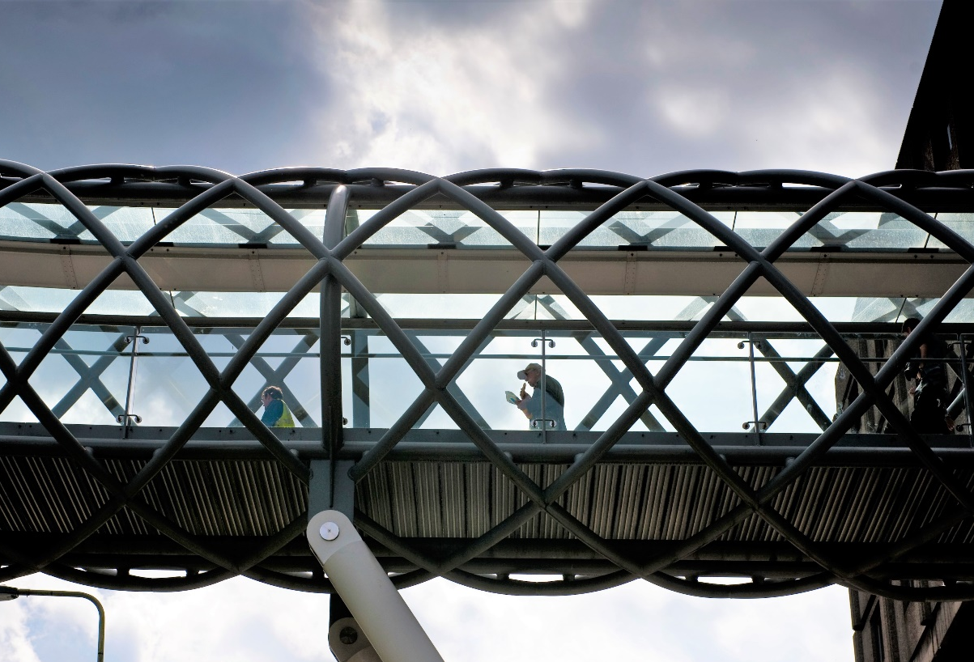
NHS Scotland Assure Information Management System (AIMS)

AIMS Implementation

Did you know that NHS Scotland Assure have rolled out a digital estate tool for the whole of NHS Scotland?
AIMS is a digital repository for NHS health boards’ physical buildings making it easy for boards to search, retrieve and make sense of their existing information.
This information can include manuals, warranties and computer-aided design (CAD) drawings and with AIMS integrating into other national systems, it will show backlog maintenance data for a building such as a hospital or health centre.
At critical times, this dynamic single source of data gives fast access to relevant and reliable information. This will save time, be cost effective, efficient and can offer assurance at all stages of a building’s lifecycle.
Before AIMS, there was no single centralised source of truth for built environment information. Data was available, often on many different devices such as CDs or local servers. A lack of indexing made it hard to find specific data when needed and sharing data could be complex and difficult to manage.
Louise Gardiner’s Digital Estate and Asset Management team first had to master the system to roll the programme out and support all health boards. Working closely with the system provider, they completed a ‘train the trainer’ course to facilitate learning sessions for NHS Scotland wide colleagues.
Programme management is a big part of Louise’s role, but as she explains, “Boards could appreciate the benefits but introducing a new system while staying on top of business as usual can be challenging. To ensure support was always nearby, a dedicated AIMS Implementation and Support Channel was created. This gives users various support materials such as demonstration videos, user guides and implementation strategies. This is further supported by an AIMS User Group which meets on a quarterly basis and is a forum for Boards to come together to share best practice, lessons learned and suggested developments to the system. The team also held sessions with advisory groups and the principal supply chain partners (PSCPs).
Collaboration was essential. Key stakeholders from NHS Scotland boards and NSS teams including Facilities Management, Digital and Security, National Procurement and ARHAI Scotland worked with us to scope the system’s technical capabilities and ensure it fulfilled NHS Scotland’s needs. The Centre for the Protection of National Infrastructure (CPNI) gave advice on the security requirements of the system to ensure a security-minded approach was adopted. We also worked with boards to help identify pilot projects, uploading documents to AIMS and creating projects in the system.”
Working remotely can be a barrier to communicating effectively with many colleagues from different boards. Louise adds, “It was vital we were able to stay in touch, so we formed a steering group, working groups and a user group to stay updated via newsletters and meetings. Collaboration was key to the success of this project and the fantastic efforts of health board colleagues across the country.”
Eleven boards are working towards implementing and rolling out the system and all other boards are being encouraged and supported by the team to start their AIMS journey.
By rolling out AIMS, we’re actioning the Queen Elizabeth University Hospital’s independent review recommendations about greater use of digital technologies to create, log and store project documentation. This will lead to quicker responses on the healthcare estate when there is the need for information, particularly in relation to trigger events.
The project will help improve compliance and assurance within the built environment through better information management.

Who we are
NHS Scotland Assure is part of NHS National Services Scotland.
NHS Scotland Assure unites experts including microbiologists, infection prevention and control nurses, architects, planners, engineers and others, bringing a multi-disciplinary approach to reducing risks and improving the quality of the healthcare built environment.
Want to find out more? Contact us on nss.DEandAMTeam@nhs.scot

