Patient Group Direction (PGD)

This PGD authorises community pharmacists to supply olopatadine 1mg/ml eye drops to patients aged 3 years and over presenting with symptoms of seasonal allergic conjunctivitis under NHS Pharmacy First Scotland.

Publication date: 17 May 2023

Most Recent Changes

|  |  |  |
| --- | --- | --- |
| Version | Date | Summary of changes |
| 1.0 | 17/05/2023 | * New national PGD produced. |

Contents

Authorisation 3

1. Clinical situation 5

2. Description of treatment 7

3. Adverse reactions 9

4. Characteristics of staff authorised under the PGD 13

5. Audit trail 14

6. Additional references 16

7. Individual authorisation (Appendix 1) 17

8. Version history 19

# Authorisation

This PGD is not legally valid until it has had the relevant organisational authorisation.

PGD olopatadine 1mg/ml eye drops

This specimen PGD template has been produced in collaboration with the Primary Care Community Pharmacy Group to assist NHS Boards in the uniform provision of services under ‘NHS Pharmacy First Scotland’ banner across NHS Scotland. NHS Boards should ensure that the final PGD is considered and approved in line with local clinical governance arrangements for PGDs.

The community pharmacist who may supply olopatadine eye drops under this PGD can do so only as a named individual. It is the responsibility of each professional to practice within the bounds of their own competence and in accordance with the General Pharmaceutical Council Standards for Pharmacy Professionals and to ensure familiarity with the manufacturer’s product information/summary of product characteristics (SPC) for all medicines supplied in accordance with this PGD.

NHS Board governance arrangements will indicate how records of staff authorised to operate this PGD will be maintained. Under PGD legislation there can be no delegation. Supply of the medicine has to be by the same practitioner who has assessed the patient under the PGD.

This PGD has been approved on behalf of NHS Scotland by NHS 24 by:

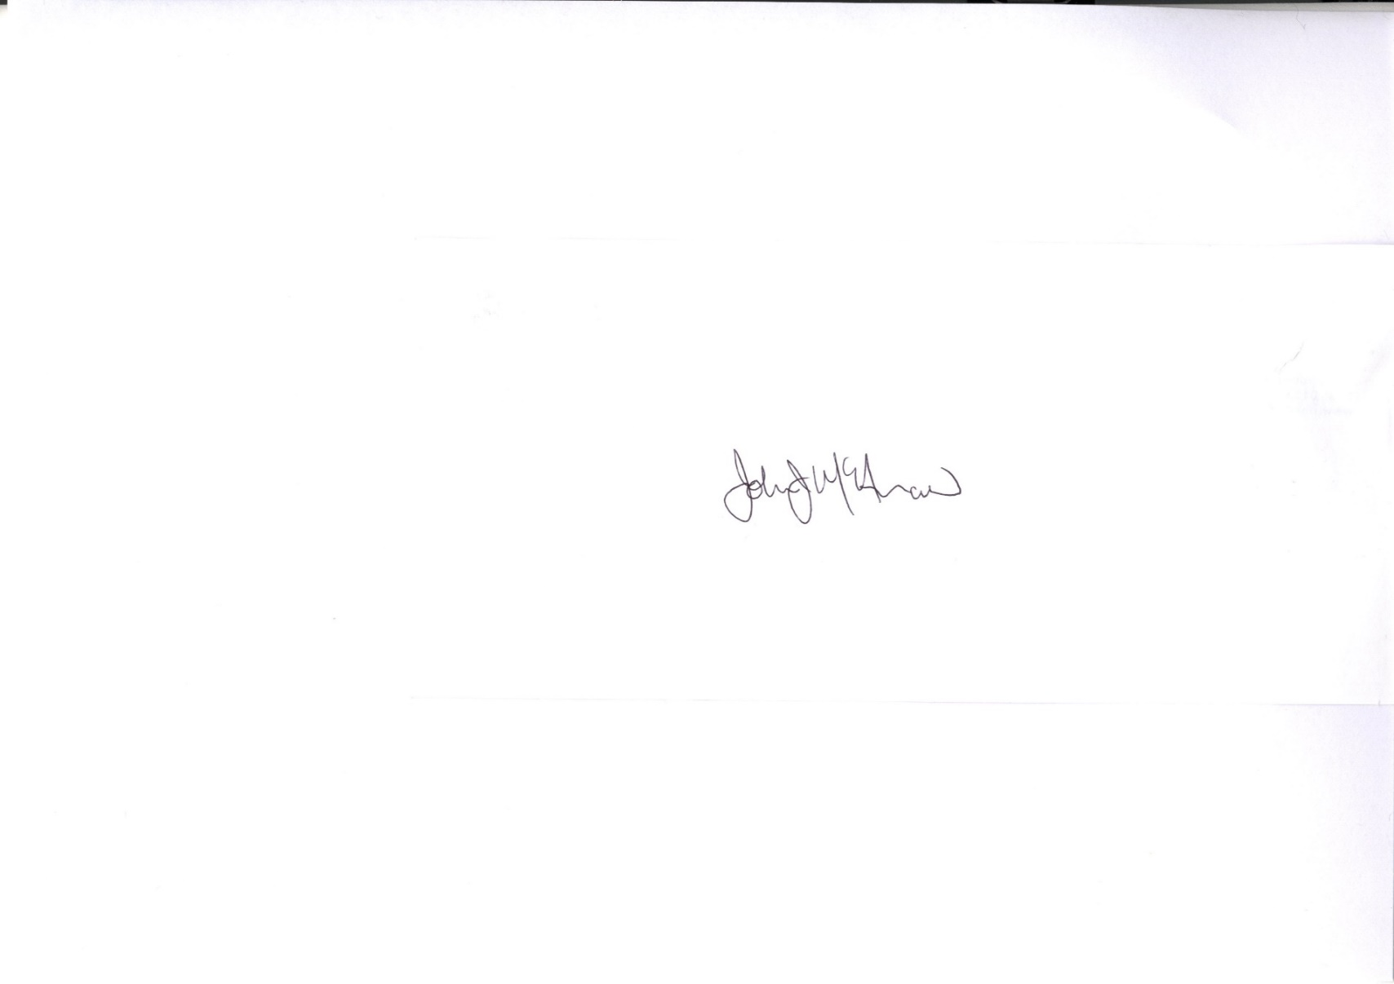Doctor (Name / Signature): Dr Laura Ryan

Pharmacist (Name /Signature): Dr John McAnaw

NHS Scotland representative (Name / Signature): Mr Jim Miller

Approved on behalf of NHS…………*insert Board*………………………… by:

Medical Director (Name / Signature) …………………………………………………..   
Director of Pharmacy/Senior Pharmacist (Name / Signature) ………………………  
Clinical Governance Lead (Name / Signature) ………………………………………..  
Date approved: ………………………………

Effective from: *insert date*

**It is the responsibility of the person using the PGD to ensure they are using the most recent issue**.

Expiry date: 17 May 2026

1. Clinical situation
   1. Indication

Relief of signs and symptoms of seasonal allergic conjunctivitis

* 1. Inclusion criteria

Patients aged 3 years and older with ocular symptoms of seasonal allergic rhinitis **who have been diagnosed with allergic conjunctivitis.**

**AND**

**Who have had treatment failure or remain symptomatic despite use of at least one other allergy treatment for ocular symptoms available over the counter.**

NB: A combination of oral, nasal spray and eye treatment products may be required to obtain acceptable symptom control. However, olopatadine should not be used together with other topical eye treatments for allergic conjunctivitis.

* 1. Exclusion criteria

Patients under 3 years of age.

Patient without a diagnosis of allergic conjunctivitis.

Previous hypersensitivity to olopatadine or to any of the excipients.

Pregnancy.

Patient of child-bearing ability not using effective contraception.

Breast Feeding.

Current treatment with olopatadine which exceeds 4 months in duration.

Individuals for whom no valid consent has been received.

* 1. Cautions/need for further advice/circumstances when further advice should be sought from a doctor/optometrist

Caution in previous frequent or prolonged use of olopatadine in patients with dry eyes.

Compromised cornea.

Red eye caused by another reason e.g., accompanied by purulent discharge, altered visual acuity, wearing of contact lenses, chemical exposure, anticoagulation.

* 1. Action if excluded

Seek advice from local optometrist. Document the reason for exclusion and any action taken in Patient Medication Record (PMR).

* 1. Action if patient declines

If appropriate, refer to optometrist and document the reason for declining treatment and advice given in PMR.

1. Description of treatment
   1. Name of medicine/form/strength

Olopatadine 1mg/ml eye drops

* 1. Route of administration

Topical ocular administration

* 1. Dosage

One drop into affected eye(s)

* 1. Frequency

Twice daily (Eight hourly)

* 1. Duration of treatment

Until resolution of symptoms (e.g., red, itchy, gritty, watery discharge, swollen eyelids).

* 1. Maximum or minimum treatment period

MAXIMUM treatment period in total – FOUR months (28 days per individual bottle).

* 1. Quantity to supply

One 5ml bottle per supply

* 1. ▼ black triangle medicines

No

* 1. Legal category

Prescription Only Medicine (POM).

In accordance with the MHRA all medicines **supplied** under a PGD **must** either be from over-labelled stock or be labelled appropriately in accordance with the regulatory body guidelines for the labelling of medicines for the professional providing the supply.

* 1. Is the use out with the SPC?

No.

* 1. Storage requirements

As per manufacturer’s instructions

Store below 25⁰C in a cool, dry place

* 1. Additional information

None

1. Adverse reactions
   1. Warnings including possible adverse reactions and management of these.

**Please refer to current BNF or SPC for full details**

If a patient experiences any side effects that are intolerable or hypersensitivity reactions occur, the medication should be discontinued.

For a full list of side effects, refer to the marketing authorisation holder’s Summary of Product Characteristics (SPC). A copy of the SPC must be available to the health professional supplying the medication under this PGD. This can be accessed on [www.medicines.org.uk](http://www.medicines.org.uk)

Common side effects include headache, distortion in the sense of taste (dysgeusia), eye pain, eye irritation, dry eye, abnormal sensation in eyes, nasal dryness and fatigue.

Other less common side effects include: rhinitis, dizziness, hypoaesthesia, corneal erosion, corneal epithelium defect, corneal epithelium disorder, punctate keratitis, keratitis, corneal staining, eye discharge, photophobia, blurred vision, visual acuity reduced, blepharospasm, ocular discomfort, eye pruritis, conjunctival follicles, conjunctival disorder, foreign body sensation in eyes, lacrimation increased, eyelids pruritis, erythema of eyelid, eyelid oedema, eyelid disorder, ocular hyperaemia

In the event of severe adverse reaction individuals should be advised to seek medical advice.

* 1. Reporting procedure for adverse reactions

Pharmacists should document and report all adverse incidents through their own internal governance systems.

All adverse reactions (actual and suspected) should be reported to the appropriate medical practitioner and recorded in the patient’s medical record. Pharmacists should record in their PMR and inform the patient’s GP/optometrist as appropriate.

Where appropriate, healthcare professionals and individuals/carers should report suspected adverse reactions to the Medicines and Healthcare products Regulatory Agency (MHRA) using the Yellow Card reporting scheme. Yellow cards and guidance on their use are available at the back of the BNF or online at [www.mhra.gov.uk/yellowcard](http://www.mhra.gov.uk/yellowcard).

* 1. Advice to patient or carer including written information

Written information to be given to individuals:

* Provide manufacturer’s consumer information leaflet/patient information leaflet (PIL).

Verbal advice to be given to individuals:

* Advise individual on mode of action, benefits of the medicine, possible side effects and their management.
* Give general advice for managing high pollen count: stay indoors as much as possible, keeping windows and doors shut; avoid cutting grass, large grassy places and camping; shower and wash your hair after being outdoors, especially in the countryside; wear wrap-around sunglasses when outside; keep car windows closed and consider buying pollen filters for car air vents.
* Wearers of contact lenses should remove lenses prior to application of olopatadine eye drops and wait at least 15 minutes after instillation before re-inserting lenses.
* In case of concomitant therapy with other topical ocular medicines, an interval of 10 minutes should be allowed between successive applications. Eye ointments should be administered last.
* Demonstrate the best way to self-administer eye drops.
* Vision may be blurred for a few minutes after instillation – if affected, the patient should not drive or operate hazardous machinery.
* Advise that there might be mild stinging on instillation of drops.
* Treatment with olopatadine should be for a maximum of four months at a time.
* In patients of childbearing potential, effective contraception is required whilst using olopatadine.
* Olopatadine contains benzalkonium chloride which may cause eye irritation.
* Advise to seek medical advice in the event of a severe adverse reaction.
* If the condition worsens or symptoms persist, seek further advice from an optometrist.
* Inform the individual that they can report suspected adverse reactions to the MHRA using the Yellow Card reporting scheme on: [www.mhra.gov.uk/yellowcard](http://www.mhra.gov.uk/yellowcard).
  1. Monitoring

Not applicable

* 1. Follow up

None

If patient is requiring to use for longer than 4 months, then refer to optometrist/GP for review.

* 1. Additional facilities

The following should be available when the medication is supplied:

* An acceptable level of privacy to respect patient’s rights to confidentiality and safety
* Access to a working telephone
* Access to medical support (this may be via telephone)
* Approved equipment for the disposal of used materials
* Clean and tidy work areas, including access to hand washing facilities or alcohol hand gel
* Access to current BNF (online version preferred)
  + [BNF British National Formulary - NICE](https://bnf.nice.org.uk/)
  + [BNF for Children British National Formulary - NICE](https://bnfc.nice.org.uk/)
* Access to SmPC/PIL/Risk Minimisation Material:
  + [Home - electronic medicines compendium (emc)](https://www.medicines.org.uk/emc/)
  + [MHRA Products | Home](https://products.mhra.gov.uk/)
  + [RMM Directory - (emc)](https://www.medicines.org.uk/emc/rmm-directory)
* Access to copy of current version of this PGD

1. Characteristics of staff authorised under the PGD
   1. Professional qualifications

Pharmacist with current General Pharmaceutical Council (GPhC) registration.

**Under PGD legislation there can be no delegation. Supply of the medication has to be completed by the same practitioner who has assessed the patient under this PGD.**

* 1. Specialist competencies or qualifications

Persons must only work under this PGD where they are competent to do so.

All persons operating this PGD must:

* Be familiar with the olopatadine 1mg/ml eye drop medicine and alert to changes in the manufacturer’s product information/summary of product information.
* Have successfully complete the NES Pharmacy e-learning module:

[Seasonal Allergic Rhinitis (Hay Fever) for NHS Pharmacy First Scotland | Turas | Learn](https://learn.nes.nhs.scot/67704/pharmacy/cpd-resources/seasonal-allergic-rhinitis-hay-fever-for-nhs-pharmacy-first-scotland)

<https://learn.nes.nhs.scot/67704/pharmacy/cpd-resources/seasonal-allergic-rhinitis-hay-fever-for-nhs-pharmacy-first-scotland>

* Be able to assess the person’s/ parent’s/ carer’s capacity to understand the nature of the purpose of the medication in order to give or refuse consent.
  1. Continuing education and training

All practitioners operating under this PGD are responsible for:

* Maintaining their skills, knowledge and their own professional level of competence in this area according to the General Pharmaceutical Council Standards for Pharmacy Professionals
* Ensuring they remain up to date with the use of medications included and be aware of local treatment recommendations.
* Attend approved training and training updates as appropriate.
* Undertake relevant continuing professional development when PGD or NES Pharmacy modules are updated.

1. Audit trail
   1. Authorisation of supply

Pharmacists can be authorised to supply the medicine specified in this PGD when they have completed local Board requirements for service registration.

Pharmacists should complete the individual authorisation form contained in the PGD (Appendix 1) and submit to the relevant NHS Health Board prior to using the PGD.

* 1. Record of supply

An electronic or paper record must be completed to allow audit of practice. All records must be clear, legible, contemporaneous and in an easily retrievable format.

Pharmacists must record the following information, included in the assessment form, in the PMR (either paper or computer based):

* name of individual, address, date of birth / CHI number
* name of GP with whom the individual is registered (if known)
* confirmation that valid consent to be treated under this PGD was obtained (include details of parent/guardian/person with parental responsibility where applicable)
* details of presenting complaint and diagnosis
* details of medicine supplied - name of medicine, batch number and expiry date, with date of supply.
* details of exclusion criteria – why the medicine was not supplied (if applicable)
* advice given, including advice given if excluded or declines treatment under this PGD
* details of any adverse drug reactions and actions taken
* referral arrangements (including self-care)
* signature and printed name of the pharmacist who undertook assessment of clinical suitability and, where appropriate, subsequently supplied the medicine

**The patient’s GP (where known) should be provided with a copy of the GP notification form for the supply of olopatadine 1mg/ml eye drops, or appropriate referral on the same, or next available working day.**

These records should be retained in accordance with national guidance1 (see page 56 for standard retention periods summary table). Where local arrangements differ, clarification should be obtained through your Health Board Information Governance Lead.

All records of the drug(s) specified in this PGD will be filed with the normal records of medicines in each service. A designated person within each service will be responsible for auditing completion of drug forms and collation of data.

1. Scottish Government. *Scottish Government Records Management.* Edinburgh 2020. Available at [SG-HSC-Scotland-Records-Management-Code-of-Practice-2020-v20200602.pdf](https://www.informationgovernance.scot.nhs.uk/wp-content/uploads/2020/06/SG-HSC-Scotland-Records-Management-Code-of-Practice-2020-v20200602.pdf) (Accessed on 31st March 2023)

Additional references

Practitioners operating the PGD must be familiar with:

1. National Institute for Clinical Excellence / Public Health England. Available at: [Allergic rhinitis | Health topics A to Z | CKS | NICE](https://cks.nice.org.uk/topics/allergic-rhinitis/)*.* (Accessed 31st March 2023)
2. Current edition of British National Formulary (BNF) and BNF for children
3. Marketing authorisation holder’s Summary of Product Characteristics. Electronic Medicines Compendium. *Olopatadine 1mg/ml eye drops, Solution SPC.* Available at [Olopatadine 1 mg/ml Eye drops, Solution - Summary of Product Characteristics (SmPC) - (emc) (medicines.org.uk)](https://www.medicines.org.uk/emc/product/10890/smpc) (Accessed 31st March 2023)

# 7. Individual authorisation (Appendix 1)

PGDs FOR THE SUPPLY OF TREATMENTS FOR SEASONAL ALLERGIC RHINITIS BY COMMUNITY PHARMACISTS UNDER THE “NHS PHARMACY FIRST SCOTLAND” SERVICE

***Health Boards to provide authorisation form to pharmacy contractors***

# 8. Version history

|  |  |  |
| --- | --- | --- |
| Version | Date | Summary of changes |
| 1.0 | 17/05/2023 | New National PGD produced. |