Patient Group Direction (PGD)

This PGD authorises community pharmacists to supply mometasone furoate 50micrograms/actuation nasal spray to patients aged 3 years and over presenting with symptoms of seasonal allergic rhinitis under NHS Pharmacy First Scotland.

Publication date: 17 May 2023

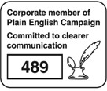

Most Recent Changes

|  |  |  |
| --- | --- | --- |
| Version | Date | Summary of changes |
| 1.0 | 17/05/2023 | * New national PGD produced. |

Contents

Authorisation 3

1. Clinical situation 5

2. Description of treatment 8

3. Adverse reactions 10

4. Characteristics of staff authorised under the PGD 14

5. Audit trail 16

6. Additional references 18

7. Individual authorisation (Appendix 1) 19

8. Version history 21

# Authorisation

This PGD is not legally valid until it has had the relevant organisational authorisation.

PGD mometasone furoate 50micrograms/actuation nasal spray

This specimen PGD template has been produced in collaboration with the Primary Care Community Pharmacy Group to assist NHS Boards in the uniform provision of services under ‘NHS Pharmacy First Scotland’ banner across NHS Scotland. NHS Boards should ensure that the final PGD is considered and approved in line with local clinical governance arrangements for PGDs.

The community pharmacist who may supply mometasone nasal spray under this PGD can do so only as a named individual. It is the responsibility of each professional to practice within the bounds of their own competence and in accordance with the General Pharmaceutical Council Standards for Pharmacy Professionals and to ensure familiarity with the manufacturer’s product information/summary of product characteristics (SPC) for all medicines supplied in accordance with this PGD.

NHS Board governance arrangements will indicate how records of staff authorised to operate this PGD will be maintained. Under PGD legislation there can be no delegation. Supply of the medicine has to be by the same practitioner who has assessed the patient under the PGD.

This PGD has been approved on behalf of NHS Scotland by NHS 24 by:

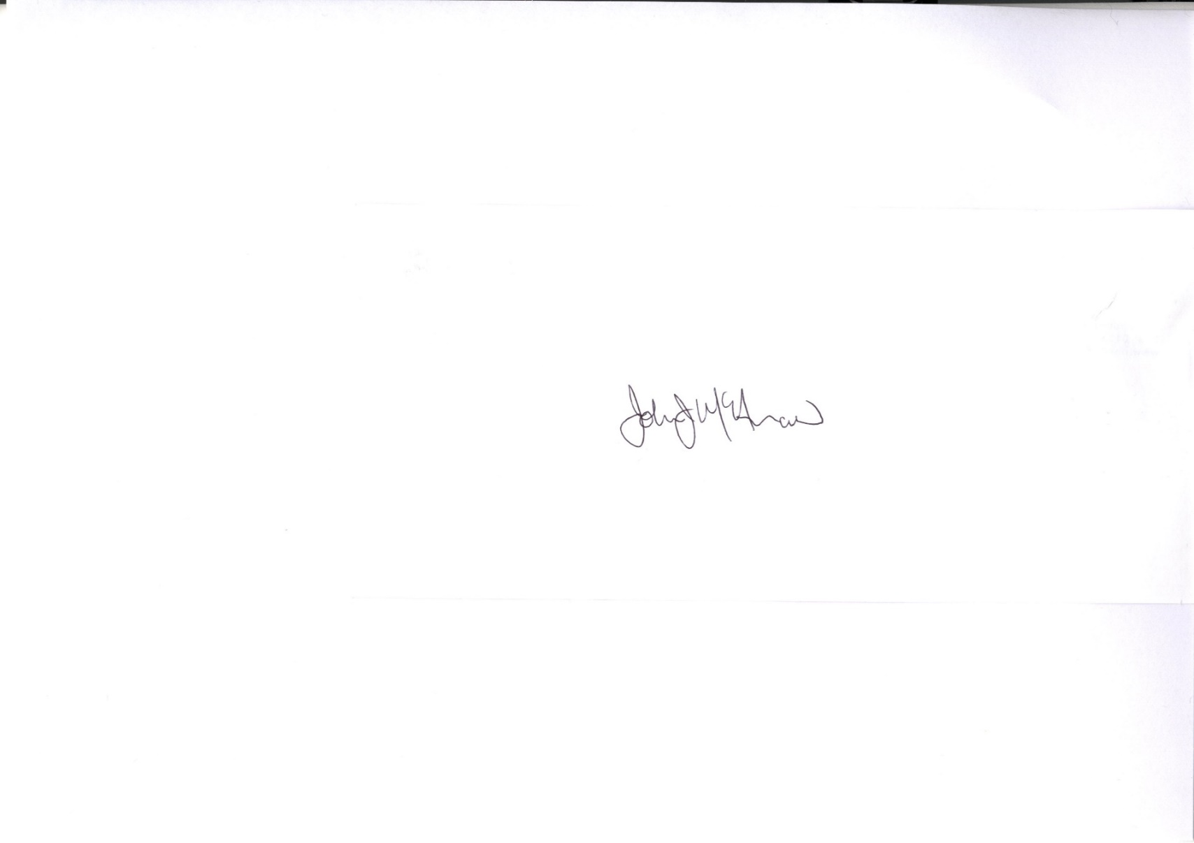Doctor (Name / Signature): Dr Laura Ryan

Pharmacist (Name /Signature): Dr John McAnaw

NHS Scotland representative (Name / Signature): Mr Jim Miller

Approved on behalf of NHS…………*insert Board*………………………… by:

Medical Director (Name / Signature) …………………………………………………..   
Director of Pharmacy/Senior Pharmacist (Name / Signature) ………………………  
Clinical Governance Lead (Name / Signature) ………………………………………..  
Date approved: ………………………………

Effective from: *insert date*

**It is the responsibility of the person using the PGD to ensure they are using the most recent issue**.

Expiry date: 17 May 2026

1. Clinical situation
   1. Indication

Relief of symptoms of seasonal allergic rhinitis, in adults and children over 3 years of age.

* 1. Inclusion criteria

Patients aged 3 years and older with symptoms of seasonal allergic rhinitis:

* **Who have had treatment failure or remain symptomatic despite use of at least two other allergy treatments available over the counter within the last six months.**

NB: A combination of allergy treatment products may be required to obtain acceptable symptom control. However, mometasone nasal spray should not be used together with other nasal steroid treatments.

Valid consent to receiving treatment under this PGD has been obtained.

* 1. Exclusion criteria

Patients under 3 years of age.

Hypersensitivity to mometasone furoate or to any of the excipients within the nasal spray.

Nasal blockage in the absence of rhinorrhoea, nasal itch and sneezing.

Unilateral discharge.

Untreated localised infection involving the nasal mucosa e.g., herpes simplex.

Patients with symptoms associated with acute bacterial sinusitis e.g., fever, severe pain, purulent discharge.

Patients who have experienced recent nasal surgery or trauma where healing is not complete.

Pregnancy.

Breast Feeding.

Individuals for whom no valid consent has been received.

* 1. Cautions/need for further advice/ circumstances when further advice should be sought from a doctor

Consult [Mometasone Furoate 50 micrograms/dose Nasal Spray, suspension - (SmPC)](https://www.medicines.org.uk/emc/product/5224/smpc) for full list of cautions and special warnings.

* Mometasone furoate nasal spray should be used with caution, if at all, in patients with active or quiescent tuberculous infections of the respiratory tract, or untreated bacterial, fungal or systemic viral infections.
* Patients who are potentially immunosuppressed should be warned about of the risk of exposure to certain infections (e.g., chicken pox, measles) and the importance of obtaining medical advice if such exposure occurs.
* Systemic effects of nasal corticosteroids may occur, particularly at high doses prescribed for prolonged periods. These effects are much less likely to occur than with oral corticosteroids and may vary in individual patients and between different corticosteroid preparations.

* Potential systemic effects may include Cushing’s syndrome, Cushingoid features, adrenal suppression, growth retardation in children and adolescents, cataract, glaucoma and more rarely, a range of psychological or behavioural effects including psychomotor hyperactivity, sleep disorders, anxiety, depression or aggression (particularly in children)
* Visual disturbance – if patient presents with visual disturbances e.g., blurred vision or other visual disturbances, referral to an ophthalmologist should be considered for evaluation of possible causes.
  1. Action if excluded

Consider alternative NHS Pharmacy First Scotland treatments (either under PGD or otherwise).

If appropriate, refer to GP practice and document the reason for exclusion and any action taken in Patient Medication Record (PMR).

* 1. Action if patient declines

If appropriate, refer to GP practice and document the reason for declining treatment and advice given in PMR.

1. Description of treatment
   1. Name of medicine/form/strength

Mometasone furoate 50micrograms /actuation nasal spray, suspension

* 1. Route of administration

Nasal Spray

* 1. Dosage

Adults and children aged 12 years and over:

* TWO sprays (50 micrograms/actuation) into each nostril once daily (total dose 200 micrograms).
* Once symptoms are controlled, dose reduction to ONE spray in each nostril (total dose 100 micrograms) may be effective for maintenance.
* If symptoms are inadequately controlled, the dose may be increased to a maximum daily dose of FOUR sprays in each nostril once daily (total dose 400 micrograms). Dose reduction is recommended following control of symptoms.

Children aged 3 – 11 years:

* ONE spray (50 micrograms/actuation) into each nostril once daily (total dose 100 micrograms).
  1. Frequency

Once daily administration

* 1. Duration of treatment

Supply can be repeated for up to 6 months if required i.e., duration of hay fever season.

* 1. Maximum or minimum treatment period

Mometasone furoate nasal spray demonstrates a clinically significant onset of action within 12 hours after the first dose in some patients with seasonal allergic rhinitis; however, full benefit of treatment may not be achieved in the first 48 hours. Therefore, the patient should continue regular use to achieve full therapeutic benefit.

* 1. Quantity to supply

1 x 140 dose nasal spray per supply.

* 1. ▼ black triangle medicines

No

* 1. Legal category

Prescription Only Medicine (POM).

In accordance with the MHRA all medicines **supplied** under a PGD **must** either be from over-labelled stock or be labelled appropriately in accordance with the regulatory body guidelines for the labelling of medicines for the professional providing the supply.

* 1. Is the use out with the SPC?

No.

* 1. Storage requirements

As per manufacturer’s instructions – use within 2 months of first use.

Store below 25⁰C in a cool, dry place

* 1. Additional information

None

1. Adverse reactions
   1. Warnings including possible adverse reactions and management of these.

**Please refer to current BNF, BNF for Children or SPC for full details.**

If a patient experiences any side effects that are intolerable or hypersensitivity reactions occur, the medication should be discontinued.

Common side effects include headache, sneezing, nose bleeds, sore nose or throat, ulcers in nose, respiratory tract infection.

For a full list of side effects, refer to the marketing authorisation holder’s Summary of Product Characteristics (SPC). A copy of the SPC must be available to the health professional supplying the medication under this PGD. This can be accessed on [www.medicines.org.uk](http://www.medicines.org.uk).

In the event of severe adverse reaction e.g., swelling of eyes, face, lips or throat, shortness of breath or wheezing, developing of rash or feeling faint, individuals should be advised to seek medical advice immediately.

* 1. Reporting procedure for adverse reactions

Pharmacists should document and report all adverse incidents through their own internal governance systems.

All adverse reactions (actual and suspected) should be reported to the appropriate medical practitioner and recorded in the patient’s medical record. Pharmacists should record in their PMR and inform the patient’s GP as appropriate.

Where appropriate, healthcare professionals and individuals/carers should report suspected adverse reactions to the Medicines and Healthcare products Regulatory Agency (MHRA) using the Yellow Card reporting scheme. Yellow cards and guidance on their use are available at the back of the BNF or online at [www.mhra.gov.uk/yellowcard](http://www.mhra.gov.uk/yellowcard).

* 1. Advice to patient or carer including written information

Written information to be given to individuals:

* Provide manufacturer’s consumer information leaflet/patient information leaflet (PIL)

Verbal advice to be given to individuals/parent/carer:

* Advise the individual on mode of action, benefits of the medicine, possible side effects and their management.
* Give general advice for managing high pollen count: stay indoors as much as possible, keeping windows and doors shut; avoid cutting grass, large grassy places and camping; shower and wash your hair after being outdoors, especially in the countryside; wear wrap-around sunglasses when outside; keep car windows closed and consider buying pollen filters for car air vents.
* When using nasal spray for first time, the pump should be primed. See PIL for full details.
* Advise the individual on nasal spray technique – see PIL for details.
* While an improvement in symptoms may be observed within 12 hours of use, it may take several days to obtain the full therapeutic effects of the medication.
* If conditions worsens or symptoms persist, seek further medical advice initially from the pharmacy. Inform the individual that they can report suspected adverse reactions to the MHRA using the Yellow Card reporting scheme on: [www.mhra.gov.uk/yellowcard](http://www.mhra.gov.uk/yellowcard).
  1. Monitoring

Not applicable

* 1. Follow up

Advise patient if symptoms do not improve after 1 month of regular use or worsening symptoms, they should return to the pharmacy for re-assessment. If patient has exhausted all treatment options available in community pharmacy or is requiring to use for more than 6 months, then refer to GP practice for review.

* 1. Additional facilities

The following should be available when the medication is supplied:

* An acceptable level of privacy to respect patient’s rights to confidentiality and safety
* Access to a working telephone
* Access to medical support (this may be via telephone)
* Approved equipment for the disposal of used materials
* Clean and tidy work areas, including access to hand washing facilities or alcohol hand gel
* Access to current BNF (online version preferred)
  + [BNF British National Formulary - NICE](https://bnf.nice.org.uk/)
  + [BNF for Children British National Formulary - NICE](https://bnfc.nice.org.uk/)
* Access to SmPC/PIL/Risk Minimisation Material:
  + [Home - electronic medicines compendium (emc)](https://www.medicines.org.uk/emc/)
  + [MHRA Products | Home](https://products.mhra.gov.uk/)
  + [RMM Directory - (emc)](https://www.medicines.org.uk/emc/rmm-directory)
* Access to copy of current version of this PGD

1. Characteristics of staff authorised under the PGD
   1. Professional qualifications

Pharmacist with current General Pharmaceutical Council (GPhC) registration.

**Under PGD legislation there can be no delegation. Supply of the medication has to be completed by the same practitioner who has assessed the patient under this PGD.**

* 1. Specialist competencies or qualifications

Persons must only work under this PGD where they are competent to do so.

All persons operating this PGD must:

* Be familiar with the mometasone fuorate 50 microgram nasal spray medicine and alert to changes in the manufacturer’s product information/summary of product information.
* Have successfully complete the NES Pharmacy e-learning module:

[Seasonal Allergic Rhinitis (Hay Fever) for NHS Pharmacy First Scotland | Turas | Learn](https://learn.nes.nhs.scot/67704/pharmacy/cpd-resources/seasonal-allergic-rhinitis-hay-fever-for-nhs-pharmacy-first-scotland)

<https://learn.nes.nhs.scot/67704/pharmacy/cpd-resources/seasonal-allergic-rhinitis-hay-fever-for-nhs-pharmacy-first-scotland>

* Be able to assess the person’s/ parent’s/ carer’s capacity to understand the nature of the purpose of the medication in order to give or refuse consent.
  1. Continuing education and training

All practitioners operating under this PGD are responsible for:

* Maintaining their skills, knowledge and their own professional level of competence in this area according to the General Pharmaceutical Council Standards for Pharmacy Professionals
* Ensuring they remain up to date with the use of medications included and be aware of local treatment recommendations.
* Attend approved training and training updates as appropriate.
* Undertake relevant continuing professional development when PGD or NES Pharmacy modules are updated.

1. Audit trail
   1. Authorisation of supply

Pharmacists can be authorised to supply the medicine specified in this PGD when they have completed local Board requirements for service registration.

Pharmacists should complete the individual authorisation form contained in the PGD (Appendix 1) and submit to the relevant NHS Health Board prior to using the PGD.

* 1. Record of supply

All records must be clear, legible, contemporaneous and in an easily retrievable format to allow audit of practice.

A Universal Claim Framework (UCF) record of the screening and subsequent supply, or not, of the medicine specified in this PGD should be made in accordance with the NHS Pharmacy First Scotland service specification.

Pharmacists must record the following information, included in the assessment form, in the PMR (either paper or computer based):

* name of individual, address, date of birth / CHI number
* name of GP with whom the individual is registered (if known)
* confirmation that valid consent to be treated under this PGD was obtained (include details of parent/guardian/person with parental responsibility where applicable)
* details of presenting complaint and diagnosis
* details of medicine supplied - name of medicine, batch number and expiry date, with date of supply.
* details of exclusion criteria – why the medicine was not supplied (if applicable)
* advice given, including advice given if excluded or declines treatment under this PGD
* details of any adverse drug reactions and actions taken
* referral arrangements (including self-care)
* signature and printed name of the pharmacist who undertook assessment of clinical suitability and, where appropriate, subsequently supplied the medicine

**The patient’s GP (where known) should be provided with a copy of the GP notification form for the supply of mometasone 50micrograms nasal spray, or appropriate referral on the same, or next available working day.**

These records should be retained in accordance with national guidance1 (see page 56 for standard retention periods summary table). Where local arrangements differ, clarification should be obtained through your Health Board Information Governance Lead.

All records of the drug(s) specified in this PGD will be filed with the normal records of medicines in each service. A designated person within each service will be responsible for auditing completion of drug forms and collation of data.

1. Scottish Government. *Scottish Government Records Management.* Edinburgh 2020. Available at [SG-HSC-Scotland-Records-Management-Code-of-Practice-2020-v20200602.pdf](https://www.informationgovernance.scot.nhs.uk/wp-content/uploads/2020/06/SG-HSC-Scotland-Records-Management-Code-of-Practice-2020-v20200602.pdf) (Accessed on 31st March 2023)

1. Additional references

Practitioners operating the PGD must be familiar with:

1. National Institute for Clinical Excellence / Public Health England. Available at: [Allergic rhinitis | Health topics A to Z | CKS | NICE](https://cks.nice.org.uk/topics/allergic-rhinitis/)*.* (Accessed 31st March 2023)
2. Current edition of British National Formulary (BNF) [BNF British National Formulary - NICE](https://bnf.nice.org.uk/), and BNF for children [BNF for Children British National Formulary - NICE](https://bnfc.nice.org.uk/)
3. Marketing authorisation holder’s Summary of Product Characteristics. Electronic Medicines Compendium. *Mometasone furoate 50mcg / actuation Nasal Spray, suspension. SPC.* Available [Mometasone Furoate 50 micrograms/dose Nasal Spray, suspension - Summary of Product Characteristics (SmPC) - (emc) (medicines.org.uk)](https://www.medicines.org.uk/emc/product/5224/smpc) (Accessed 31st March 2023)

# 7. Individual authorisation (Appendix 1)

PGDs FOR THE SUPPLY OF TREATMENTS FOR SEASONAL ALLERGIC RHINITIS BY COMMUNITY PHARMACISTS UNDER THE “NHS PHARMACY FIRST SCOTLAND” SERVICE

***Health Boards to provide authorisation form to pharmacy contractors***

# 8. Version history

|  |  |  |
| --- | --- | --- |
| Version | Date | Summary of changes |
| 1.0 | 17/05/23 | New National Specimen PGD produced. |