Document Title | NHSS Procurement Community Benefit Gateway: Guidance for 3rd Sector Organisations
Document Ref: | STS703-003
Department: | Strategic Sourcing
Approval: | Refer to Q-Pulse

Table of Contents
1. Introduction 3
2. Background 3
3. How does it work? 4
4. How Do I Enter a Need? 5
5. Review Stage 8
6. Receiving a bid 8
7. Delivery Phase and Closure 9
8. Appendix A – Community Benefit Definition 9
9. Definitions 11
10. Document Storage Locations 11
11. Associated Documented Information 11
12. Document Change History 11

Introduction
Please note this guidance is designed for 3rd Sector Organisations: defined as; -
Third Sector: The third sector includes community groups, voluntary organisations, charities, social enterprises, co-operatives and individual volunteers that exist wholly or mainly to provide benefits for society or the environment.
In March 2021 NHS National Procurement, a division of NHS National Services Scotland in conjunction with the NHSScotland Procurement community introduced the Community Benefits Gateway; an online space at https://nhsnss.service-now.com/community_benefit to connect community needs with NHSScotland suppliers in order to identify true community needs and help deliver against them.
It should be noted that the Gateway itself is not a funding platform and should not be viewed as such that said there may be offers of funding that suppliers may make against specific needs.

Background
Public procurement has a responsibility to support its local communities through its contract spend and is obligated to deliver benefits through public procurement regulations. One of the main routes that we achieve this is through Community Benefits. These could be local initiatives that support the social or environmental wellbeing of a local area. We include the need for community benefits delivery in most of our contracts. However, much of the time we do not have a fixed idea of what these benefits are at the time we award these contracts, so we know there is a gap.
The Community Benefits Gateway is our solution to get the community benefit ‘needs’ from those organisations who are best placed to identify them; 3rd Sector Organisations. The third sector includes community groups, voluntary organisations, charities, social enterprises, co-operatives that exist wholly or mainly to provide benefits for society or the environment. These organisations can submit a need and we will encourage our suppliers to bid against the need and support its delivery.

How does it work?
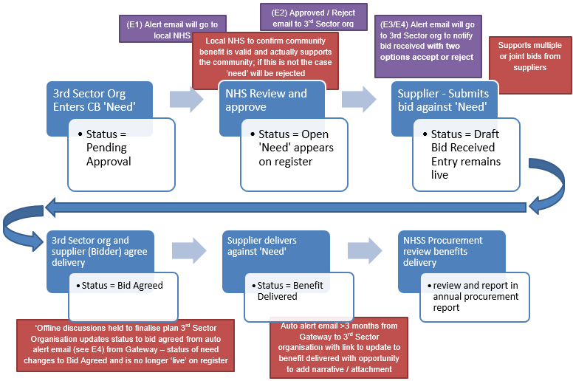
Figure 1. Gateway Process Flow
EMAILS
E1 – Alert to Local NHS Triage – “Please note a new community need <sys generated #> has been submitted for approval. Can you review and approve or reject the submission? If you are rejecting the submission a reason will be required to be entered into appropriate field that will be issued to the community organisation.
E2 - Approved / Reject email to 3rd Sector org – If Approved – “Congratulations! Your submission of need has been accepted on to the Gateway and is now available for viewing and possible bids from our supplier base, please look out for potential bid notification alerts from suppliers”.
If rejected – “Unfortunately your submission of need has been rejected, this is due to <text from appropriate field>, please respond to this email if you need further clarification”.
E3 – Supplier confirmation – “Congratulations! Your bid has been submitted to <community org name> in support of <sys generated #>, a representative from <community org name> should be in touch soon to discuss your bid.
E4 – 3rd Sector Org Alert – “Hi, please be aware a supplier has bid against your need. Bid & contact details are as follows; <detail from supplier bid>
Please review the bid and contact the bidder to agree the next steps. Important! Your ‘need’ will remain visible on the register until you agree a bid which means other suppliers may also bid against your need.
If you agree to the bid, you will need to click the Accept button below as this will remove your need from the register and maintain the correct status of your need within the system. If you do not agree to the bid, please click the ‘Reject’ button which will keep your need visible on the register. Accept & Reject buttons.
E5 - Reminder email to 3rd Sector Org – “Hi, as it’s been 3/6 months since you agreed the supplier bid, just a reminder for you to update the outcome of your need by clicking the appropriate button below” Outcome successful or Not yet completed or Unsuccessful Outcome.

How Do I Enter a Need?
It’s very simple! First though your organisation will have to register – by navigating to https://nhsnss.service-now.com/community_benefit and completing the registration form.
HINT: We would suggest that a generic email address is added to ensure any alerts are not reliant on any one individual.
Once you register you will see the following;
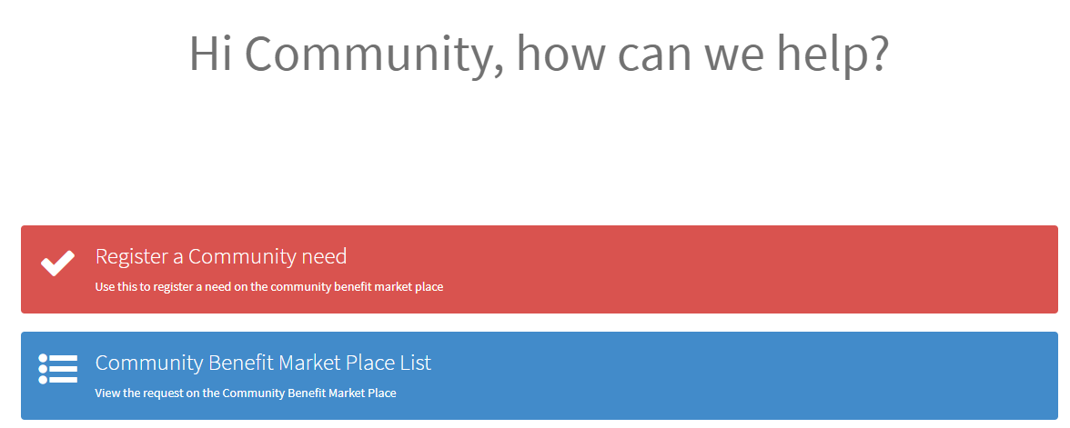
Figure 2. Main Screen
Click on the red bar to enter your requirement. The Gateway form will appear; the fields are as follows;
Field | Field Type | Description
Name | Auto insertion from registration details
Organisation | Auto insertion from registration details
Organisation Details | Free Text | Please provide a brief description of your organisation's profile (i.e., activities, mission, goals) and/or URL to your website.
Location | Dropdown List (single choice) | Please select the Health Board area where the community need is located.
Community Need Name/Title | Free text | Please provide the name of your community need e.g. Dementia friendly community garden).
Type of community need | Dropdown List (single choice) | Please select the type of community need that your project would benefit from.
Support required/proposed community need. | Free text | Provide a brief summary of what your community need is aiming to achieve (e.g., revamp dementia friendly community garden for local community, upgrade IT equipment, take group of disabled children to an event).
Specifics of community need. | Free text | Please provide specific details of what support your community need requires to be fulfilled (e.g., type and number of pieces of equipment, wood to create a flower bed, paint (colour, type, size of tin) to repaint an area etc). Please avoid using acronyms or technical jargon.  Example tangible item (e.g., IT equipment, mobility equipment)  Non-tangible example (e.g., job shadow opportunity, mental health training).
Beneficiaries | Dropdown List (multi choice) | Please select the specific group that will benefit from your community need. You can select more than one.
Support Category | Dropdown List (multi choice) | Please select the support category that the community need falls under. You can select more than one.
What evidence is there to support your proposed community need? | Free text | Please provide a summary of why you believe your community need is required. Please include any data or evidence you have.
What impact do you hope your community need will have? | Free text | Please provide a summary of what impact you hope to achieve (e.g., Upgrading the community garden will help to make the space more accessible for our users with dementia)
How will you measure the success of your community need? | Free text | Please provide details of how you hope to measure the success of your community need. It is useful to think about what outcomes you can monitor (i.e. number of people supported).
Community need target start date. | Date Field | Please select a date when you would like to start the delivery of the community need.
Community need target delivery date. | Dropdown List (single choice) | Please select the date when you require the community need to be delivered.
Delivery deadline date for community need (if applicable) | Date Field | Is there an absolute end date when the project must be completed.
Community Need Location (Postcode) | Postcode Field | Please indicate the postcode your community need. If the community need is delivered across different postcodes, then please provide the main area that your outcomes will be delivered.
Table 1. Entry form Fields
At the bottom of the form there is the option to add attachments, where you can add more detail about your organisation and the project, the free text fields in the table relating to the project can reference the attachment if required.
Click submit and that is it!

Review Stage
After you submit your need your local public health or procurement team will review the need to ensure it aligns with local or national health improvement priorities. We aim to have your need reviewed within a few days of submission. See appendix A for further detail on community benefits.
If approved, you will receive a notification similar to the following;
“Congratulations! Your submission of need has been accepted on to the Gateway and is now available for viewing and possible bids from our supplier base, please look out for potential bid notification alerts from suppliers”.
You will be able to see your need on the register by returning to the landing page in Figure 2 and clicking the blue bar.
If rejected, you will receive a notification similar to the following;
“Unfortunately your submission of need has been rejected, this is due to <reason from reviewer>, please respond to this email if you need further clarification”.

Receiving a bid
Once your need has been approved it will appear on the Gateway register and will be available for NHSS suppliers to review and, possibly submit a bid to meet your need.
If a supplier decides to bid against your need as detailed in Figure 1 you will receive a notification by email to the email address registered in the system. Which will be similar to the following;
“Hi, please be aware a supplier has bid against your need. Bid & contact details are as follows; <detail from supplier bid>
Please review the bid and contact the bidder to agree the next steps. Important! Your ‘need’ will remain visible on the register until you agree a bid which means other suppliers may also bid against your need.
If you agree to the bid, you will need to click the ‘Accept’ button below as this will remove your need from the register and maintain the correct status of your need within the system. If you do not agree to the bid, please click the ‘Reject’ button which will keep your need visible on the register.
Note clicking ‘Accept’ will open up an email link, simply click send on this email to trigger the status update.
The email itself will have two links or buttons to either accept or reject the bid. It is important that you engage with the supplier who has bid to understand their offer fully and to decide whether you wish to accept. If you accept you must click the accept button or link in the email to remove your requirement from the register and to move the project into ‘Bid Accepted’ status. If you do not accept please click the reject button to keep your need on the register for other potential bids. If it is a partial bid, you may defer clicking the buttons and await additional bids to completely fulfil your need.
After agreement, you and the supplier can move into delivery phase.

Delivery Phase and Closure
Our expectation is that you and your chosen supplier will work together to deliver against the need and to hopefully meet your timescales. However, in order to maintain integrity of the Gateway we must ensure that projects are finalised. To this end an automated email will be sent to you after 3 months and 6 months to allow you to enter a completion note. The email will look something like this;
“Hi, as it’s been 3/6 months since you agreed the supplier bid, just a reminder for you to update the outcome of your need by clicking the appropriate button below
Outcome successful or Not yet completed or Unsuccessful Outcome.”
Clicking the button or link will take you to a form where you can enter some additional detail to inform NHSS of the outcome of your project. This is very important that you complete this as it allows us to understand what has been achieved and where benefits have been delivered.

Appendix A – Community Benefit Definition
What do we mean when we talk about community benefits?
Specifically, we are talking about improving the economic, social, and environmental wellbeing of our local area.
What is wellbeing?
- economic factors such as the availability of suitable and high quality jobs, measures to encourage local small businesses, efficient and effective transport links, lifelong learning, training and skills development, the provision of infrastructure and new information and communication technologies, etc.;
- social factors such as the promotion of good quality and affordable housing, safe communities, the encouragement of the voluntary sector, looking after the needs of children and young people (particularly the most vulnerable), access to the arts or leisure opportunities, access to education, etc.;
- health-related factors such as the promotion of good physical, social and mental health and developing and promoting policies which have a positive impact on health outcomes, especially on health inequalities;
- environmental factors such as the availability of clean air, clean water, clean streets, the quality of the built environment, the removal of objects considered hazardous to health, removal of disfiguring or offensive graffiti from buildings, protecting communities against the threat of climate change, freedom from a high risk of flooding, improving and promoting biodiversity and accessibility to nature.
In addition to the established benefits listed above other benefits include:
  - supply chain development;
  - community engagement events; and
  - professional advice to communities
Specifically, for NHS Scotland there is a general duty to improve the health of the population of Scotland, it is likely that measures that are seen to improve public health will be highly regarded in any assessment. These may include for instance seeking to improve employment opportunities for the population at risk of ill health (including: young people; those with a disability; and long-term unemployed).

Definitions
Description | Definition
NHSS | NHSScotland

Document Storage Locations
Master copies of documents which are held in Q-Pulse may be published to other areas, such as websites or Microsoft Teams channels. It is the document owners’ responsibility to ensure that documents which are published to these locations are recorded as such. The published document should be the same version as the master copy on Q-Pulse.
Any locations of this nature should be recorded below to identify where the document has been published:
Description | Link
N/A | N/A

Associated Documented Information
Document Ref | Document Title
N/A | N/A

Document Change History
For activation dates, refer to Q-Pulse
Version | Description of Amendments
1 | Created to provide guidance and uploaded onto Q-Pulse
2 | Hyperlink edited in section 4 as it was incorrectly linking to the test site
3 | Replacing references to marketplace with gateway
4 | Added note to section 6
5 | Grammatical amendments
6 | Field amendments made to table on page 6  Transferred to the most up to date document template.

