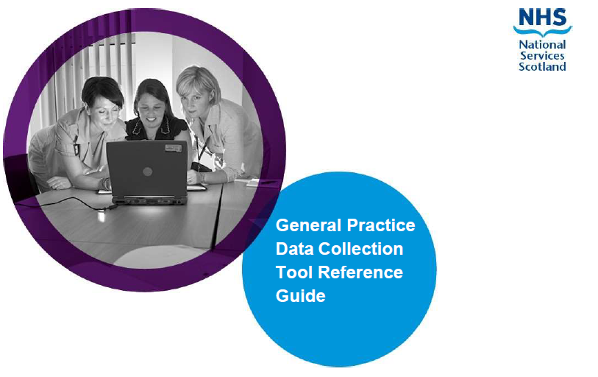



Introduction
The General Medical Services (GMS) framework document clearly sets out the need for robust and reliable data about General Practice. This collection is focusing on the workforce information at the practice level to allow accurate planning for a resilient and sustainable workforce..
The question set has been reviewed in agreement with a short life working group containing representation from BMA, RCGP and Scottish Government.
All GP practices have a contractual obligation to provide the following data to cover a 12 month period:
- individual staff data - job roles, contract type, hours/session worked, age and sex
- workforce data - Aggregate information on absences (sick leave, maternity/paternity leave, parental leave and special leave), temporary cover and vacancy information for in hours staff employed by the GP Practice

Information Governance
The level of personal information collected has been kept to a minimum and is required to process the information for publication and planning purposes. Identifiable information will not be published or shared with the Scottish Government. The information collected will be passed over to NHS Education for Scotland (NES) for analysis and publication. For the purpose of ongoing annual collection and to reduce the burden on practices the information is retained by NSS for re-presenting in future years collections.
Further information on NSS data protection policy can be found here: Data protection | National Services Scotland (nhs.scot)

Helpful Information
Before beginning the questionnaire, below are some of the information you may wish to have to hand to help with completion:
- Contract details for all staff members employed (including partners and GP trainees) between April 1st to March 31st, including start and leaving date details for all staff members that fall between these dates
- Date of Birth for all staff members
- NMC/GMC numbers
- Sickness and other absence information
- Vacancy information for the period from April 1st to March 31st
- Details of locum/sessional GP cover

Link to GMC lookup - The medical register - GMC (gmc-uk.org)
If you have any difficulties or queries that are not covered in this guidance document, please contact the Project Team at P&CFS: NSS.GPDataCollection@nhs.scot

Overview
The GP Workforce Data Collection App includes Guidance Notes, four sections, and a Submit button on the Finalise Year page. These need to be completed for the period from April 1st to March 31st:
Guidance Notes
1_Practice Information
2_Staff Information
3_Vacancies
4_Absences
5_Finalise Year
You can complete the survey in stages if you wish. You must save your answers before you leave the survey, this will save what you have entered to date and will appear when you go back in.
Please note that throughout this survey we require Doctor time to be recorded in sessions and non-Doctor time to be recorded in hours. This is relevant across all sections of the survey.

Accessing the App
You can access the App by following this Link

Begin the Survey ( Home page )
The app will show the details assigned to your current practice.
Please check if the assigned practice code & auto-completed user name are correct:
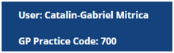
If not, You can submit a request by clicking the available button:

and an email process will be triggered for you to send the issue to the project team at NSS.GPDataCollection@nhs.scot before continuing.
From the home page, click on the Site Menu button:
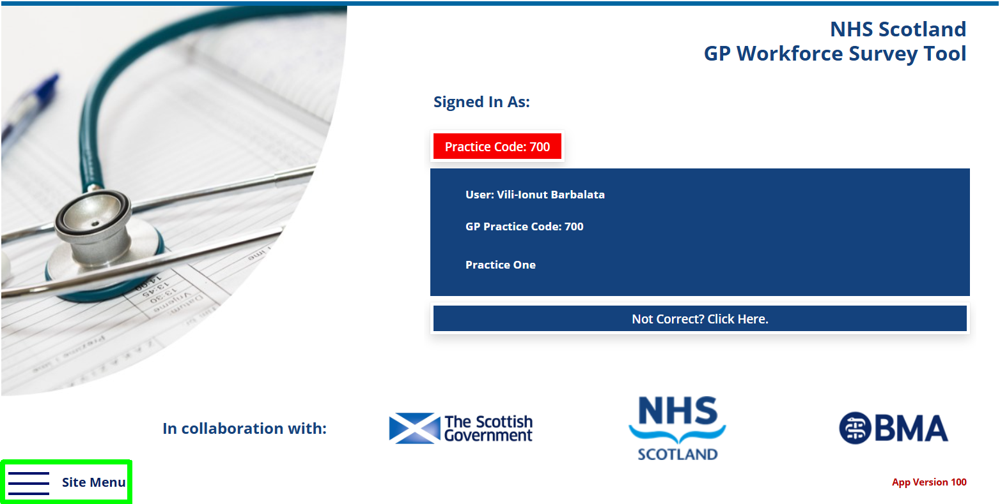

Select Practice Information from the Navigation bar:
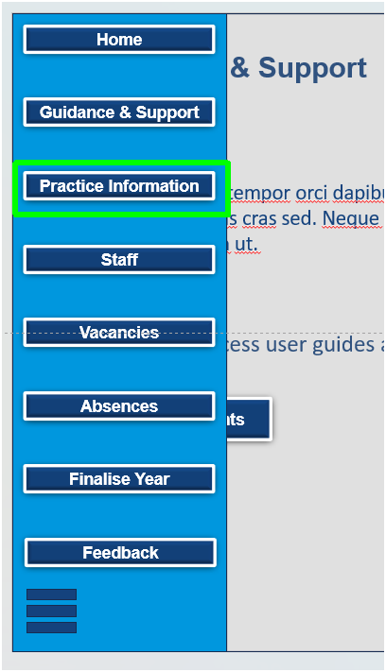

Practice Information

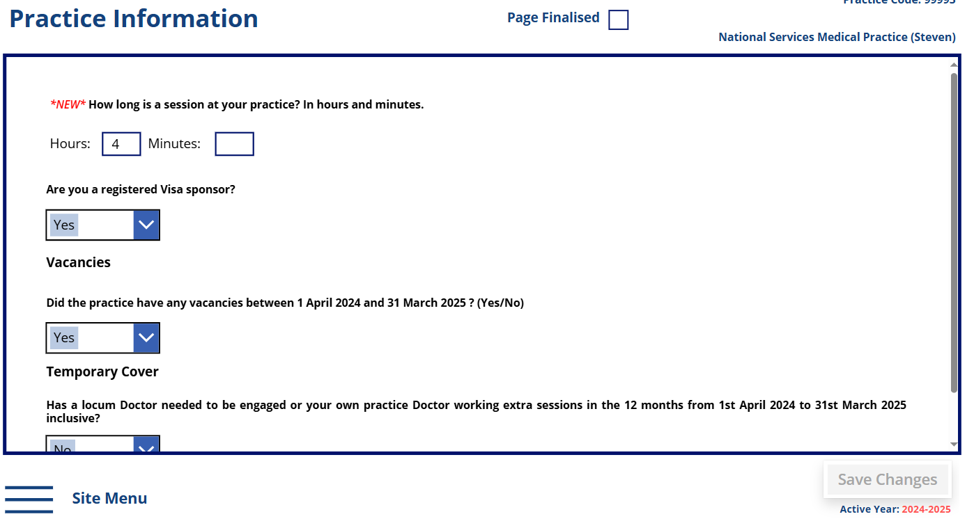
How long is a session at your practice? In hours and minutes. Please enter your session length.
Visa Sponsor – Does your Practice take part in the Visa Sponder Scheme
Vacancies – if you had any vacancies within the Practice in for the year please select Yes from the drop down menu, otherwise select No.
Temporary Cover – if you select Yes from the drop down menu, a further 3 questions will appear below
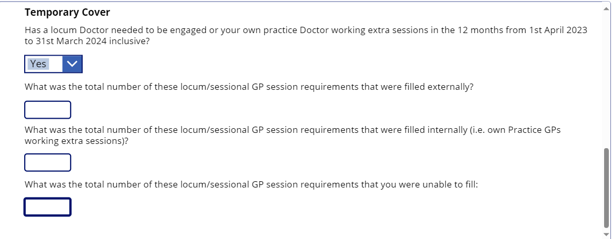
Please save your answers by selecting the Save Changes button (located at the bottom-right side):
Once you have saved your answers and you are ready for the end of year data submission, please proceed and select the Page Finalised checkbox located at the top of the page.

After this page is filled in, You can move to the next section by clicking on the Site menu and accessing the Staff option:
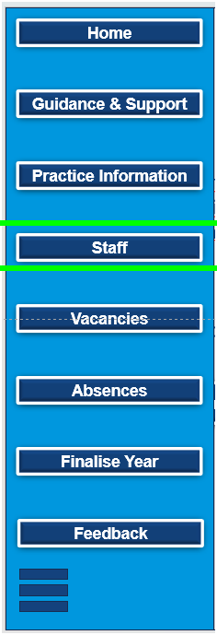

Staff Information
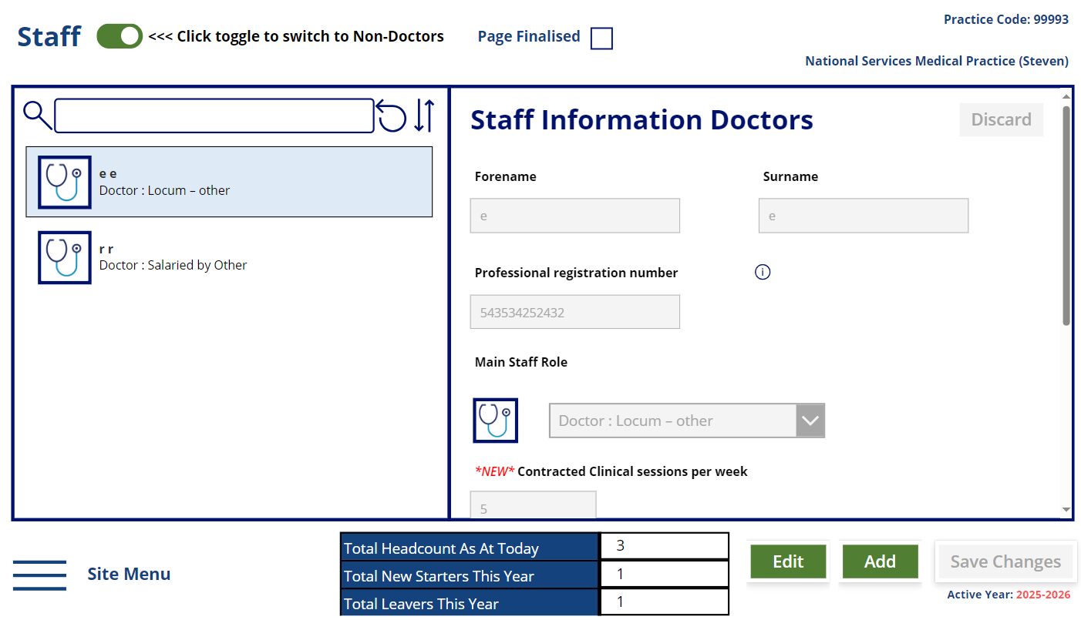

The table is for all staff in post, including partners and trainees throughout the 12 month period, April 1st to March 31st. You should include every staff member employed in a substantive post at any point during the 12 month period, across all staff groups, including partners and any trainees at your practice. You should include those on sabbatical, sick, maternity, paternity, parental, adoption or other leave.
The staff groups covered are:
- Doctor
- Non-Doctor Partners
- Nurse
- Other Direct Patient Care
- Admin/Non-clinical.
The page is divided into two views for adding staff: one for adding Doctors (which contains the Doctor groups) and one for adding Non-Doctors which contains the Non-Doctor Partners, Nurse, Other Direct Patient Care and Admin/Non-clinical groups.
Trainee Doctors are not required to be recorded in the App as this information is held by NES.

1.Adding a staff record:
1.1.In order to add Doctors or Non-Doctors staff, according to your need, the toggle in the upper left might need to be switched to either of the two options:
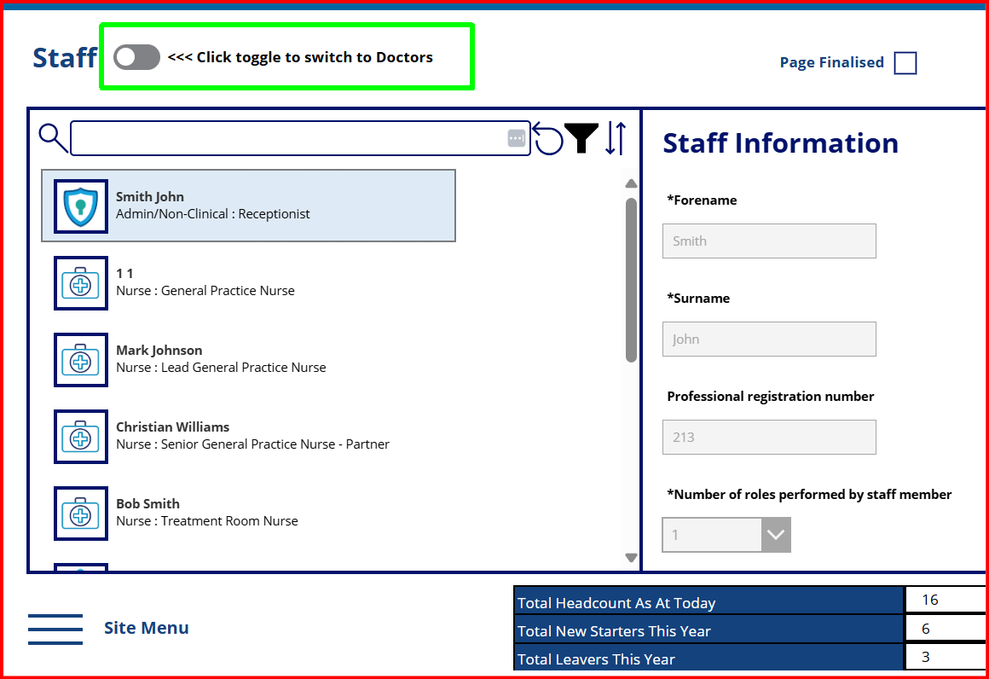
^ This switches between the two groups of staff and only the personnel belonging to the active view groups is shown in the list from the left sidebar.
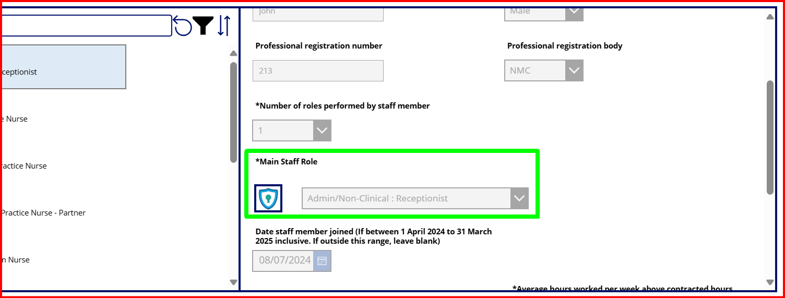
If you completed the data collection survey last year, the data you submitted will be pre-populated into the relevant columns. Note, as we move to a year round collection, the age field has been replaced with Date of Birth, this is to allow one off data entry, you will need to add Date of Birth for all staff to enable the calculation of age.
Date of Birth – if DOB is not known, please enter 01/04/1950. (this field is only visible on the Non-Doctors view)
If your Practice did not complete the data collection survey last year, this area will be blank and you will need to enter all information requested.
NB : Non Doctor Staff please enter the number of hours that the staff member is contracted for.
If you do not wish to enter staff members names, you can enter Initials only. Staff members names are important for us to identify individuals who may work across other Practices and also help you to identify whose information you enter.
Please be assured that names are confidential and are never published.
Dates for Date of Birth, Date staff member joined and Date staff member left can be selected using the calendar and drop down menus within.
1.2.After ensuring the right view is activated, please click the Add button (on the bottom-right side of the page):
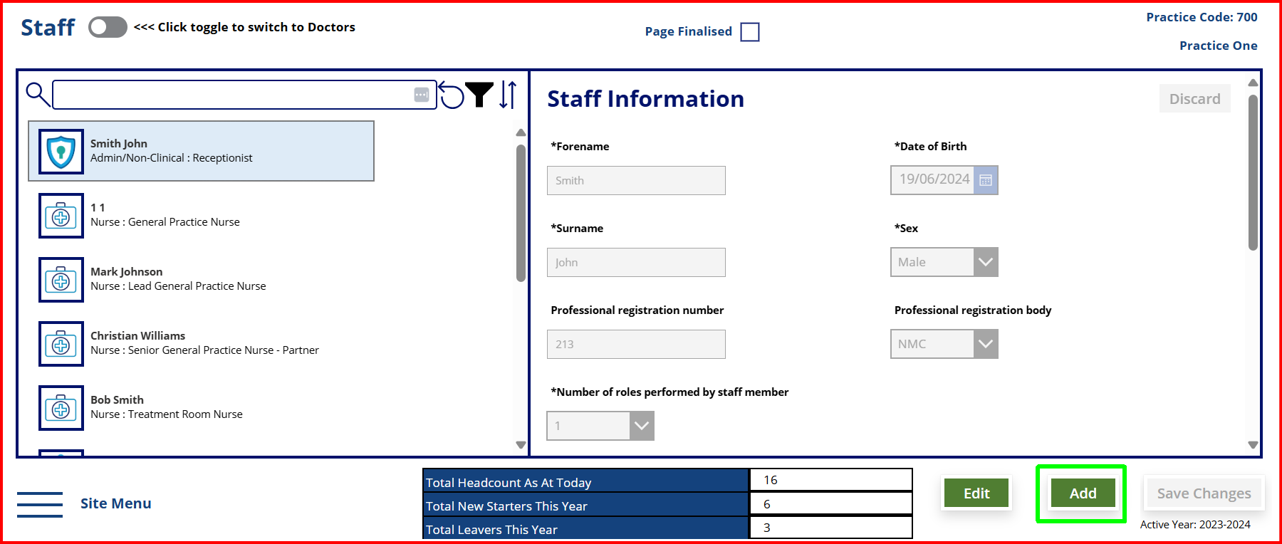
Red rectangles indicate mandatory fields that must be filled in before changes to the record can be saved:
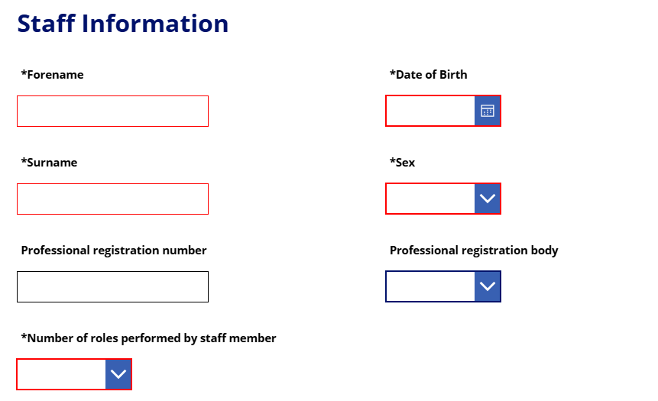
Please note that the staff pages features more fields that the ones present in the screenshot above. They are accessible by using the scroll bar on the right of the page by clicking & dragging the scroll bar or using the mouse scroll.
1.3. If you wish to enter more members of staff, click on the Add button again.
1.4. Once you have finished entering your data, please click on Save Changes.
1.5. Once you have saved your answers and you are ready for the end of year data submission, please proceed and select the Page Finalised checkbox located at the top of the page.

2.Editing an already existing staff record:
2.1.Select the record on the left side of the screen (a blue rectangle will appear over it):
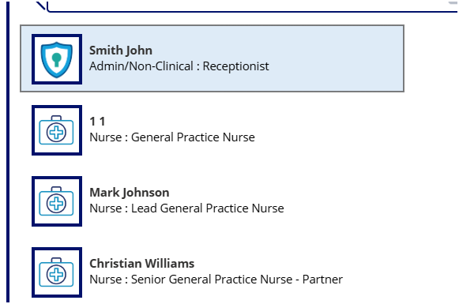
2.2.Press the Edit button in order to enable the record data insertion:

As a result, the fields color will switch from grey to white and You will be able to insert new data for said record.
Please note that the Site menu button will not be available while there is unsaved data. It can be re-enabled by pressing Save Changes or by using the Discard button (see point #4.).

3.Search, Filter and Sort options.
3.1. Search can be made based on First Name, Last Name or Staff group.
3.2. Filtering can be done by Staff Group (“Role”) by pressing on the funnel icon
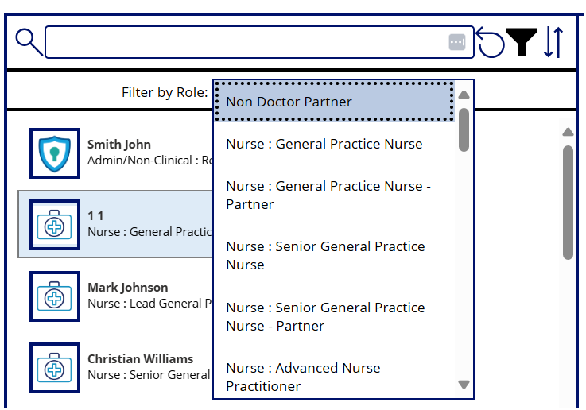
3.3. Sorting can be done by most recently added record or oldest record by pressing this button, located to the right of the search bar: 
In order to reset the list to the default state (newest to oldest), the  button can be used, also located in the same area.

4.Discard changes
If you wish to cancel your edits for the current record, please use the Discard button.
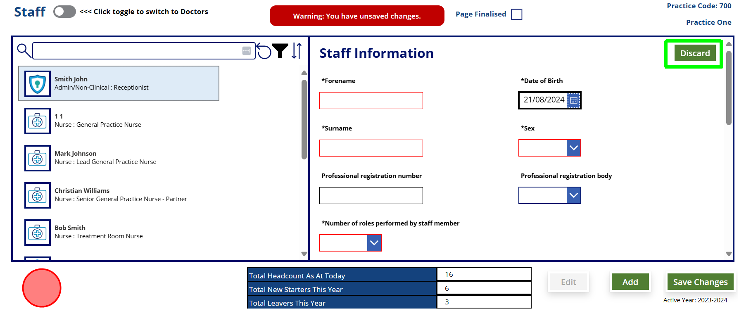
If you decide to navigate away while edits to a record have been inserted, but not saved, please note that the Site menu button will not be available while there is unsaved data.
Afterwards, You can proceed to the next page, Vacancies, by selecting the associated button from the site menu:
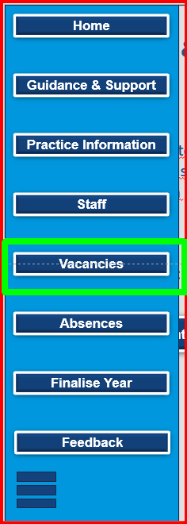

Vacancies
If your Practice did have vacancies (and You have answered ‘Yes’ to the Vacancies question on the Practice Information page), please select – Add New Record and begin completing your data.
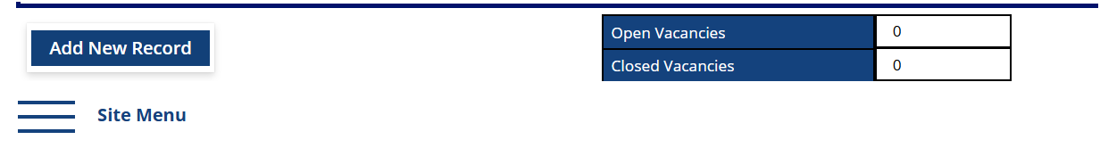
The Open Vacancies and Closed Vacancies fields from the table located at the bottom of the page are auto-calculated.If no Date is present for a record, the total will not take into account said record.
Please begin to fill in data by clicking in each box, according to your need:
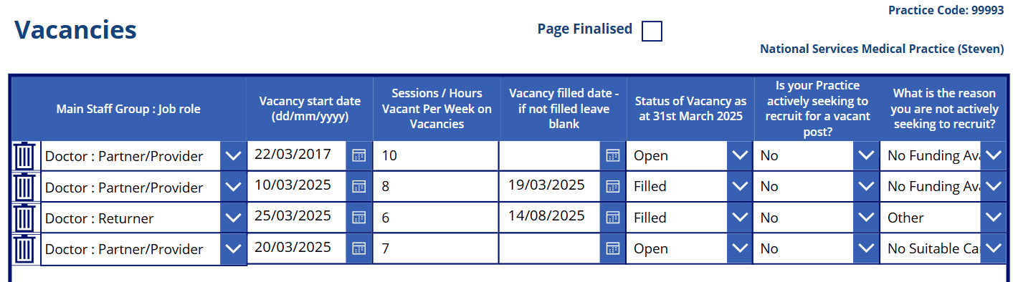
Once you have finished entering your data please press Save Changes:
Once you have saved your answers and you are ready for the end of year data submission, please proceed and select the Page Finalised checkbox located at the top of the page:
The page can be finalised without any record present, if the practice didn’t have any vacancies and You have answered ‘No’ to the Vacancies question on the Practice Information page.
The last page to be filled in is the Absences page and can be accessed by selecting the Absences button in the Site menu:
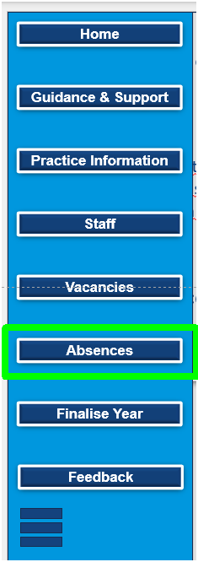

Absences
Please enter your data by clicking inside each grey box, where applicable. The sum for each column is calculated and shown at the top in the white cells. NB: This page can take upto 60 seconds to save your data. Please do not navigate away from this page until the save changes button turns green. 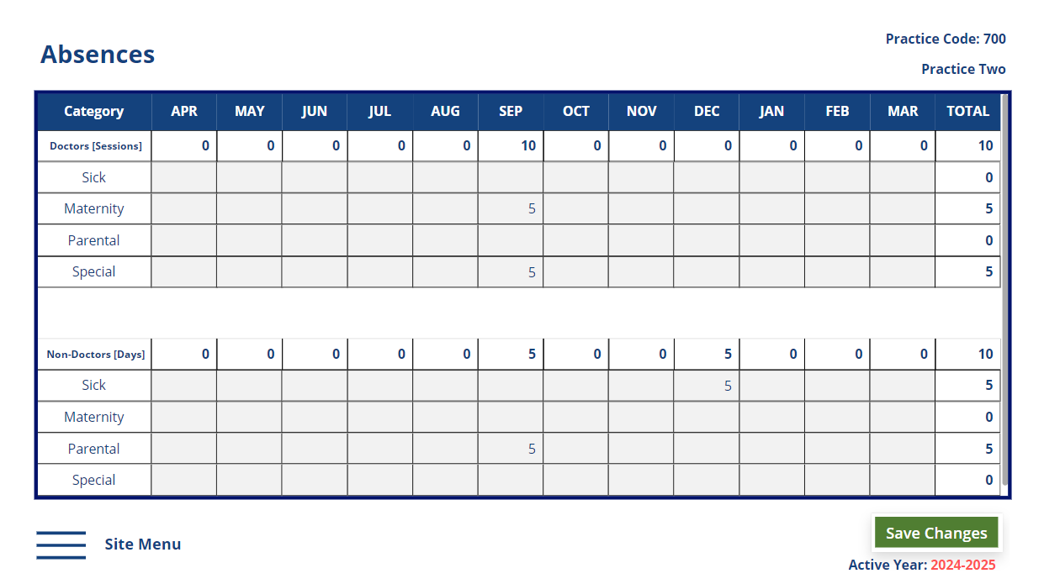
Please enter the details of the total absences for Doctor and Non-Doctor staff groups for the year from April 1st to March 31st. The absences should be split into total sick leave (including both paid and unpaid), maternity/paternity/adoption leave, parental leave and Special leave. Annual leave and public holidays should not be included.

Once you have completed entering your data, please click on Save Changes.
Please note that it may take a while for the sum to be reflected in the column totals (under 1 minute). After saving the changes, this notification will appear at the top of the page:
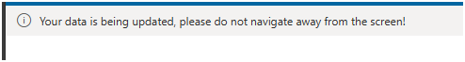

Doctor absences should be entered in number of sessions.
Non-doctor absences should be entered in hours.
To affect the total in the right-most column, you can enter custom numbers in the March column.
Once you have saved your answers and you are ready for the end of year data submission, please proceed and select the Page Finalised checkbox located at the top of the page.

Final Submission
After all of the pages have their checkboxes selected, the Finalise Year page can be accessed in order for You to Submit the data via pressing on the Site menu / Finalise Year button:
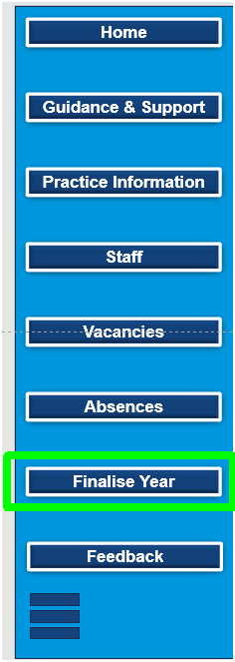
Please note that the Submit button is going to be disabled by default, if at least one of the checkboxes is not selected on the Practice Information, Staff, Vacancies and Absences pages.
Once again, the Vacancies page can be checked as finalised without any record present.
The checkboxes on the Finalise Year page are automatically checked here if they have been selected on each of the previous four pages in question; they are not editable on this page. If one of the checkboxes (or all) is NOT selected here, You must navigate to the page in question and select its associated Page Finalised checkbox located at the top of said page and then return to the Finalise Year page to complete your submission.
Please press on the Submit YYYY-YYYY Data button by 31st May. Upon clicking the button, an email will be sent to you containing CSV files of your data that you will be able to open in excel, should you wish to.

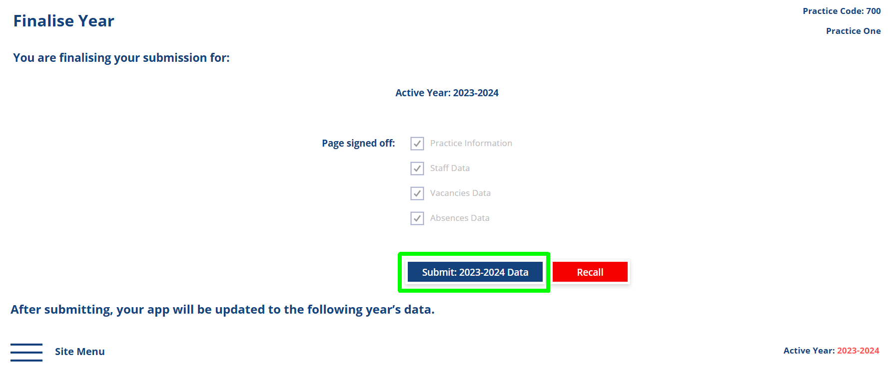

A notification will appear on the top of the page:

If you wish to update or amend your data, please click on Recall.
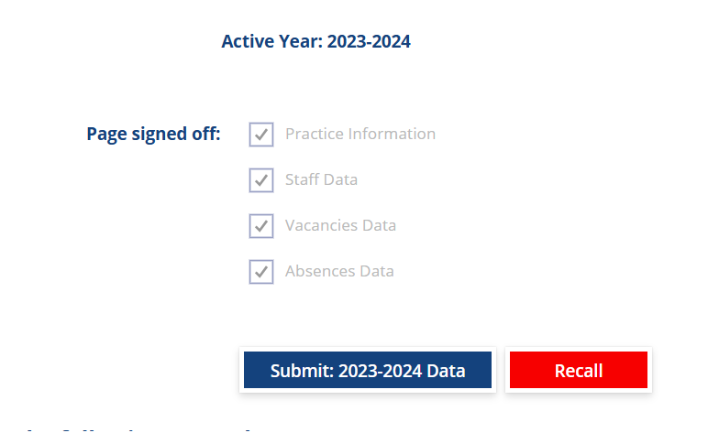
Doing this will uncheck all the four checkboxes so further edits can be made on the four pages.
After this is done, You can update or amend the relevant records, Save your changes on each page, return to the Finalise Year page and click on Submit YYYY-YYYY Data

Other Considerations
If at any moment you wish to return to the Home page, the Site menu / Home button can be used:
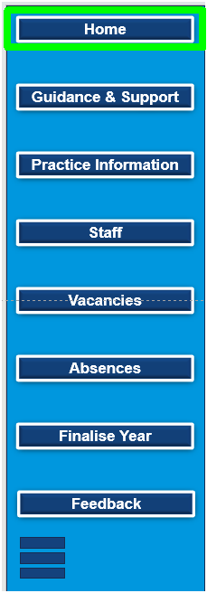
When an app update is available or in progress, you will be notified at the top of the page in a banner such as this one:
After the version is published, you will get the chance to update the app: by pressing on the Refresh button below. Doing this is highly recommended, in order to have the latest features that may solve some technical issues that are present.

-= Thank you for completing this data collection =-

