ePractitioner Certificate Renewal Guide

This is a quick reference guide to renewing the ePractitioner digital certificate using the electronic certificate management tool. You may, however, find that included with this letter you have been supplied with a PMR Software Provider specific insert which advises contacting their I.T. helpdesk in the first instance. In this case we would advise doing this before proceeding further. You may also wish to contact your local IT if they are normally involved with downloading and installation of certificates or applications on your server.

Additional Information: Initial Login Error Message.

You may see the below error message when attempting login:

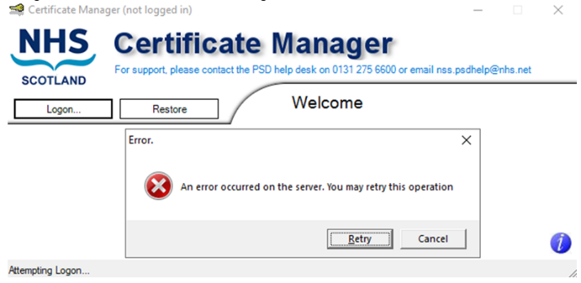

This is expected if a new version of the application is available, please click Cancel and close the CMT application. The new version of the application can be downloaded and automatically installed by going to the following page on your browser:

https://www.eps.nds.scot.nhs.uk/CCMS/install.html

This page will provide instructions for download, install and successful verification of installation:
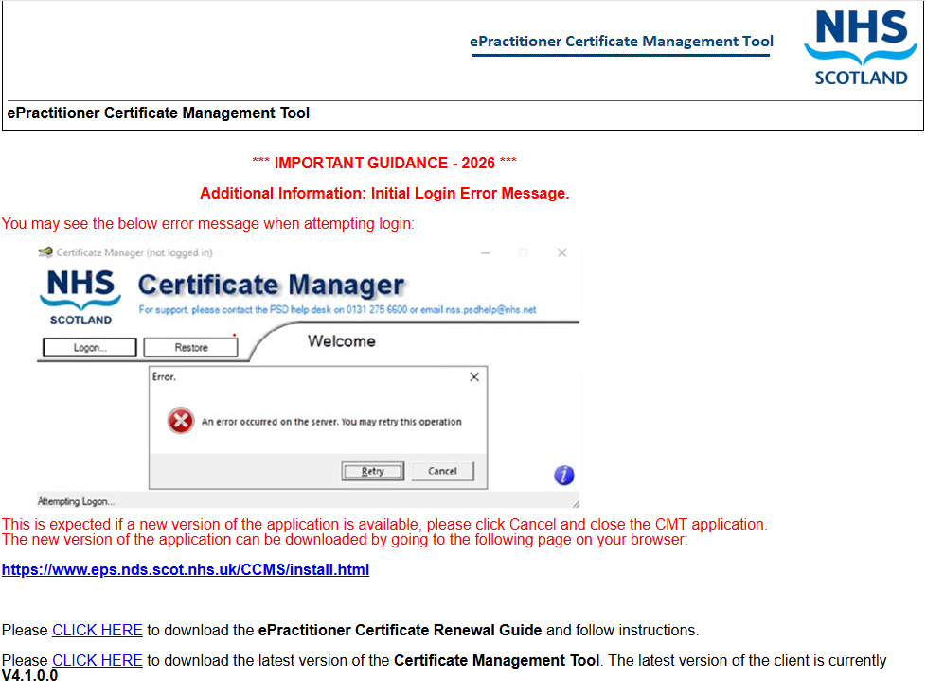

Pre-requisites for requesting a Certificate.
Before proceeding you will require:
- CMT updated to version 4.1.0.0
- Your ePractitioner PIN number (supplied on secure ePractitioner stationary).
- Administrator logon privileges.
Identify where eCMT may be started from.  There may be a shortcut on the machine desktop which can be used to access eCMT, as shown. | 

Alternatively, eCMT can be accessed via the Windows Start menu, as follows: -
Windows Start
-> All Programs
-> Certificate Manager
-> Certificate Manager

Start eCMT to run as Administrator by either:
- Right click Certificate Manager from Start Menu and select Run as Administrator.
- Right click Certificate Manager desktop shortcut and choose ‘Properties’. Select the ‘Compatibility’ tab and tick the box titled ‘Run this program as an administrator’. Click ‘Apply’ and then ‘OK’

The below confirmation request message will always be displayed.

User will be required to confirm that they have selected to run as Administrator.  Select Yes to confirm.  Select No if Run as Administrator has not been selected and restart with Administrator privileges. | 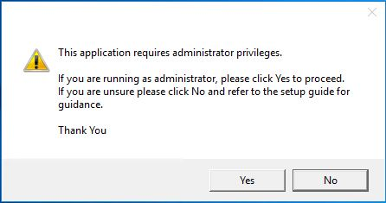
eCMT will start up and perform initial checks for updates.  The latest version of the CMT must be used. This is currently version 4.0.8.0, as shown opposite. |  | 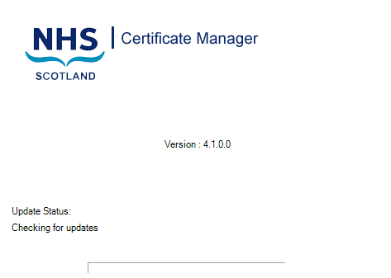
If you are offered version v3.0.0.2 (shown opposite) or any version less than v4.1.0.0, please upgrade to the new version from the following location:  https://www.eps.nds.scot.nhs.uk/CCMS/install.html |  | 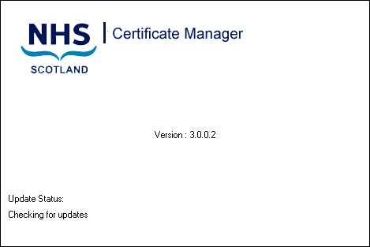
Log in to the eCMT.  - Press the ‘Logon’ button on the Welcome screen. |  | 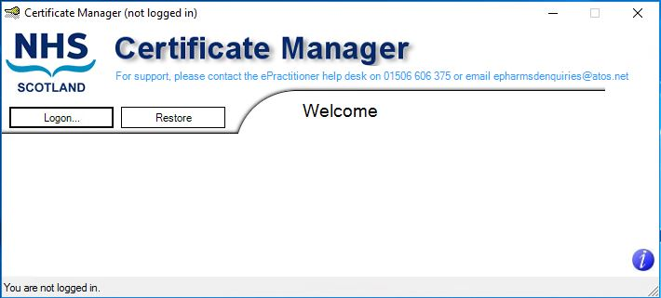
Validate credentials.  - Your EPOC number should be pre-filled in the EPOC field. If it is not, please call the Helpdesk and they will provide it.  - Enter the PIN number provided and press ‘Submit’.  - (If you have more than one PIN, please use the most recent). |  | 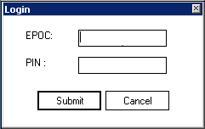
The main certificate management overview screen will now be presented.  Request and Download certificate.  - Press the ‘Request and Download Cert’ button. |  | 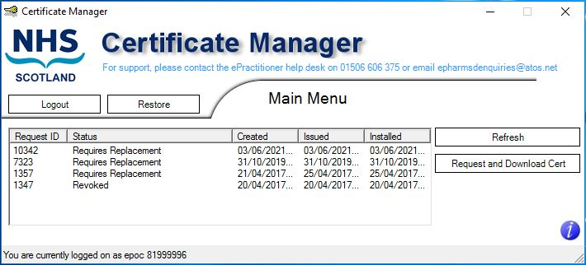
Accept Client Terms and Conditions.  - Read the Acceptable Use Policy of the Client Certificate Management Service and press the ‘I accept’ button. |  | 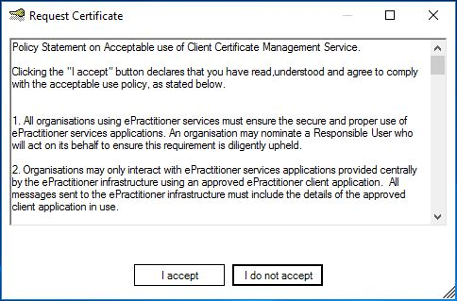
Choose Backup or No Backup.  - Once the certificate has been downloaded successfully you will be offered the option to back up the new certificate. Click the ‘Yes’ button to do so, if required. |  | 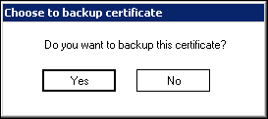

Backup the certificate.  - Select a folder location and choose a filename and secure password that you will remember.  - (Your Board may have advised of a folder location to save the certificate backup).  - Click the ‘Backup’ button to back the certificate up to the desired location. |  | 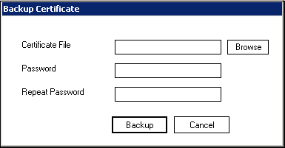  Note: The password must be at least 8 characters long, must contain at least one upper case character (A,B,C…), at least one lower case character (a,b,c…) and at least one numeric character (1,2,3…).
Confirmation will be provided of successful certificate download, install and backup. | 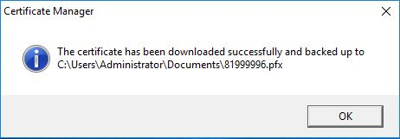
The main certificate management overview screen will be presented to the user displaying the details of the status of the request. | 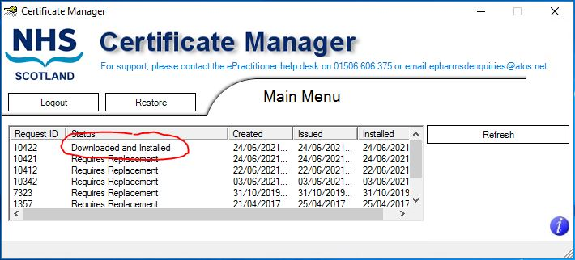

Please be aware that for ePharmacy users, PCR and PCRUA will be unavailable immediately following a certificate renewal. Access to these systems should be available 30-40 minutes after the certificate update.

For more information on the ePractitioner Certificate Renewal process please contact the ePractitioner helpdesk on 02045 836 906.

For any other queries please contact your NHS helpdesk:
- NHS PDS Helpdesk (0131 275 6600) for Pharmacy & GP practices
- NHS PDS Dental Helpdesk (0345 034 2458) for Dental & Ophthalmic practices.

