. 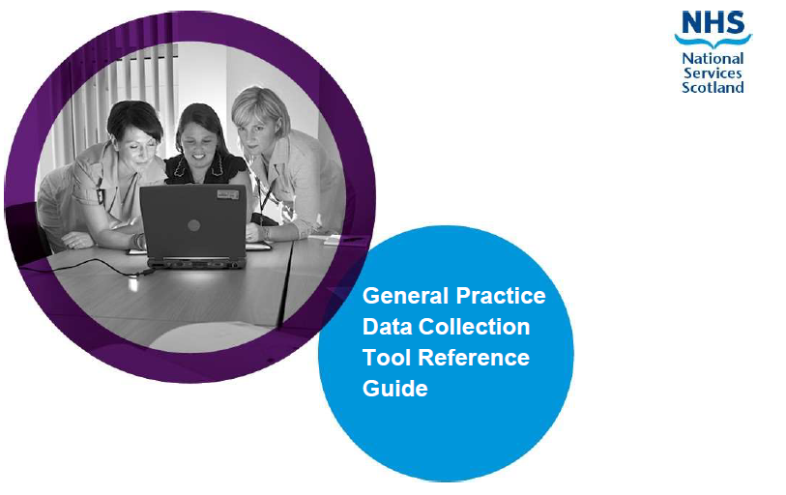



Contents
1. Introduction 2
2. Before you start 4
3. Overview 5
4. Accessing the App 6
5. Using the App 6
6. Home page 7
7. Declaration Forms 8
8. Practice Information 8
9. Staff Information 11
9.1 Which Staff are Included 11
9.2 Adding a staff record: 12
9.3 Editing an already existing staff record 15
9.4 Search, Filter and Sort options. 16
9.5 Finalising the staff data submission 16
10. Vacancies 17
11. Absences 19
12. Final Submission 20
13. Other Considerations 22

Introduction
The General Medical Services (GMS) framework document clearly sets out the need for robust and reliable data about General Practice. This collection is focussed on the workforce information at the practice level to allow accurate planning for a resilient and sustainable workforce.
The questions set undergo ongoing review in agreement with a short life working group containing representation from BMA, RCGP and Scottish Government.
Further questions have also been agreed with the BMA to support the oversight of the new investment in core general practice which includes £310 million allocated over the next three years to expand the general practice workforce.

All GP practices have a contractual obligation to provide the following data:
- individual staff data - job roles, contract type, hours/session worked, age and sex
- workforce data - Aggregate information on absences (sick leave, maternity/paternity leave, parental leave and special leave), temporary cover and vacancy information for in hours staff employed by the GP Practice
From 1 Apil 2026 the survey will be undertaken quarterly. This edition of the survey will cover the period 1st April 2026 to 30th June 2026.
The data collection App will be pre-populated with information based on your previous return. Practices will need to be update this information to provide accurate data on the workforce for the reporting period.

Information Governance
The level of personal information collected has been kept to a minimum and is required to process the information for publication and planning purposes. Identifiable information on individual staff will not be published or shared with Health Boards or the Scottish Government. The information will now be collected, analysed and published by Public Service Delivery Scotland. For the purpose of ongoing annual collection and to reduce the burden on practices the information is retained by NSS and its successor Public Services Delivery Scotland (PSDS) for re-presenting in future years collections.
The data will be used by PSDS to produce an annual publication on the General Practice Workforce which will be made available on the PSDS website. As in previous years, this will contain aggregate level data, and it will not be possible to identify individual GP Practices or individual members of staff.
The data will also be used by Health Boards to verify intended and actual increases to the General Practice workforce at a practice level. To facilitate this, PSDS will provide password protected dashboards to identified Health Board representatives with the capacity of the workforce at practice level by staff type.

Freedom of Information
We are committed to openness and transparency in accordance with the Freedom of Information (Scotland) Act 2002 (FOISA). Please note that information held by our organisation may be subject to disclosure under the Freedom of Information (Scotland) Act 2002 (FOISA). This means that any recorded information we hold, including correspondence and documents, could be released in response to a valid FOI request, unless an exemption applies such as the release of identifiable information.
If you do not wish to enter staff members names, you can enter Initials only. Staff members names are important for us to identify individuals who may work across other Practices and help you to identify whose information you enter. Names are treated as confidential and will never be published.
Further information on Public Services Scotland data protection policy can be found on the NSS website.

Before you start
Before beginning the questionnaire, you may want to gather the following information to help with completion:
- Progress in expanding the practice workforce utilising the £15m Workforce Payment issued in September 2025.
- An agreed plan for the practice’s intentions to utilise the additional Workforce Funding to expand and/or redesign the practice workforce. This needs to be in line with Core Funding Increase for Workforce Capacity Guidance for General Practice issued on 23 March 2026, and the associated Annex B and Annex C guidance on Practice Intentions to Expand the Workforce and the Release of Tranche 2 Funding.
- Your intentions for funding freed up in the Global Sum as a result of expenses investment (whether you plan to use this to increase workforce capacity or to address other sustainability pressures).
- Contract details for all staff members employed (including partners and GP trainees) between 1st April 2026 to 30th June 2026, including start and leaving date details for all staff members that fall between these dates
- Date of Birth for all staff members (used to identify the age profile of the workforce)
- NMC/GMC numbers (used for unique identification of nurses and doctors and for linking to NPCCD)
- Sickness and other absence information
- Vacancy information for the period from 1st April 2026 to 30th June 2026
- Details of locum/sessional GP cover

Registration numbers can be found on the NMC and GMC websites.
If you have any difficulties or queries that are not covered in this guidance document, please contact nss.gpdatacollection@nhs.scot
The Scottish Practice Management Development Network, together with its Local Coordinators, has extensive experience and expertise and can offer assistance. Please contact practicemanager@nes.scot.nhs.uk with any queries.

Overview
The GP Workforce Data Collection App includes Guidance Notes, six data entry sections and a Submit button on the Finalise Year page. 4 of these need to be completed for the period from 1st April 2026 to 30th June 2026.
The six data entry sections of the return cover:
Declaration Form Part 1 and Part 2:
These sections are in place this quarter purely to check over the data you entered, the email sent will include key updates required to look into.
These sections are being displayed for your information.
Practice Information:
Contains high level information on the practice
Staff Information:
A list of staff who work at the practice, with details on their roles and hours worked
Vacancies:
A list of vacancies within the practice
Absences:
The total of hours and sessions that staff have been absent in the practice each month
Finalise Year:
You can complete the survey in stages if you wish. You must save your answers before you leave the survey, this will save what you have entered to date and will appear when you go back in.
Please note that throughout this survey we require Doctor time to be recorded in sessions and non-Doctor time to be recorded in hours. This is relevant across all sections of the survey.

Accessing the App
You can access the App by following this Link.
If you cannot access the App, please contact us using the email here - NSS.GPDataCollection@nhs.scot. Note this mailbox is only monitored Monday – Friday during normal business hours. There is often a high volume of queries coming into the mailbox so please be patient.

Using the App

On each page are the following buttons:
Site Menu – This button brings up the navigation pane allowing you to get to each section of the survey.
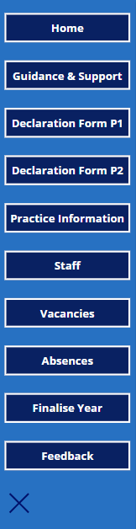

Home page
The app will show your username and GP Practice Code. Please check that these are correct.
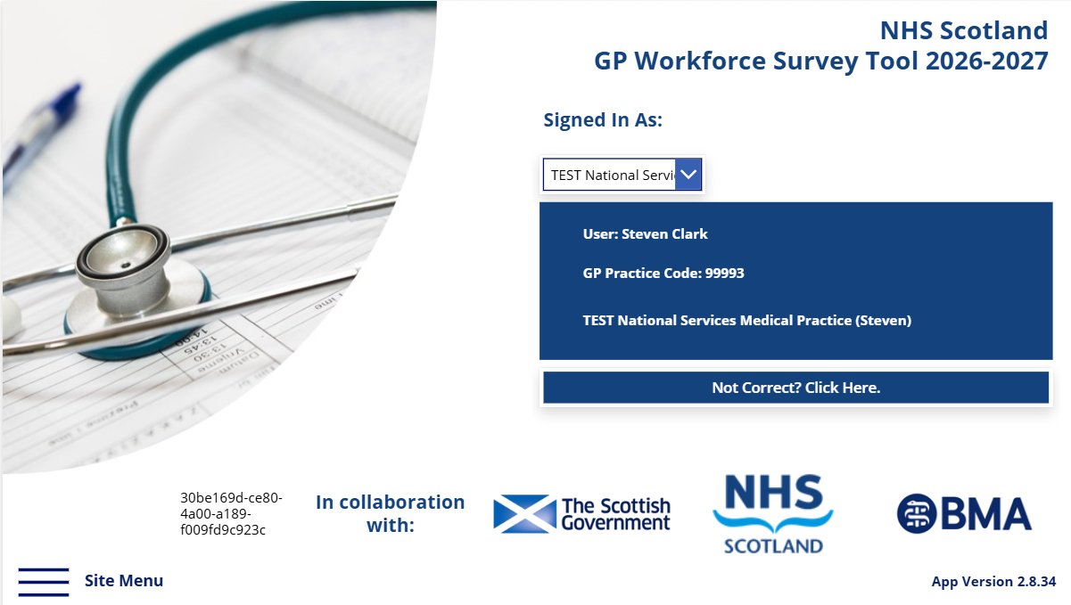
If not, submit a request by clicking the “Not Correct” button, which generates an email to the project team at NSS.GPDataCollection@nhs.scot before continuing. Note this mailbox is only monitored Monday – Friday during normal business hours. There is often a high volume of queries coming into the mailbox so please be patient.

From the home page, click on the Site Menu button:
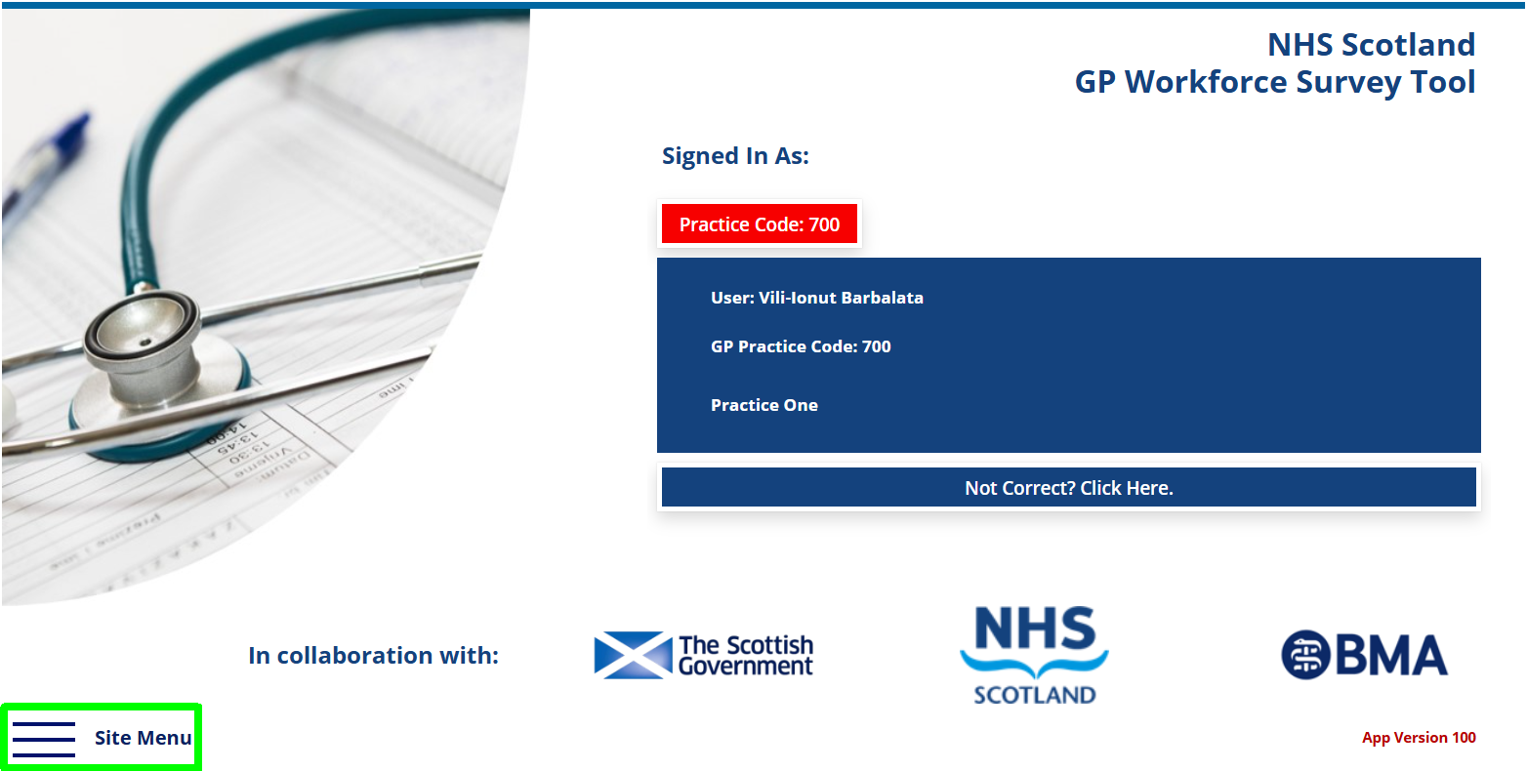

Declaration Forms
Declaration Form Part 1 (2025/26 Workforce Payment) and Part 2, Section 1 (Expenses Reimbursement) are available this quarter to allow practices to review and, where necessary, amend information submitted as part of the annual return.
Practices should review and update Declaration Form Part 2, Section 2 (Workforce intentions) as necessary to reflect current plans., The email sent will include key updates required to look into.

Practice Information

From the Site Menu, select Practice Information from the Navigation pane, you will be presented with this screen for completion:
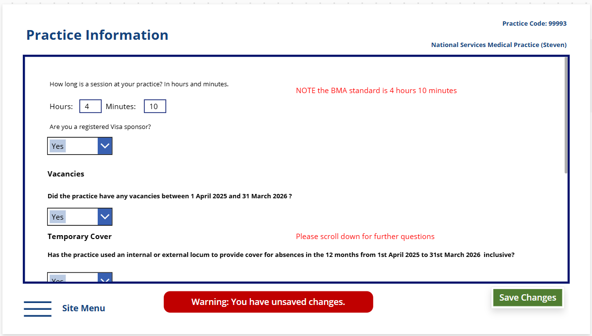
How long is a session at your practice? In hours and minutes. Please enter the length of a GP session.
The Current BMA standard for a Salaried GP session is 4 hours 10 minutes. More information can be found here
Visa Sponsor – Please enter whether the practice is registered with the Home Office to sponsor GPs who require a visa to work in the UK.
More information about GP Visa Sponsorship can be found here.
Vacancies – if you had any vacancies within the Practice for the reporting period please select Yes from the drop-down menu, otherwise select No.
Temporary Cover – if you have used an internal or external locum to provide temporary cover for when a GP is absent from work select Yes from the drop-down menu, a further 3 questions will appear below. Otherwise select No.
Temporary cover is defined as cover for holiday, sickness leave, parental leave, or other absence. It does not include cover for vacant posts.
The following questions only appear if you select ‘Yes’ to the question about Temporary Cover:
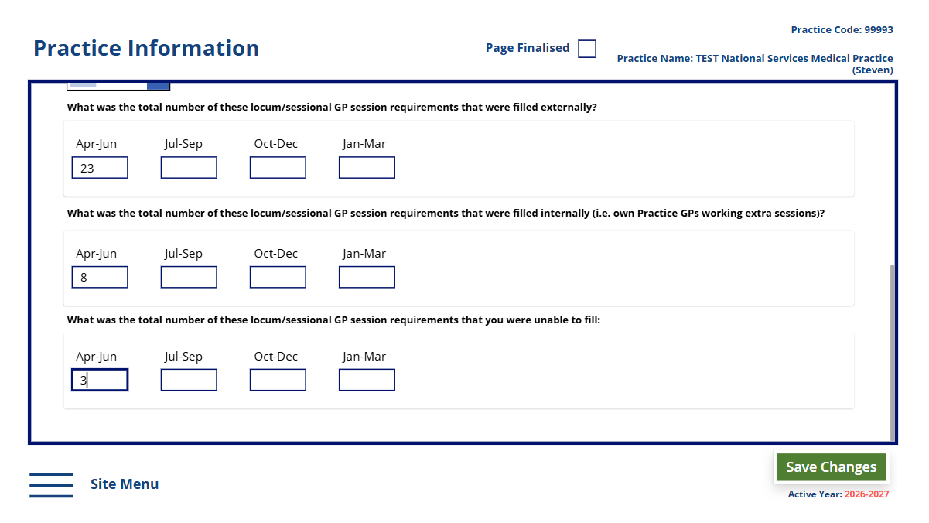
Has the Practice used an internal or external locum to provide cover for absences in the 3 months from 1st April 2026 to 30th June 2026 inclusive – Yes/No.
An internal locum is a GP already working within the practice who works an additional session to cover the absence. An external locum is a GP who does not already work in the practice and is employed specifically to cover the absence.
If you select Yes from the drop-down menu, a further 3 questions will appear below.
How many sessions were covered by an external locum – Enter the number of locum sessions filled by Doctors who were not employed by the practice
How many sessions were covered by an internal locum (i.e. own Practice GPs working extra sessions) – Enter the number of locum sessions filled by Doctors who worked for the Practice
How many sessions were you unable to cover by either an internal or an external locum – Enter the number of locum sessions that you tried to fill, that you were unable to

Please save your answers by selecting the Save Changes button (located at the bottom-right side):

Staff Information
To add or update staff information click on the Site menu and select Staff from the Navigation pane:

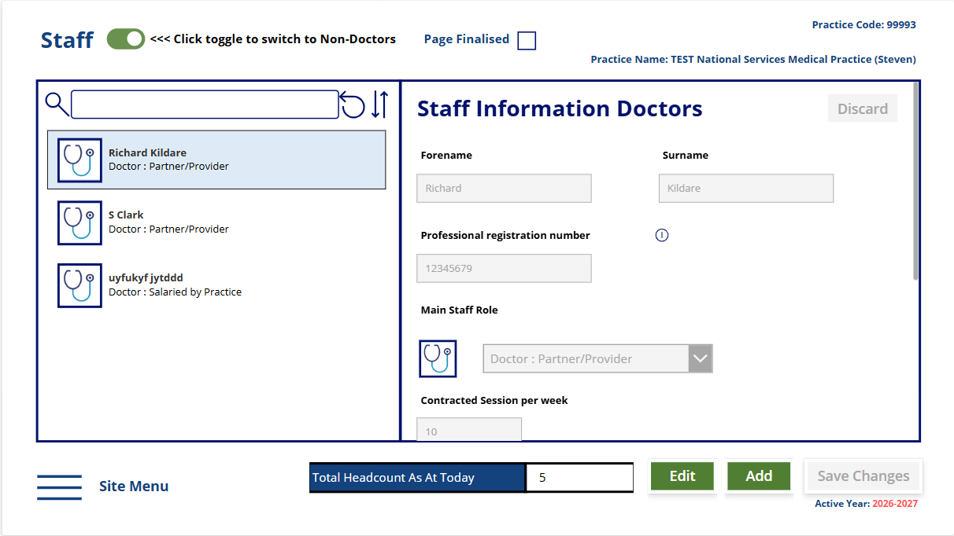

Which Staff are Included

All staff employed in a substantive post across all staff groups, including partners. Trainee Doctors are not required to be recorded in the App as this information is held by NES.
You should include those on sabbatical, sick, maternity, paternity, parental, adoption or other leave.
The page is divided into two views for adding staff:
- Doctors - which contains the Doctor groups
- Non-Doctors which contains the
  - Non-Doctor Partners,
  - Nurse,
  - Other Direct Patient Care and
  - Admin/Non-clinical groups.

Adding a staff record:

If any staff have joined the practice since the last time the practice submitted a survey, they should be added to the survey app.
1.1. Use the toggle in the top left to select Doctors or Non-Doctors:
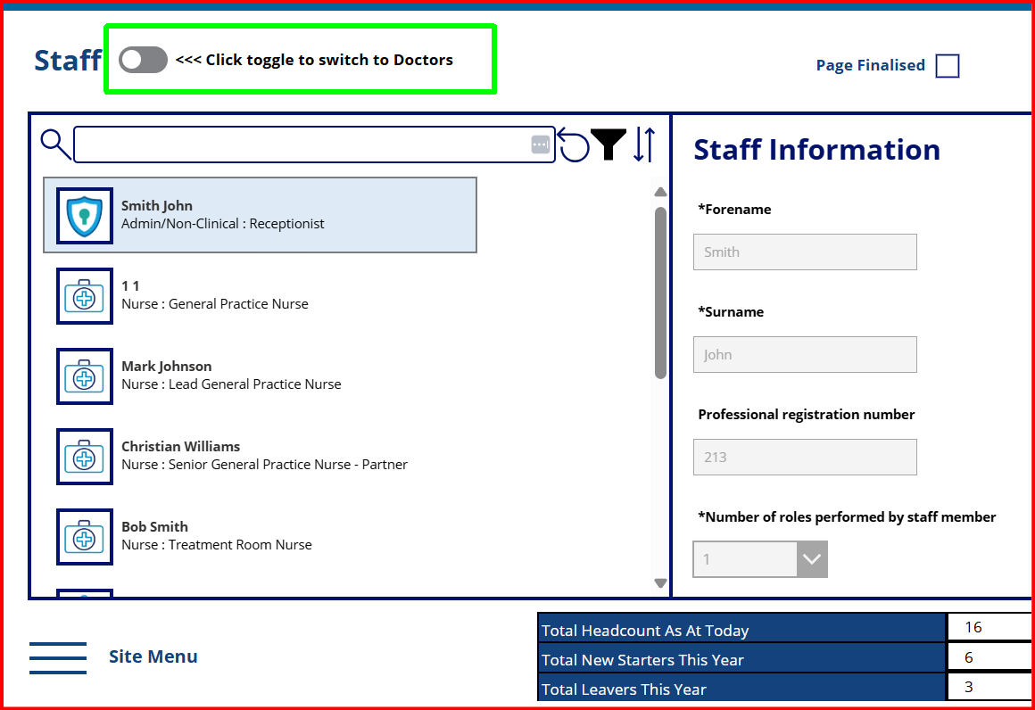
This switches between the two groups of staff and only the staff belonging to this Staff Group are shown in the left sidebar.
You can amend an existing staff member by scrolling down on the left-hand side and locating the record for that member of staff. There is a search bar also that can be used to locate the record.
To add a new member of staff, click on the Add button (bottom-right side of the page):
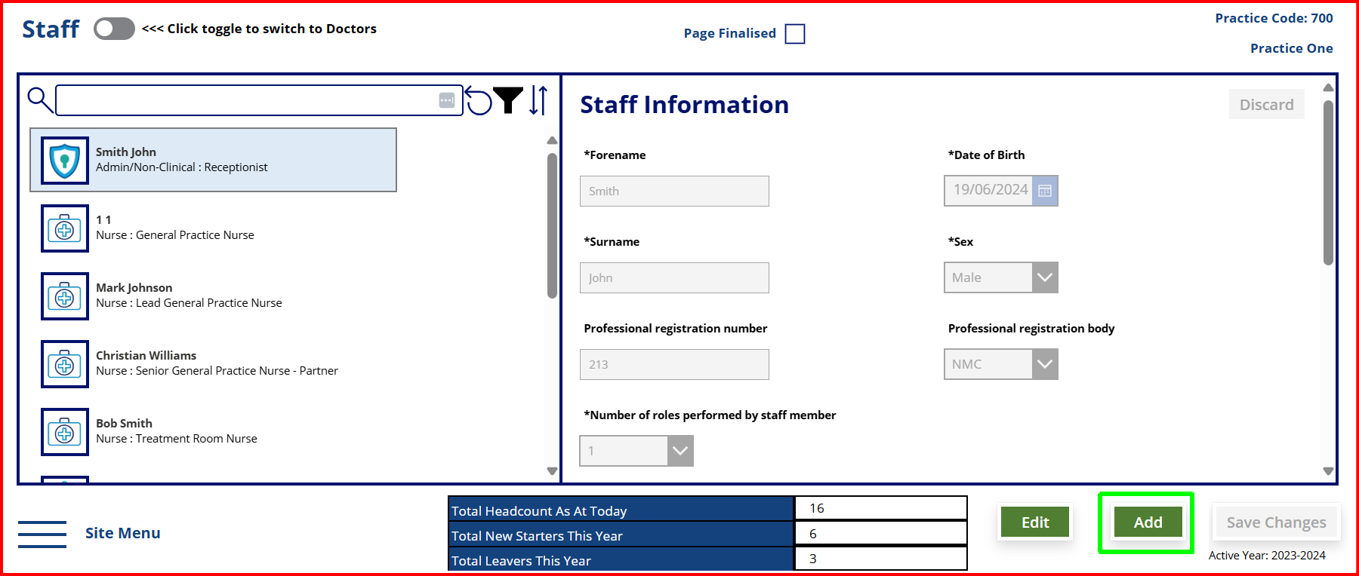
The staff pages features more fields that the ones present in the screenshot above. They are accessible by using the scroll bar on the right of the page by clicking & dragging the scroll bar or using the mouse scroll.
Forename – First name of staff member
Surname – Last name of staff member
If you do not wish to enter staff members names, you can enter Initials only. Staff members names are important for us to identify individuals who may work across other Practices and help you to identify whose information you enter. Names are treated as confidential and will never be published.
Date of Birth – Please enter as 01/MM/YYYY if DOB is not known, please enter 01/04/1950. (this field is only visible on the Non-Doctors view)
Sex – Select from Male/Female/Prefer not to say/Unknown
Professional registration number – If a staff member has a professional registration, please enter the number.
Professional registration body - If a staff member has a professional registration, please enter the body that staff is registered with.
Number of roles performed by staff member – If staff member performs multiple roles across the practice, please enter the number of different roles they perform
For example: A healthcare assistant could also work as a receptionist.
Main Staff Role – The main role that the staff member performs in that practice.
Please use this link to the General Practice Nurse (GPN) Development Framework that sets out the different levels, roles and responsibilities of GPNs to enable you to submit accurate data for this staffing group. General Practice Nursing (GPN) Development Framework | Turas | Learn
Date staff member joined – Date staff member started their employment within the practice
Date staff member left – Date staff member ended their employment within the practice
Hours/Sessions Worked – If member of staff is in a Doctor role, enter the number of sessions per week, otherwise enter the number of hours that the staff member is contracted for.
Dates for Date of Birth, Date staff member joined and Date staff member left can be selected using the calendar and drop-down menus.
Red rectangles indicate mandatory fields that must be filled in before changes to the record can be saved:
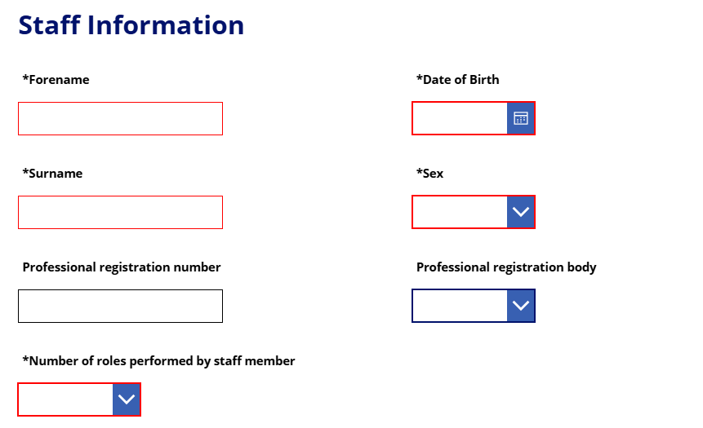
1.2. Once all fields have been completed, ensure you save your changes by clicking on the save changes button.
1.3. To add more staff, click on the Add button again, using the toggle to switch between Doctors and Non-Doctors as necessary
1.4 To discard any changes you have made, use the Discard button in the upper left.
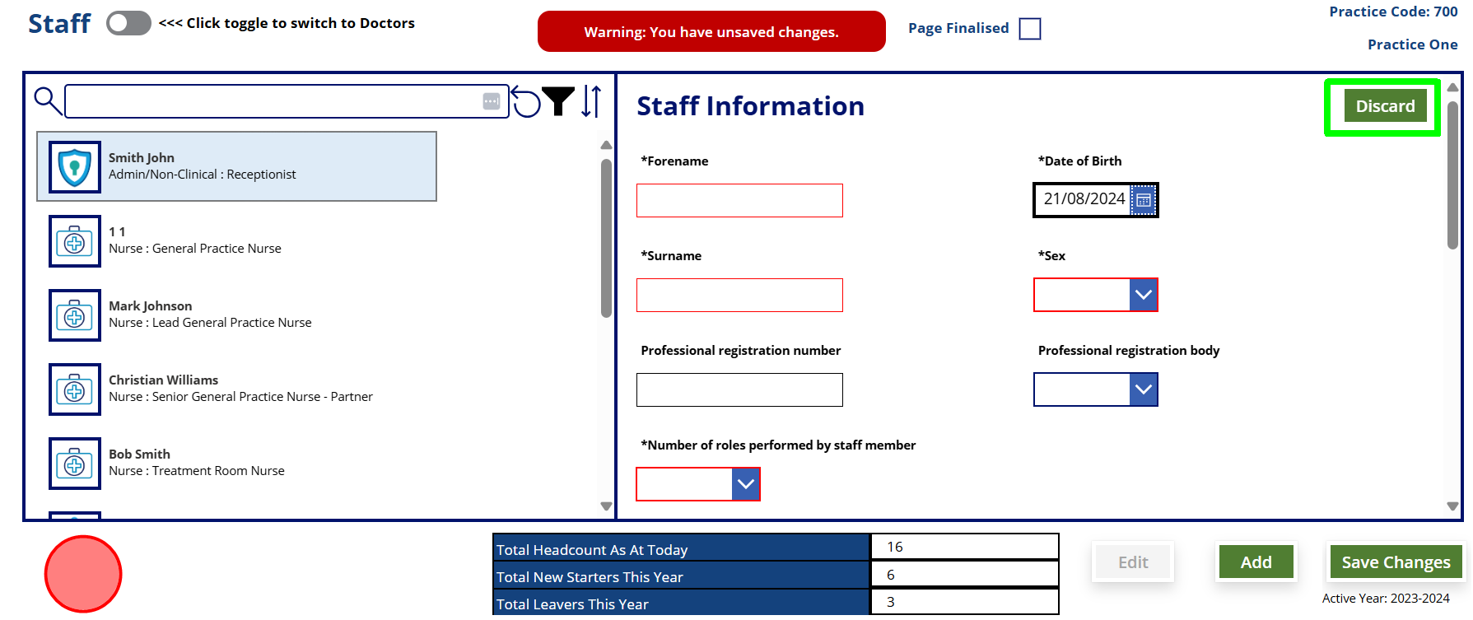

If you decide to navigate away while edits to a record have been made, but not saved, please note that the Site menu button will not be available while there is unsaved data.

Editing an already existing staff record
If a staff member has changed jobs, or left, since the previous submission, their current record should be updated with a leave date. You must not delete the record.
2.1. Select the relevant staff members record on the left side of the screen (a blue rectangle will appear over it):
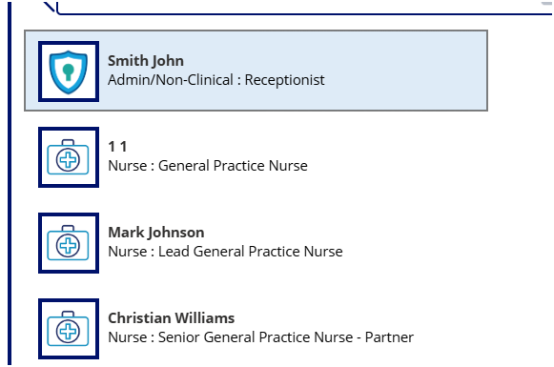
2.2. Press the Edit button:

As a result, the fields colour will switch from grey to white and you will be able to update the staff record.
Once the updates have been made, they can be Saved using the Save Changes button.
To discard any changes made to that staff’s record, use the Discard button
Please note that the Site menu button will not be available while there is unsaved data.
It can be re-enabled by pressing Save Changes or by using the Discard button.

Search, Filter and Sort options.
At the top of the list of staff on the upper left are options to search, filter and sort the staff records
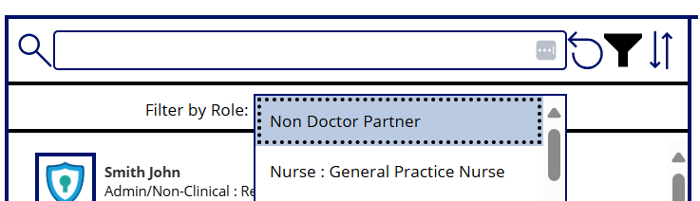
- Search by First Name, Last Name or Staff group
 - Filter by Staff Group
- Sort staff records by Date added
 - reset the list to the default state

Finalising the staff data submission

Once you have added any new staff, and if necessary, made updates to the current staff, please select Save, then tick the Page Finalised tick box at the top of the page.

Vacancies

For the purpose of this collection a vacancy is defined as an established, funded post within a practice that is currently unfilled and is actively being recruited to.
This does not include posts that are currently being filled by locums, as this data is collected through the staff information.
To add or update Vacancy information click on the Site menu and select Vacancies from the Navigation pane:
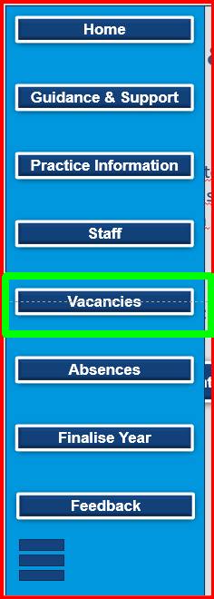
To add a new vacancy, please select – Add New Record.
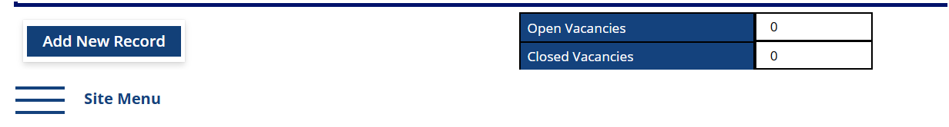
Main Staff Group: Job Role – Enter the main staff group and job role the vacancy is aiming to fill
Vacancy Start Date – Use the date the advert was posted.
Sessions/ Hours per week – How many Sessions (for Doctors) or Hours (for non doctors) is the post the vacancy is trying to fill.
Vacancy filled date – The date that the member of staff who was succesful started in post. If a candidate is due to start in the future, this start date can be used.
Status of Vacancy – What is the status of the vacancy at the end of the quarter. If a candidate has been appointed but not started, this can be classed as filled.
Is your practice actively seeking to recruit for a vacant post – Is the practice actively seeking a candidate, e.g. is there a live advert for the post. If a candidate has been appointed but not started then capture them here.
What is the reason you are not actively seeking to recruit – If you have selected no to the previous question, please select the reason you are not currently seeking to recruit.
No Funding available – There is a gap in the service you are wanting to provide, but there is no current funding for this.
No Suitable candidate – There is funding for the position, but when the post was advertised, no suitable candidate applied or succesful at interview.
The Open Vacancies and Closed Vacancies fields from the table located at the bottom of the page are auto-calculated. If no Date is present for a record, the total will not take into account said record.
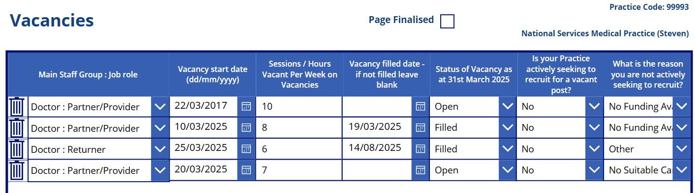

Once you have finished entering your data please press Save Changes, and once again select page finalised on the pop-up box when it appears if you have completed all your information.
The page can be finalised without any record present, if the practice didn’t have any vacancies and You have answered ‘No’ to the Vacancies question on the Practice Information page.

Absences

To add or update Absence information click on the Site menu and select Absences from the Navigation pane:
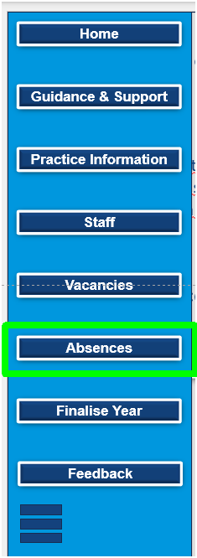
Please enter the monthly absence data in each grey box. The sum for each column is calculated and shown at the top in the white cells.
The absences should be split into
- Total sick leave (including both paid and unpaid),
- Maternity/paternity/adoption leave,
- Parental leave and
- Special leave.
Annual leave and public holidays should not be included.
NB: This page can take up to 60 seconds to save your data. Please do not navigate away from this page until the save changes button turns green.
Doctor absences should be entered in number of sessions.
Non-doctor absences should be entered in hours.
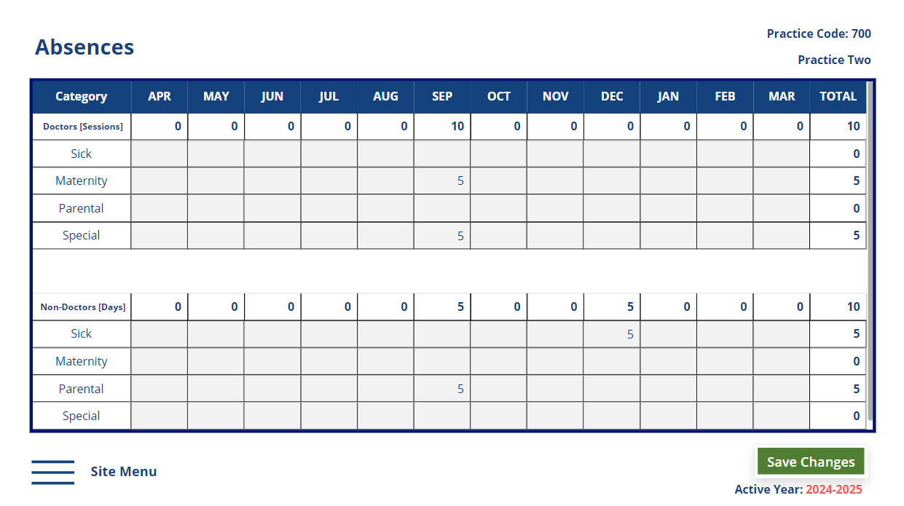
Please enter your absence data for 1st April 2026 to 30th June 2026.
Use the Save Changes button to save your changes.
Please note that it may take a while for the sum to be reflected in the column totals (under 1 minute). After saving the changes, this notification will appear at the top of the page:
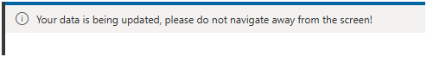

.

Final Submission
After each page has been finalised, the Finalise Year page can be accessed from the Navigation pane.
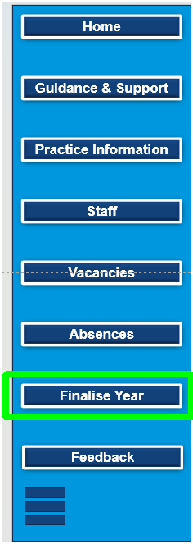
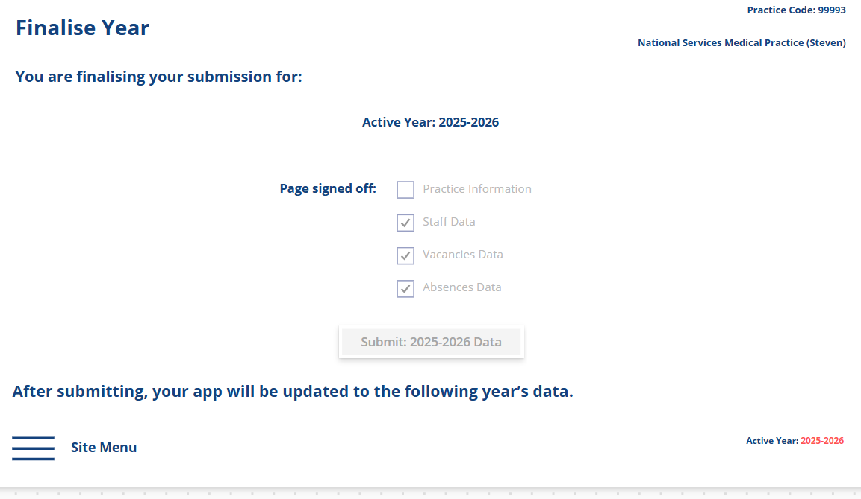
Please note that the Submit button is disabled by default, if at least one of the checkboxes is not selected on the Practice Information, Staff, Vacancies and Absences pages.
The Vacancies page can be checked as finalised without any record present.
The checkboxes on the Finalise Year page are automatically checked here if each page has been confirmed as being finalised after saving, in the pop-up dialogue box.
If one of the checkboxes (or all) is NOT selected here, you must navigate to each page in question, click on Save and then select Page Finalised from the pop-up dialogue box and then return to the Finalise Year page to complete your submission.
Please press the Submit 2026/2027 data button.

A notification will appear on the top of the page:

If you wish to update or amend your data, please click on Recall.
Doing this will uncheck all the four checkboxes so further edits can be made on the four pages.
After this is done, you can update or amend the relevant records, Save your changes on each page, return to the Finalise Year page and click on Submit 2026 - 2027 Data

Other Considerations
If at any moment you wish to return to the Home page, the Site menu / Home button can be used:
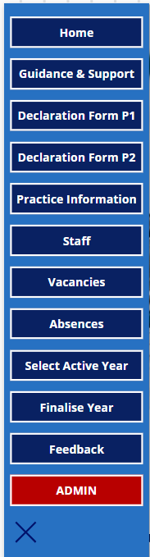
When an app update is available or in progress, you will be notified at the top of the page in a banner such as this one:
After the version is published, you will get the chance to update the app: by pressing on the Refresh button below. Doing this is highly recommended, in order to have the latest features that may solve some technical issues that are present.

-= Thank you for completing this data collection =-

